Empirical Methods in Political Science
An Introduction
Contents

Introduction
Jean Clipperton

What is Political Science?
This textbook focuses upon empirical methods used in political science. Before turning to the methods, it can be helpful to understand what political science is and what political science research can look like. Broadly, the discipline focuses on power and events throughout history. Some scholars focus on modern issues (e.g. Brexit) while others focus on historical ones (e.g. the New Deal in the U.S.). There are a variety of methods used and scholars are typically organized around the area/region they study.

Subfields in Political Science
There are four primary subfields in political science (although we can consider many subdivisions, additional groupings, and so on): comparative politics, American politics, international relations/world politics, and theory. For this text, we will focus on quantitative political science and so we will consider the first three subfields.
- Comparative politics as a subfield focuses upon comparisons of countries or regions to one another. Typically, ‘comparativists’ have expertise that enables them to dig deeply into their region. However, the questions they ask are broadly relevant beyond the researcher’s region of expertise.
- American politics focuses upon….American politics. Here, scholars typically focus on behavior (e.g. voting), institutions (e.g. Congress), or history (American Political Development, a.k.a. ‘APD’). In other countries (e.g. Australia, Americanists are considered ‘comparativists’ ... so it’s all relative). Here, scholars typically focus on one of the approaches (e.g. institutions), but increasingly more scholars focus on both behavior and institutions, for example.
- International relations, also known as IR or world politics, focuses on large-scale global questions. Questions here are often about trade, economic development, and/or political economy. There are different branches of IR. Focusing on the quantitative side, many IR scholars work with large datasets, perhaps only slightly more so than in other fields. Qualitative work, specifically, case studies, represents approximately 45% of the field as measured by (Bennett, Barth, and Rutherford 2003).
- Methods Quantitative Methods is sometimes considered a subfield of political science and it is devoted to the development of quantitative methods, such as statistics, computational social science, and game theory. Methods scholars focus on tasks such as developing new methods for answering questions where previous ones had failed. For example, if you wanted to study something that either happens or doesn’t, then a regression wouldn’t be appropriate. You would need a new/different research method. Similarly, if you’re looking at something that unfolds over different stages, you might need to develop a strategic model to understand how the actors are incentivized to act.

Questions in Political Science
Questions in political science span the globe and often consider power: who has power, how that power is used and/or abused, and how power is specified. Here are a few questions that are or have been frequently studied:
- Why are some countries democratic and others aren’t?
- Does democratic rule make people better off? How?
- What sort of political institutions lead to best outcomes?
- What policies and institutions help diverse groups to live in peace?
- What are causes of war? How can we prevent war?
- What leads to cooperation between countries?
- What are best ways to promote prosperity and avoid poverty?
- Why do people vote and participate in politics as they do?
- Is there a ‘resource curse’?
These are big questions. While progress has been made toward answering many of them, they are often so large and broad that a different interpretation can lead to a different finding: for example, what would be a best outcome for a political institution, Stability (and thus low turnover) or a responsive government?
As we go through the text, we’ll introduce different research questions and topics that span subfields and methods to demonstrate the range of political science research.

What are Empirical Political Science Methods?
In this textbook, we will focus on empirical research methods – meaning how political scientists use and think about quantitative data. These methods are how political scientists go from their initial question to being able to find an answer. They can be a regression/statistics, but they can also involve interviews, or mapping out social networks.
Political scientists use a range of methods to answer their research questions, with the key focus being whether the tool is appropriate for the job. Often, political scientists will specialize in one primary method, and receive training in a few others. This will shape how the researcher sees questions (for example, my own training is quantitatively-focused and so I tend to think about things from a quantitative mindset while a friend of mine has a qualitative background, so to her, she thinks about things like process as a key driver) and how that researcher is able to answer those questions.

Types of Methods
There are many types of methods used in political science. In the realm of quantitative political science, common methods include the following approaches listed below. There is one chapter that focuses upon techniques like interviews and participant observation, but the broad focus of the book is on quantitative data. Discussion about quantitative and qualitative methods is an important distinction within the discipline.
- Surveys: Perhaps the most accessible or well-known approach. Surveys are questions asked of respondents. We will focus on how surveys are designed and how respondents are selected.
- Experiments: Experiments are often described as the ‘gold standard’ for research and are common in many areas outside political science. In an experiment, there are frequently two groups that are identical to one another except that one group gets the ‘treatment’ and the other group does not. For example, one group might be exposed to a political ad of a certain type while the remaining group is not, to understand the connection between politics and emotions as in (Karl 2019).
- Large N: In cases where there are a wealth of data, scholars may opt for statistical research. What this looks like can depend upon the size of the data.
- Small N: Studies that have fewer observations or use approaches like interviews often focus on the mechanisms behind a process. For example, under what circumstances do institutions evolve and change? See: (Mahoney and Thelen 2009; Ostrom 2015).
- Game Theory: In game theoretic approaches we represent the strategic choices actors make as a series of interdependent choices. There are frequently two key actors who must make decisions (such as cooperation or defection or the imposition of sanctions (Pond 2017)). These actions weigh the utility of certain choices dependent upon what and how their opponent(s) behave.
- Social Networks: In social network research, it is the connections between individuals that become the items of interest. How do different actors relate to one another? How might information move around/through a community? These communities can be real (high school social networks, families) or virtual (who follows whom on twitter, whose work is cited by others).
- Machine Learning: In this approach, very large datasets are used. Frequently, the aim is to discover patterns and connections in the data or to otherwise harness the power of many observations to discern the hidden order in the data.

Qualitative and Quantitative Political Science
Empirical research methods typically use quantitative data. These data are frequently numerical and can often show broad trends that are happening within the question of interest. Other scholars use qualitative methods. In a qualitative framework, the ‘data’ can be anything from noticing how spaces are shared by individuals at the Paris Climate Summit (Marion Suiseeya and Zanotti 2019) to interviews (Helmke 2005). Often (but not always; see: Pearlman (2017)) qualitative researchers work with fewer cases (small-n data) and quantitative researchers look at larger datasets (large-n data).

Multiple or Mixed Methods
Mixed or multiple methods refers to how many different approaches a scholar or scholars use in their analysis. Although they often specialize in one method, researchers may still combine methods – either through their own training and/or background – or through collaborating with others. For example, the use of experiments and surveys (Teele, Kalla, and Rosenbluth 2018; Bonilla and Mo 2018) or interviews and observation (Vargas 2016)).
Both quantitative and qualitative approaches offer valuable insight into any given research question and there has been a bit of a divide that’s arisen within the discipline as technology evolves. With the increasing availability of quantitative data and low barriers to data gathering, it can be tempting to emphasize quantitative methods. Given the additional training often needed to hone and refine one’s skillset, individuals frequently rely on a primarily quantitative or qualitative approach. However, there is some movement toward what is termed a ‘mixed method’ or ‘multi-method’ approach in which both quantitative and qualitative data are used in a research project (Seawright 2016). As it will become clear at the end of the text, each method has advantages and disadvantages: combining methods can help leverage the strengths of each chosen method while minimizing the disadvantages when including a complementary method. Of course, this approach is not without a high cost – individuals must then be trained and proficient in multiple methods, something that can be challenging and time consuming.
Because of our (Clipperton et al) own background and training, we emphasize empirical approaches, but there are still many different ways to approach a question. A common trope regards advanced methodological training as equating to obtaining a hammer so that everything looks like a nail. Our hope is that you’ll develop an understanding of the different tools available in the political scientist’s tool kit so that you will be able to appreciate and interpret existing work while thinking critically about how to approach your own research questions. The research question itself can help you choose an appropriate method–rather than the reverse.

Scientific Method
Regardless of the question and the method, political scientists need a way to work through the evaluation of their question. For that, we will thank Karl Popper and his push not only for falsification but for urging that scholars have a method for their inquiry.
In this text, we rely on an adaptation of the scientific method. This is something we will use for each research article and every research proposal, so it’s important to understand each component fully. Below, we lay out the different elements of the scientific method.
- Puzzle: This is the research question. It must be something that needs answered – often in the format, ‘research leads us to expect x, but we observe y’ or ‘here are two contradictory arguments, which is right?’ In any case, a puzzle is something that is not only unanswered, but interesting. It can somehow tell us about the world in a broader way, even if the question itself is quite narrow.
- Theory: This is the explanation or answer to the question. Typically, you will have an outcome that you wish to explain with some important factor. In the following chapter, we’ll introduce theory more fully.
- Hypotheses & Implications: while a theory is more broad and about the relationship of factors, hypotheses are often testable implications that stem directly from the theory.
- Evidence/Test: evidence is how the authors support their theory and conclusions. It might be longitudinal data with a regression; it might be survey data with differences of means; it might be interview data. Here, you’ll explain how they are evaluating their argument.
- Falsifiablity: Is it possible to disprove the theory? Sometimes articles might focus on a new paradigm for approaching a research area. These would not be falsifiable as they’re an approach or suggestion. Falsifiable questions can be proven wrong – for example, if I argue that voters prefer candicates who made a promise and kept it over those how made no promises or did not follow through, I could easily evaluate this with empirical evidence. Did voters elect someone who made promises over someone who did not? (Bonilla 2022).
- Conclusions: This is what the study concludes – what are the major findings? Be specific about the findings and whether/how they generalize. For example, if the article is focusing on the 1980 Ugandan elections, what are the findings and what does that tell us overall?
- Do I buy it?: This is where you’ll enter your critique of the article. You might wonder about the method they chose, how it was executed, or their particular case study. This is the point where you’ll describe your concerns and then evaluate whether the evidence presented is sufficient enough to overcome those objections.
Note that the scientific method is a helpful means to organize an article (minus the last element), but it’s an even more helpful way to organize your notes about an article. Using the scientific method can help provide a consistent, clear, organized structure that focuses on the essential elements of an article or book. In all but the last stage, you will want to be as objective as possible–laying out only the relevant elements/details. In the final portion, ‘do I buy it’, you will put down your critique. But to criticize something, you must first understand what is being argued.

What Can Research Tell Us?
When reading or conducting research, there are twin goals at play: the first is what relationships can be established in the research project/dataset itself; the second is how the question answered by the research project can speak about a broader population than just the data in the research project.

Support for hypotheses
This first component has to do with what can be established within the framework of the question and data. For example, suppose your research question has to do with political attitudes of young Americans. To answer this, you collect data from a random sample of Americans (See: chapters on Data and Hypothesis Testing) your findings would pertain to your research question within your data. If you had a statistically significant relationship, you would find support for your hypotheses. If you failed to have a statistically significant relationship, you would not find support for your hypotheses. You would make conclusions about the individual data points within your dataset.

Generalizability
The second component has to do with how your research fits into a broader picture: what can your research tell us about young Americans and how does that fit into a larger context? Supposing you conducted your sample appropriately (See: chapter on Data), you would be able to speak to not only the individuals in your sample, but the population they are intended to represent. This is the important component of research and why we will spend a large amount of time discussing sampling approaches and appropriate methodology. While your sample of, say, 1600 data points may be interesting, it’s really only interesting in that it can tell us about the 327 million other data points we don’t know anything about.

Overview of the Textbook
The textbook proceeds with an introduction to theory and concept building, moves to an explanation of causal inference (how do we ‘know’ whether something is causal?), and then provides a quick introduction to data and hypothesis testing. Following that, each chapter is devoted to a particular research method used within political science: surveys, experiments, large N, small n, game theory, social network analysis, and machine learning. Each chapter follows a similar format and layout to help introduce the method, its advantages, disadvantages, and different applications.

Causal Inference and the Scientific Method
By Pilar Manzi and Maximilian Weylandt

Introduction
Social scientists, like other scientists, do a variety of work. Some are doing research that primarily aims to describe a situation. For example, Pan and Xu (Pan and Xu 2018) use a large online survey to present the first macro-overview of ideological preferences among Chinese citizens. They find that people who prefer authoritarian rule also tend to support the state intervening in the economy, while people who favor democratic reforms support market reforms at higher rates. They don’t try to explain why this is so, but just present the state of things as they have found them. Others go beyond description and try to establish cause-effect relationships. De la O (De La O 2013) uses experimental data from the Mexican Conditional Cash Transfer to estimate how the transfers affect beneficiaries’ electoral participation and party choice. She finds that early enrollment in the program caused an increase in voter turnout and in support for the incumbent party. No matter what the research goal is, all of these different types of work follow the scientific method. Following this method is what makes us political scientists and not political commentators. The method guides us through our research process, offering a framework for answering questions through empirical data. It carries us from our initial research puzzle all the way to our conclusions.
While all research requires careful and thoughtful work, this chapter will focus more on what’s involved in investigating causal processes. Causal claims have been a part of the field since its origins. One of the old debates in comparative politics, for example, concerns whether a country’s growing wealth results in more democracy. There have been numerous attempts at establishing a causal relationship between these two factors, yet most have been followed by valid criticisms that cast doubt on the authors’ conclusions. These debates have been centered around: how to determine if development causes democracy or if democracy causes development; what level of development is necessary for democracy; and, how to explain the presence of developed countries that are authoritarian, among others.
These perennial discussions have led some authors, such as (Seawright 2010), to argue that it is futile to attempt establishing causality among development and democracy, at least with large cross national datasets.
Despite the challenge of making causal claims, it is a goal pursued by many researchers because it offers the strongest means of evaluating and testing a theory. In recent years, quantitative scholars especially have begun using increasingly sophisticated methodologies (influenced by a similar movement among economists) to establish causality. As you’ll read in the “Experiments” chapter, experimental political science introduced the ability to see cause-effect relationships among subjects with a much greater degree of confidence than before. Yet scholars have also advanced on the casual path with data that does not come from experiments. In short, the quantitative methods for causal inference have expanded tremendously in complexity and power. In the end, there is no magical statistical procedure that can show causality; each problem requires the application of careful thought.
This chapter will introduce you to terms that are crucial in thinking about causality, such as omitted and confounding variables, reverse causality, and spuriousness. It will provide you with a key set of questions that you should ask yourself when considering a potential causal relationship. Above all, we want to stress that causality cannot be shown easily. This is especially true in political science: the concepts we deal with are contested in their definitions, the way we measure concepts is prone to error, and the subjects of our research are, at the end of the day, humans. Showing causality is difficult but important work that requires careful consideration of the relationships among variables.
We’ll begin by discussing the scientific method, which may already be familiar to some of you. Next, we’ll discuss some hurdles to good description, before going into more detail on establishing cause-effect relationships, or what’s called “causal inference.”

Setup: The Scientific Method
If you have taken a science class before, you may have seen a diagram or flowchart that describes the scientific method, or the scientific process. There is no one canonical description, but the scientific method is generally held to include a few parts.
- We start with a puzzle about the real world. Our aim is often to explain something interesting- perhaps an anomalous case that is not explained by existing literature or a new phenomenon that needs explaining. But first, be aware of the type of puzzle or question you are elaborating. Normative questions, on the one hand, regard ethical or moral concerns; they are about what should and what ought be. Positive questions, on the other hand, are not about what is right or wrong, but simply about why and how things occur the way they do. This textbook focuses on how to investigate positive questions. You should try striking a good balance on the scope of your question: you want your puzzle to be specific enough to be answerable, yet not too detailed so as to only speak to a tiny part of the literature. Let’s say we are interested in understanding who supported left-wing populist Evo Morales in Bolivia.
Note that this question is not about what should be driving peoples’ vote, but about understanding what is driving it. The question speaks to a broader literature on voting behavior and populism, yet at the same time is restricted to a specific context and is clear enough so as to be answerable. Another important thing to keep in mind is how the question is worded. Not all puzzles and research questions are about causality. In this case, for instance, the question is more descriptive in nature. If we were to ask what causes people to vote for a certain candidate, then we would need to make sure that our method and our findings actually allow us to make causal claims. As you will learn later, most often than not this is not the case.
- Then, we come up with a theory that explains our puzzle. Often, you will encounter several theories that could explain your puzzle. Among some of the theories on voting behavior there are those that emphasize ideological linkages, party attachments, or candidate image. Yet another group of scholars focus on class cleavages or economic interests. This literature broadly states that voters should support candidates whose programs will benefit them economically. If you research a puzzle you will familiarize yourself with arguments from the whole field, though in practice, scholars tend to focus on one theory.
- This theory usually has (a) hypothesis/hypotheses and implications. If economic considerations drive the vote, we should see this in the data: poor and wealthy voters’ choices should differ. More specifically, lower-income Bolivians should be more likely to vote for Evo Morales, whose core promises included implementing social grants and extending social services. Wealthy business-owners, on the other hand, might have been more inclined in voting against him in fear of being heavily taxed or having their business expropriated. As with the case of formulating questions, the formulation of hypotheses should correspond to the tools you have available to test them. If you do not have experimental data, you should be wary about hypothesizing that low- economic status causes voters to support Evo Morales.
- These implications can be tested against evidence. The evidence might have already been created, or we might create the evidence ourselves. For instance, we could take advantage of existing surveys and analyze that data with a regression. Alternatively, we could implement our own exit poll in the next elections and test our hypothesis on this database.
- Finally, after testing our hypotheses, we can make conclusions about our research. If our results show that low-income citizens voted for Evo Morales at higher rates that business-owners, then this could indicate support for our hypothesis. If not, we could turn to a different theory on voting behavior and come up with observable implications and hypotheses, and then test them with the data. Note how this loops around to the beginning of the process: the evidence we have here informs further engagement with theory, and so on. As mentioned in the above steps, the implications we can derive are conditioned on the type of evidence and type of tests we can perform. Unfortunately, we cannot make causal implications when our method purely allows for descriptive statistics. In short, there needs to be an overall fit between our research question, our hypotheses, our tests and the conclusions we extract from them.
While some articles and books do all of the things listed above, these steps do not all have to be followed in the same project for it to be scientifically sound. Science is a collaborative enterprise, and sometimes research progresses from the efforts of several scholars put together. One article could simply provide a new set of data, for example, that either challenges conventional wisdom or describes a situation for the first time. Let’s say we run the exit survey after the Bolivian election, and publish an article that describes the demographic characteristics of different voters and who they voted for. Others can then start using that data in their research and test different theories against the available data. As mentioned, there are often competing arguments explaining the same observations. Some scholars argue that voters are voting based on which party they expect will deliver them more economic benefits in the future (theory 1), others that voters reward parties for how well they have treated them in the past (theory 2), and yet others claim vote choice is inherited and taught within families (theory 3). Survey questions could probe whether voters expect to gain from the new administration (theory 1), or how they have fared under different parties in the past (theory 2). In-depth interviews or ethnographic research could show that voters feel a deep connection with parties that goes back to their childhoods (theory 3).

Exploration or Cheating?
The process explained above is somewhat abstract, and often not followed exactly in practice. When a researcher gets new data, it is tempting to immediately have a look at it and see what connections one can find. If done right, this is inductive research: a deep engagement with the data leads us to new hypotheses about the world. This is often contrasted with deductive research, where we have theories and test them against data. (See also the discussion on theory-building versus theory testing in the “Theory” chapter).
Some people (often people working with large-n data) are strong proponents of the latter approach. They argue that you should not come up with theories after the fact to fit the patterns in your data. This is because starting with the data can lead to misconduct. A famous recent example of this happened with Cornell Professor Brian Wansink, who published dozens of headline-grabbing studies on nutrition. A closer look revealed that he used a variety of questionable research practices. See how a Buzzfeed investigation reports on emails from his lab:
First, he wrote, she should break up the diners into all kinds of groups: “males, females, lunch goers, dinner goers, people sitting alone, people eating with groups of 2, people eating in groups of 2+, people who order alcohol, people who order soft drinks, people who sit close to buffet, people who sit far away, and so on...”
Then she should dig for statistical relationships between those groups and the rest of the data: “# pieces of pizza, # trips, fill level of plate, did they get dessert, did they order a drink, and so on...” (Lee 2018).
What they did is sometimes called p-hacking: manipulating the data until one gets a p-value that indicates a statistically significant result (you’ll learn about p-values in chapter on “Hypothesis Testing”. Wansink was explicit about manipulating these values, writing to a colleague: “If you can get the data, and it needs some tweeking, it would be good to get that one value below .05”(Lee 2018).
There are a number of ways the research process can be compromised. On one end there is outright fraud, like the case of Michael LaCour, who outright fabricated data on an experiment he supposedly ran. (The authors who found it are Broockman, Kalla, and Aronow (2015), but a more accessible summary can be found at fivethirtyeight or This American Life). On the other hand, research may be compromised by researchers selecting the one statistical procedure that shows results among many others that do not. This can happen subconsciously as well! Research almost never involves a clear way forward, and so there will always be the temptation to look at the evidence in a different way – until suddenly we get the results we thought we would get.
There is a bit of a divide between qualitative/small-n and quantitative/large-n scholars on this issue. The former often caution against starting with the data, while the latter consider it essential. A qualitative scholar might argue that you cannot come up with good hypotheses without knowing a good deal about the cases you are interested in – without looking at the data. In reality, quantitative scholars also perform exploratory analyses. There is no way to guarantee that research was done ethically and conscientiously, but the academic community is coming up with new methods, such as pre-registration to increase confidence in how they proceed.
What is the difference between inductive and deductive research?
Inductive research generally begins with the gathering of evidence and then generates theory after analyzing the evidence. Deductive research follows the opposite order: it begins with a theory and hypothesis, then on to collecting evidence and testing the hypothesis in light of the data collected.
Along each step of the process, there are many hurdles to good research. Before we can even begin our research, be it descriptive or causal, we have to be clear about what we are actually researching. Sure, it sounds interesting to research partisanship, or polarization, or corruption, or gentrification. But what do those terms actually mean? And how exactly can you measure it? As we’ll discuss in more detail in the chapter on Data, there is never one right way to define or measure concepts, and these differences alone can make huge differences in study outcomes.
Say we agree on how to define gentrification, and how we want to measure it. Even with a clear measurement that is easily available, measurement errors will creep in either due to human error or randomness. When doing research with a lot of cases (large-N research) it’s almost never possible to collect data on all the instances of the thing we are interested in, so we need to find a representative sample. As you will learn in Chapters on data and surveys, this process results in a fair amount of uncertainty when done perfectly, and much more when done imperfectly. Similarly, researchers working with a smaller number of cases still have to restrict their choices somewhat as they are researching cases in great depth in the chapter on Small N has more on this).

The Fundamental Problem of Causal Inference
Once we have found some patterns in our data, we can delve into the question of causality. Spoiler: Establishing causality is a very bold claim and can seldom be achieved in the social sciences. As you will learn throughout this book, you can do good research and make important contributions to the literature without necessarily making causal claims. Yet, the issue of causality is often present in research, even implicitly. When trying to understand how the world works, the causes of what we are seeing are never far from our minds.
When we talk about a causal inference we are saying that X (our independent/explanatory variable) causes Y (our dependent/outcome variable). In other words, this means that if X does not occur, then Y does not occur. This is called the counterfactual: a scenario where everything remains exactly the same except for the presence or absence of our independent variable. Let’s illustrate with a simple example:
I want to know if taking an aspirin will ease my headache. I can take the aspirin (the independent variable) and then see if my headache (dependent variable) goes away. But I cannot go back in time and NOT take the aspirin to see if the headache would have disappeared anyways. I could test the counterfactual (not taking the pill) the next time I get a headache, yet I will never be able to compare these two situations because everything has changed: the amount of sleep I got, the things I ate that day, the activities I did, and a million other details that I could not have possibly controlled to reflect the exact same scenario of the day of the first headache. This also known as the dilemma of holding all else equal ("ceteris paribus"), and it is the fundamental problem of causal inference.
Since we will never have access to testing a causal claim through enacting the counterfactual, thinking about cause-effect relationships – both coming up with theories and testing them – is a very complex matter. There are several things we must keep in mind in the process of thinking about causality.
In your own words, explain the importance of "all else equal".
“All else equal” refers to the attempt of recreating the counterfactual. The counterfactual refers to that situation where everything remains exactly the same except for the presence/absence of the treatment (the explanatory variable).
Let’s take the example of media consumption and partisanship. Say you propose the theory that watching Fox News causes viewers to vote for Republican candidates at higher rates. (For scholarship on this issue, see for example Schroeder and Stone (2015) and Hopkins and Ladd (2014)). Four questions can help us structure our thinking about this potential causal relationship, both in the abstract and when working with data to test its existence.
- First, we need to determine if there is any relationship between X and Y. There are many ways of doing so, ranging from simple descriptive statistics to more complex methods such as regression. For example, you could conduct a survey that asks people about both their viewership habits and their election choices. Say you find that Fox News watchers indeed vote for Republican candidates at higher rates. Note: this specific tool (survey) will allow you to say if X and Y are correlated, yet this does not imply that X is the cause of Y, only that they are somehow associated. In fact, this is the case with many of the tools we commonly use.
Our theory: X causes Y
- Second, we need to think carefully about what is the direction of this relationship. Is X "causing" Y, or the other way around? The latter option is known as reverse causality, and needs to be considered both when you are coming up with your theory and when you are testing your data. Maybe Republicans enjoy Fox News more, because the network provides more positive coverage of their party than other networks (Coe et al. 2008).
Reverse causality: Y causes X
- Third, we need to address the possibility of confounding variables. A confounding variable is a variable (Z) which confuses – i.e. confounds – the observed relationship between X and Y. But since we do not observe this variable, we can misinterpret our results. For instance, a variable Z might be affecting both X and Y. Yet we are only observing X, so we are not taking into account the role that Z is playing in this relationship. This can lead us either to erroneously identify a causal link or to erroneously inflate the size of the relationship.
In our example, both Fox News viewership (X) and partisanship (Y) could be a function of age (Z). Old people watch more Fox News, and they are also more Republican. What we thought is a relationship between watching Fox news and voting is actually just a reflection of a different set of relationships.
This problem is also referred to as omitted variable bias. You will learn this in more detail in the chapter on “Large N”, but the idea is that you always risk leaving out variables that are key to explaining the causal relationship, and this can affect your interpretation of results.
- Confounding variables are one possible cause of a specific error called spuriousness. A spurious relation is one where X and Y move together in the same or opposing direction, yet this movement is being driven by a third factor (the confounding variable). A researcher can misinterpret this as a causal link between X and Y.
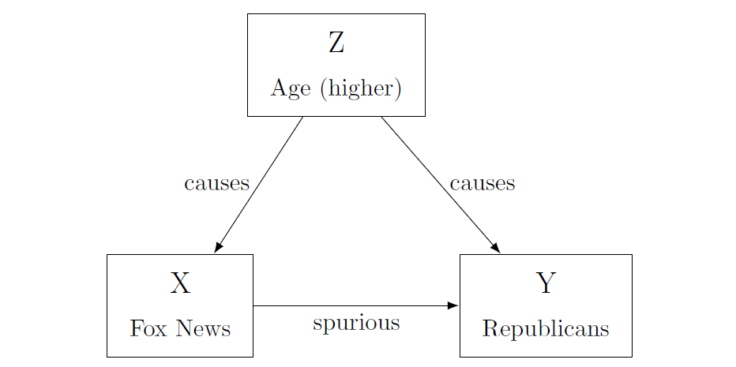
Omitted Variable: actually, age explains both X and Y!
In this case, people who watch more Fox News have higher rates of Republican support, and those who watch less show lower support: the variables move together. However, as we just discussed, this movement might be caused by a third factor. When we take this factor into account, the relationship between viewership and votes might disappear.
Alternatively, a spurious relationship can simply occur by chance: sometimes the data just indicate a relationship that is not there in reality. In our survey of television viewers, we might by simple chance have interviewed a set of viewers that both watch lots of Fox News and vote Republican, even if this association does not exist for the general population. If we have done the sampling well, that is unlikely – but not impossible.
If we do not watch out for omitted variables, and spuriousness more broadly, we might claim a causal relationship because of a chance occurrence in the data or because we have not considered all factors. In practice, this is a difficult task. It is hard to isolate only one variable, especially when we do not have measures of every single variable that could also be affecting our outcome. Actually, in some cases we can’t even think of all the possible confounding variables (Bullock and Ha 2011, 510)
- Another element to keep in mind when dealing with causality refers to the causal mechanism. Can we think of a plausible mechanism linking X to Y? Why would viewing more Fox News cause people to vote for Republican candidates? Perhaps the channel increases people’s knowledge of candidates or it may promote certain viewpoints clearly favoring the party.
In any case, having an idea of why two variables are related makes us more confident that the causal relationship exists.
If we address these questions, then we might have a chance at identifying a cause-effect relationship. Some methods are better than others at addressing these issues. Although later chapters will go into more detail on some of these methodologies, we will briefly introduce them here, focusing particularly on their strengths and weaknesses towards achieving causal inference. As mentioned above, causal inference is not restricted to quantitative methods. Causal relationship can also be revealed through qualitative methods, such as Process Tracing and Counterfactuals. These tools rely on in-depth analysis of particular cases by, for instance, examining historical documents and conducting interviews, and you’ll learn more about them in the chapter on “Small N”.
"Development causes democracy": explain how reverse causality could be operating here.
Just as development could cause democracy, it is also plausible that democracy causes development. For instance, foreign countries and international organizations could be more willing to provide aid to a democracy than to a non-democracy. Introducing more freedoms and allowing people to trade and engage in commerce freely could enhance development as well.
Among quantitative methods, there are two types of methods that try to achieve causal inference: experimental studies and observational studies. Experimental studies are the most potent tool for causal inference. Why? Because of randomization. The essential characteristic that makes experiments so powerful is the fact that we can randomly assign the treatment (our independent variable) to our units. Through this seemingly simple action, we are able to overcome many of the problems mentioned above. Recall that the fundamental problem of causal inference is that we can never test the counterfactual; there is no way of holding everything equal except the manipulation of our independent variable. However, through randomization we can make - on average- all other things equal across treatment and control group. By randomly assigning the treatment to units, we can say that the only thing that differs between the treatment and the control is the presence/absence of the treatment. This means that these two groups are even similar across variables we cannot observe, and thus, we are less likely to face a confounding variable problem.
Although experiments are the preferred tool for causal inference, they are not always available to use, either because of lack of resources, ethical issues, or because they are unattainable given our research topic. Experiments are also most common when dealing with individuals. In cross-country comparisons, it is practically impossible to carry out experiments.
Very often, we need to take data that is observational in nature and try to approximate an experiment using more or less complicated statistical procedures. The term observational comes from the fact that we are not manipulating the treatment; instead, we are simply observing the data that was collected. These methods include Difference in Difference, Regression Discontinuity, Matching, and Instrumental Variables. Explaining these is beyond the scope of this book but you can find an introduction to them in (Joshua David Angrist and Pischke 2015).
Historically, many scholars have made causal claims using simple regressions. These claims should be approached with caution, as you will learn in more detail in the chapter on “Large N”. The way we approximate "all else equal" with regressions is by controlling for possible confounding variables. We assume that, once we have controlled for these variables, all that remains is the cause-effect relationship. Yet, as mentioned earlier, it is practically impossible to control for all relevant variables. This, and other reasons, are why some scholars believe that is impossible to make causal claims with observational data. Indeed, you should be very cautious in concluding causal relationships from your regression. Notwithstanding, they are a very useful tool to describe relevant relationships and trends in data.
Finally, it is worth mentioning again that causal inference is not limited to quantitative work. In the chapter on “Small N”, you will learn about process tracing and other approaches that work better for qualitative data and situations where you have a small number of cases. Some scholars also believe in the use of both qualitative and quantitative methods within one study, complementing large-n statistical work with in-depth case work to strengthen their argument. The interplay between qualitative and quantitative work also happens at a broader level. Nothing is decided on one study alone. The most convincing findings in political science are those that have been confirmed by a variety of scholars using a range of methods.
Explain why correlation does not imply causation.
When two variables are correlated it means that there is some association between them: maybe they both increase/decrease at the same time, or they move in opposite directions at the same time. But this does not mean that the movement of one variable is causing the movement of the other. For example, aspirin use is correlated with headaches (aspirin use increases when headaches appear) but this does not mean that aspirins cause headaches.

Conclusion
In this chapter we have discussed in broad strokes some of the concerns that matter when conducting research in political science. The first lesson is about the importance of the scientific method. Following this framework is the first thing that separates punditry from political science. Anyone can comment on politics and offer an explanation on why things are the way they are. Your job is to scrutinize and analyze facts to come up with empirically based explanations of reality. The best way to do so is by following the scientific process: posing a question, engaging with existing theory, hypothesizing explanations for your puzzle, testing your hypothesis, and interpreting the evidence.
As has been mentioned throughout the chapter, research goals are varied, yet we have focused here on one of the most ambitious goals: establishing causal relationships. Determining a clean relationship between X and Y is not an easy task. Causality in the social sciences is messy and few times (if ever) is our outcome caused solely by one variable. So we must deal with the difficulties of isolating the factor we are interested in, identifying or eliminating all others that could be standing in the way.
We have stressed the obstacles that stand in the way of causal inference not to discourage you from attempting it, but for you to be a conscious researcher and consumer of research. There are still several scholars in the field that irresponsibly claim to have identified causal relationships when their methods cannot support such a claim. By having a sense of the challenges behind causal inference, you can evaluate the validity of these findings. The difference between good and bad causal research is not primarily in the method used, but in how careful the researcher has thought about the relationships at hand. Hopefully this chapter has given you some tools in that regard.

Application Questions
Imagine you have a research hypothesis: As people become more aware of the unequal distribution of income in our society, the more they will support a tax on the wealthy.
- How would you test this with an experimental study? How would you test it with an observational study?
- Perhaps you find that increased awareness of the distribution of income is related to less support for a tax on the wealthy. Can you think of any confounding variable that could be driving this relationship?
- If you decide to carry out an observational study, what variables should you control for? What are possible confounding variables?
- What would the counterfactual in this case look like?

Answers to Application Questions
- Experiment: randomly assigning people to treatment/control; treatment is a video/explanation showing how income is distributed in society; then people are asked what they think of the tax. An Observational study: A survey that asks people about how they think income is distributed and then asks them if they support a tax on the wealthy.
- Maybe those who know how income is distributed are the wealthiest, and they are not in favor of being taxed more heavily.
- Education, media consumption, place of residence, race, age.
- A person that knows how income is distributed and then shows level of support for tax; then, erasing that person’s memory and making the person unaware of how income is distributed and asking level of support for tax.

Theory
By Salih O. Noor

Introduction
Most people may not know much of anything about theory. Theory is either so “esoteric and complicated as to be incomprehensible" or "so commonplace and obvious as to be platitudinous” (Shoemaker, Jr, and Lasorsa 2003, 5–6). Either way, to most people, theories seem to be of little use. In reality, however, people use theories every day about friendship, dating, success, and so on. Political scientists rely on theory to analyze public opinion or predict election results, and weather analysts apply theory to forecast weather conditions. Most people, however, misunderstand what a theory is and what a theory does.
In this chapter we will study the meaning, significance, and building blocks of theory as well as theory-building and theory testing procedures. In the second section, we will discuss what theory is and is not, and how empirical theory differs from other kinds of claims or theories in its application of the scientific method. In the third section, we will learn some characteristics that define a good theory, discussing four very important elements of a well-crafted theory. In the fourth section, we will try to understand literature review and its importance to theory. In the last section, we will study the relationship and differences between theory-building and theory-testing, in addition to inductive and deductive reasoning and procedures in theory-building. For elaboration, we will draw at all stages on various examples from the social (and when necessary the natural) sciences, including two check boxes on the scientific method and on examples in theory-building and testing.

What is a theory?
A scientific theory is a set of logically consistent statements that tell us why the empirical social and political phenomena we observe, or the relationships between them, occur in the way they occur. More formally, a theory “is a system of constructs (concepts) and propositions (relationships between those constructs) that collectively present a logical, systematic, and coherent explanation of a phenomenon of interest within some assumptions and boundary conditions” (Bacharach 1989, 496). In short, a theory is an interrelated set of propositions about empirical reality. These propositions are comprised of (1) concepts that introduce basic terms of the theory; (2) assumptions that relate the basic concepts to each other; and (3) generalizations that relate the statements to a set of observations or, simply, report the findings on observed relationships. It is important that these propositions are “logically consistent” in that they must all be true at the same time; the theoretical concepts, assumptions, statements should be coherent with each other. Concepts, variables, and hypothesis are the building blocks of theory.
For example, the “logic of collective action” is a theory that aims to explain the dilemma of collective action and public goods. Formulated by political scientist Mancur Olson, Jr. (Olson 1965), the theory explains when (and why) do some collective groups (such as trade unions, social movements, or college students) organize better to achieve public goods (like increased wage, policy change, or improved campus security) than other groups. Olson found that the interests of highly coherent minority groups can be overrepresented, and the interests of majorities get marginalized due to the “free-rider” problem. Collective action is difficult because individual members always have incentives to "free ride" on the efforts of others, because “public goods” — goods or services that are available to every member — are by definition non-excludable (i.e. one member cannot reasonably prevent another from consuming them) and non-rivalrous (i.e. one person’s consumption of the good does not affect the others’ chances). As a result, some members (e.g. workers) can expect to enjoy public goods, such as increased wages and improved workplace conditions without bearing the costs of participating in a strike (e.g. time, money, or physical harm). In particular, large groups face tremendous challenges for collective action than small groups, because individuals in large groups gain less per capita of a successful collective action due to diminishing returns. On the contrary, small groups can provide selective incentives to their members and a prospect of greater rewards for each a successful collective action due to small number of members. As a result, Olson concludes, it is highly possible that a minority group bound together by concentrated selective incentives can dominate a majority social group. In so observing, Olson refuted previous theories that held (a) individuals in a group (of any size) will act collectively to achieve their common interests, and (b) the greatest threat in a democracy is, due to the majority’s sheer numbers, “the tyranny of the majority”.
A theory should explain why things happen, rather than just describe or predict. It is entirely possible to predict events or behaviors using a set of predictors, without necessarily explaining why such events are taking place or why they take place together. For instance, stock market analysts predict fluctuations in the stock market based on market announcements, earnings reports of major companies, and/or new data from the Federal Reserve, based on previously observed correlations. In contrast, theoretical explanations require causation, or the understanding of cause-effect relationships. Establishing causation requires four conditions: (1) correlations between two concepts, (2) temporal sequence (the cause must precede the effect in time), (3) causal pathway (causal mechanism that link cause to effect), and (4) rejection of alternative hypotheses through testing (Bacharach 1989, 496–515)
Theoretical explanations can be idiographic or nomothetic that vary in their theoretical premise and explanatory scope. Idiographic explanations are those that explain a single situation or event, say unemployment in the state of Illinois, in idiosyncratic detail. The explanation is detailed, accurate, and valid, but it may not apply to other similar situations, say other states, and is hence not broadly generalizable. In contrast, nomothetic explanations seek to explain a class of situations or events, for example unemployment in several US state, rather than a specific situation or event. Because nomothetic explanations are designed to be generalizable across contexts (events, or people, countries), they nonetheless tend to be less precise, less complete, and less detailed. As such, idiographic and nomothetic explanations rely on different assumptions of causality, different analytical tools, and different approaches to theory-building. Methodologically speaking, therefore, the two approaches to social science theory often fall along the qualitative-quantitative divide; the first typically uses small-N methods of analysis (e.g. cross-case analysis, within-case analysis or process tracing, and set theory) for one or few number of cases, while the second applies large-N methods of quantitative analysis (e.g. large-scale surveys, statistical analysis, regression) to a large number of cases. Further on these methods, read the chapters on small-N and large-N analysis.
Theories are important in the social and political sciences. They help us, among other things, to understand the nature of political and social phenomena (such as political events, behavior, institutions, and processes), to explain observed regularities among these phenomena (i.e. causal relationships between events or processes), to make predictions about as yet unobserved relationships (e.g. the possible effect of immigration policy on the 2020 US presidential elections), and to take a particular policy action (e.g. universal healthcare to reduce high healthcare costs). Without theories it is hard to have valid knowledge of political events, behavior, and processes, or tools to understand the relationships between different political events and processes.
However, theories can also have their own share of (systematic or non-systematic) limitations. As simplified explanations of reality, theories may not always provide adequate explanations of the phenomenon of interest. While social reality is often more complex, theories are designed to be simple and parsimonious explanations based on a limited set of concepts/variables and concept/variable-relationships. Furthermore, theories may impose cognitive blinders or limit researchers’ “range of vision,” causing them to miss out on important concepts that are not identified by the theory (i.e. omitted variable). The nature of these limitations sharply vary between small-N and large-N theories, with the strengths of one being the limitations of the other.
For a better understanding of what theory is, it is good to think in terms of what theory is not. First and foremost, the theory – i.e. empirical theory – we are concerned with here, such as Olson’s “logic of collective action,” is epistemologically different from normative political theory in political or general philosophy. Empirical theory is concerned with the examination of empirical political and policy matters through the scientific assessment of empirical evidence rather than, as political theory, with the realm of political ideas, values, and norms from a normative perspective. The latter is typically concerned with questions of overtly normative nature, such as: What system of government best guarantees freedom, justice, and equality in society?; When is obedience to a ruling power justified, and when is disobedience not justified?; Or how citizens ought to behave towards their rulers or the state? Empirical social theory rather inquires, for example, how and why a particular political system (e.g. democracy, dictatorship, military regime) emerges, why citizens behave in a particular way towards their government or leaders, or what caused voters to support the Democratic Party over the Republican Party in the 2016 U.S. Presidential Elections. The latter also differs from normative theory in terms of the tools, methods, and techniques applied in answering questions about the social and political world around us.
Social science theories are generated through the application of the scientific method – or the principles and procedures of interpreting the empirical world through objective, value-neutral observation of facts. Put simply, the scientific method is a process of guessing and verifying to reach descriptive or causal explanations—i.e. making assumptions/ hypotheses about the real social/political world, examining evidence (data) gathered from that world, and confirming (or disconfirming) those hypotheses in view of the evidence. Even though there is no social scientific method clearly written down that is followed by all scientists, it is possible to identify five steps associated with the method:
- Formulate a question after observing a social/political puzzle;
- Develop a theoretical model/framework to explain it;
- Propose a hypothesis/testable implication;
- Test hypotheses against evidence; and
- Confirm/reject the hypothesis after analyzing the evidence.
The scientific method stipulates clear and logical steps (Checkbox 1) that must be strictly followed in our search for explanations. Social scientists develop theories through the formulation of a question, proposing hypotheses about what they think the answers are, testing the hypothesis against evidence collected and examined in an objective and systematic manner, and drawing theoretical conclusions that are falsifiable through the iterative application of the scientific procedures. Therefore, empirical theory is different from normative political theory in that the latter relies on tools other than the scientific method to deal with normative and ethical questions. Normative questions ask for a normative response, seeking an indication of what is good or of what should be done; ultimately, the answers involve what someone likes or dislikes, values or rejects. The scientific method cannot provide the answers without regard for an individual’s personal values or preferences.
Checkbox 1: The Social Scientific Method
- STEP1: Research Question,The first step in the scientific method is to observe the world and come up with a question. The very need for a theory begins when we observe something that is so puzzling that we ask “why did it occur?” or “what caused it to occur?” What makes the observation a puzzle worth exploring is that the observation does not fit with some prior expectation or theory that we held to be true about how the world works. Therefore, we always have a preexisting theory or expectation when we observe the world that leads to a new puzzle or question.
- STEP 2: Theory or model The next step after observing something puzzling is to develop a theory (also sometimes called theoretical framework or model) to explain it. This is a set of logically consistent statements that tell us why the things that we observe occur in the way they do. The task here is to propose an explanation for the phenomenon the researcher is interested in understanding. Developing a theory requires imagination and creativity to fathom the social world, to impose some analytical order on an otherwise complex world. In short, the model will be a simplified picture of the world; it will be something that helps us understand some relationships between two or more empirical phenomena. A good model, therefore, contains only what is needed to explain the phenomenon that puzzles us and nothing else. At times, this step involves developing a theoretical framework or structure that can hold or support the theory. A theoretical framework consists of concepts, variables, and the theoretical assumptions of the theory that explains the problem under study. It is the conceptual basis for understanding, analyzing, and designing ways to investigate relationships within social systems.
- STEP 3: Hypothesis (Implications) Once we have a model, the third step in the scientific method is to deduce implications from the model. Our model will presumably provide a logical explanation for the puzzling observation that we started with; after all that is what it was designed for. To actually test the model and allow for the possibility that it can be falsified, we will have to find other implications that can be deduced from it. We must ask “If the prior world that we created to explain the phenomena that we originally found puzzling really did exist, what else ought to exist? What else should we be able to observe?” Good models are those that produce many different implications because each prediction represents another opportunity for the model to fail and, thereof, makes the model easier to falsify. If the model fails to be falsified, we gain more confidence in its usefulness. Good models also produce small surprising implication –i.e. they tell us something we would no know without the model. Models are not particularly useful if they tell us only what we already know.
- STEP 4: Test Hypotheses The fourth step is to examine whether the implications of the model are consistent with observation. We should not dogmatically uphold the implications of our model or defend them to prove they are right. On the contrary, we should try our best to falsify them because it is only after a theory has withstood these attempts that we can reasonably have confidence in it. Testing the implications that are most likely to be falsified is particularly important. Always subject a model to the harshest test that you can devise. It is also standard to ask if other (existing) models might also explain the phenomena of interest. In this case, the researcher should compare the implications of those other models with the implications of her own model. It is always the case that competing models have some of the same implications, yet they will differ in some other implications (otherwise they are not different models). The trick is to identify these points of conflict between the different models and the relevant observations in the real world that would help decide between them. This –called critical test – allows the analyst to use observation to distinguish between two or more competing explanations of the same phenomenon. After all there is only one world and only one of the models can be consistent with the real world.
- STEP 5: Evaluation Confirmation or refutation of the theory is the last step in the scientific method. Our theory has been confirmed if we observe the implications deduced from our theory. Note that we cannot say our theory has been verified or proven because we can never prove or disprove a scientific explanation. Scientific method is a means to “provisionally” understand the world, and scientific theories serve as provisional explanations of the world contingent on better methods, better analytical tools, and better evidence. Our theory may or may not be true. All we can conclude, if the observations are consistent with our theoretical implications, is that our theory has not yet been falsified. We cannot rule out the possibility that it can be falsified the next time it is tested. (Clark, Golder, and Golder 2017)
Second, a theory is not the same as a model or paradigm. Theory and model are related terms and not infrequently confused. But the two are different from each other in their definition, purpose, and application. First, as defined above, theory is a conceptual framework or general explanation of an idea. A model (not the same as theoretical model) by contrast is a verbal or a visual representation of a concept in order to make the understanding of something easier and clearer. Second, the purpose of a theory is to explain things and is less practical, whereas a model is meant to simplify things and is more practical. The social and political world is immensely complex; models present a simplified picture of the world that puzzles us. Models present in simple and concise manner concepts, assumptions, and claims, which are the building blocks of theory. Models are commonly used in all political science, but game-theoretic models in rational-choice approaches represent the most popular forms of modelling the behavior and actions of rational actors like voters, politicians, special interest groups, and states. For example, in Olson’s theory of collective action individuals are modelled as rational, interest-maximizing actors who act only under circumstances that maximize their interests. This simple model illustrates an otherwise complex social and mental reality of actors interacting in large group contexts. Therefore, theory and model coexist in the same world of social science inquiry, yet they differ, and the failure to realize this difference can lead to confusion and perhaps in disillusionment. Theories should be understood as explanations or conclusions about certain situations or problems, while models as heuristic devices that help us understand, through concepts and theories, how some aspects of the world work and explain it to others. Models, therefore, can represent a theory but they cannot be a substitute for theory.
Read (Shoemaker, Jr, and Lasorsa 2003), chapter 7, for a greater discussion of theory versus model, and (Clark, Golder, and Golder 2013), pages 121-137, for examples of game-theoretic models.
Third, a theory is not a paradigm. A paradigm is a broad, general framework or approach that defines a particular scientific discipline. It is a distinct set of concepts and assumptions, including theories, research methods, postulates, and standards that guide scientific inquiry in a particular community of scholars. It determines the kind of questions supposed to be asked and their structure, the assumptions made, the methods used, and how the results should be interpreted (Kuhn 1996, 10). Scientific paradigms set the standards for studying the empirical world, while theories are explanations of some aspects of that world. In addition, unlike theory, a paradigm is not actually testable per se. Examples of paradigms in political science include systems theory, rational choice theory, comparative historical analysis, neo-liberal institutionalism, and constructivism.
Fourth, and last, social scientific theories are general explanations, and not “covering laws” of political and social behavior. It is possible to have law-like theories in the natural sciences with universal applicability to all natural phenomena; theories of electromagnetism, evolution, and relativity are some examples. This because natural phenomena display behavior and (causal) regularities that are uniform across time or space. For example, water boils at 100 degree centigrade almost always whereas, according to Albert Einstein, light travels at a speed of 186,000 miles/second, and is unchanging. As Max Weber argued, the laws that regulate social relations are quite different from the laws that govern nature; regularities in human behavior and the physical world are fundamentally different because the former display a great degree of irregularity, fluidity, and heterogeneity. Unlike natural events, political events and processes do not lend themselves to the same explanatory logic as is found in physics and the other hard sciences.
This is to neither say that human behavior is devoid of regularities nor law-like generalizations to explain it are entirely impossible. It is not rare that social scientists seek to identify such regularities and develop general explanations; examples include: Duverger’s law of plurality voting and two-party system (Duverger 1954), modernization theory on modernization and democracy (Lipset 1959); and Moore’s “No bourgeoisie no democracy” hypothesis on the middle class and democracy (Moore 1966). These theories validly explained a broad range of historical observations, but their applicability turned out to be limited to a particular context—i.e. mostly advanced Western democracies before mid-twentieth century—which signifies that the utility of social scientific theories is context- and time-specific because regularities in human behavior hinge on the given cultural, political, and economic context. Most social scientists aspire to produce generalizations about the world; in fact, a central goal of scientific analysis is to generate concepts, models, and theories that travel across time and space. However, social and political phenomena are characterized by complexity, randomness, and diversity to yield themselves to law-like, universal theories. Cause and effect greatly vary across countries, cultures, regions, and historical contexts. What obtains to observations in a specific context often does not apply to other observations in a different context. The demise of modernization theory after the 1960s was precisely because education, urbanization, and industrialization (i.e. modernization) in the Third World did not cause democracy but instability, revolutions and dictatorships. Moreover, the more general a theory is (i.e. it explains too many observations), the less is its explanatory power concerning each observation. In fact, a social science theory that explains everything does not explain anything. Due to the complexity of causality, therefore, social science theories are judged less by their universal applicability than by their validity and robustness in explaining a particular set of observations. Theoretical generality and specificity are two competing goals in theory-building, with large-N (quantitative) analysis associated with the former and small-N (qualitative) with the latter.

What is a good theory?
A good theory should explain previously puzzling facts, be logically consistent, and produce potentially falsifiable predictions. It builds on existing theories, has clearly specified concepts (valid conceptualization) codified as measurable variables (valid measurement), and clearly shows the relationship between the concepts (causal pathway). Even though the standards for a good theory are debatable, particularly among qualitative and quantitative traditions, social scientists agree on some basic elements of what makes a good theory. We will discuss here four major characteristics of a good theory.
Parsimony is the first such element. How simple is the explanation? The simplest theory (i.e. one that uses the smallest number of variable or makes the fewest assumptions) is considered the best. A theory is considered as parsimonious when it has the ability to explain often complex phenomena in relatively few terms and statements. A parsimonious theory can specify the causal relationship (X—>Y) in clear terms using a causal model (which might involve multiple variables and relationships) that reasonably simplifies a complex empirical reality in to something comprehensible.
The second feature is generalizability or theoretical coverage. A good theory is generalizable when it has the power to explain a broad range of similar cases or phenomena outside the context of that study. In other words, the conclusions of a scientific theory are applicable to other contexts not included in the study, which is also referred to as the external validity of a theory. In qualitative research, this criterion is less important because theory is generated from a small set of cases and is less applicable to other contexts. Qualitative analysis rather puts greater emphasis on the internal validity of a study or the extent to which the theoretical claims are based on valid methods of analysis and evidence about cause and effect. Theoretical claims or inferences possess internal validity if claims of a causal relationship between two variables demonstrate that the "cause" occurrence before the "effect" (temporal precedence), the "cause" and the "effect" tend to occur together (covariation), and there are no alternative channels or mechanisms that explain the observed variation (nonspuriousness).
Observable implications or the ability of a theory to help make more accurate predictions about new unobserved instances is the third quality of a good theory. Strong theories have strong observable implications or the things we would expect to observe in the real world if our theory is right. For example, the preference theory of judges states that judges want the law to reflect their ideological preferences; and, because they lack an electoral connection, they are free to vote in accord with their ideological preferences. If this theory is correct, we should observe judges generally voting in accord with their ideological preferences, such that conservative judges cast conservative votes and liberals, liberal votes.
The fourth and last criterion used to judge a social scientific theory is falsifiability or its refutability. A good theory must be falsifiable or liable to refutation when subjected to tests using new observations or new evidence; it must be possible to identify a possible outcome of test or observation that conflicts with predictions of a given theory. In fact, according to the philosopher of science Karl Popper who introduced the concept as the basic principle of scientific inquiry, statements and theories that are not falsifiable are unscientific or not based on the scientific method. The most common way in the social sciences to support falsifiability (or safeguard against invalid refutation of a theory) is to specify the scope conditions or assumptions under which a theory is applicable. Scope conditions are parameters or boundaries specified by the analyst that identify the types of empirical contexts or observations to which the theory applies. For example, we can state that the preference theory of judges is applicable under the condition that judges vote in accordance with their ideological preferences only in the absence of a liberal (i.e., a potential whistle-blower) on the panel. The theory may be falsified when we observe that, say, conservative judges fail to cast conservative votes even in the absence of a potential whistle-blower.

Literature Reviews and Theory
We noted in the first section that developing an explanation begins with a puzzle and a research question. The first major task in a research effort often is to find a puzzling topic and to translate a general interest in a topic into a manageable research question or series of questions. Framing an engaging and appropriate research question will get a research project off to a good start by defining, and limiting, the scope of the investigation while a poorly specified question inevitably leads to wasted time and energy. But most students, when confronting a research project for the first time, either do not have a well-formulated research question as their starting point or any specific interest or topic in mind at all. We may also not know whether explanations, that fully or partially address the puzzle we have observed, already exist. To address these challenges the first major task is to conduct a literature review; i.e. to examine systematically scholarly literature that is relevant to the puzzle. Why is this important? How does thoroughly studying extant literature contribute to theory?
A literature review is a survey of books, scholarly articles, and other sources relevant to a particular issue, area of research, or theory, and by so doing, provides a description, summary, and critical evaluation of these works in relation to the research problem at hand. It is designed to provide an overview of sources you have explored while surveying a particular topic and to demonstrate to your readers how your research fits within a larger field of study (Fink 2013, 5). Good research involves reviewing previous work to motivate and sharpen a research question. Reviewing relevant literature also contributes to theory development for several other reasons. Among these are: (1) to gauge what has and has not been studied, (2) to develop general explanations for observed variations in a behavior or a phenomenon, (3) to identify potential relationships between concepts and to find hypotheses, (4) to learn how others have defined and measured key concepts, (5) to identify data sources that other researchers have used, and (6) to develop alternative research designs. Lets further discuss some of the reasons that are more crucial to theory development.
Often times, a researcher or student will start off by expressing only a general interest in a topic, such as gun violence or the effects of campaign advertising, but the specific research question has yet to be formulated; for example, “What is the social background of individuals who engage in mass shooting?” or “Do negative TV campaign advertisements sway voters?” A review of previous research on these topics can help you carve a research topic by identifying research questions that others have addressed.
A researchers, on the other hand, may start with an overly specific research question such as "Do evangelicals have different views on abortion policy than non-evangelicals?" Reading the literature on public opinion on abortion will likely reveal that your specific research question is one of many aimed at answering the more general research question: What are the social attributes of people who are opposed to abortion, and do they differ from those who support abortion access? Compared to the former question, which is too narrow to sustain a research paper, the latter research question constitutes a topic that is likely to lead to theoretically crucial conclusions and more observable implications.
A literature review also can help you to identify gaps or analytical shortcomings in the literature. Here, you may find that, after reading the scholarly work in an area, previous research does not adequately answer the question for lack of effective research tools, sufficient data, and/or appropriate theoretical approach. You may design a new research project to answer an old question in a novel way using new data. A study may also replicate a previous study to confirm or challenge a hypothesis or expand our understanding of a concept. Replication is one of the cornerstones of scientific work; by testing the same hypothesis through different research design or confirming the results from previous research using the same data and methods, we can increase our confidence that the results are valid.
At other times, a researcher may begin with a hypothesis to develop an explanation for a relationship that has already been observed. Here, a literature review may reveal similar observations made by others previously and may also help you develop general explanations for the relationship by identifying theories that explain the phenomenon of interest. Your research will be more valuable if you can provide a general explanation of the observed or hypothesized relationship rather than simply a report of the empirical verification of a relationship.
A researcher, on the other hand, should be alert for competing or alternative hypotheses rather than just seeking theories that support the plausibility of own hypothesis. Here, you may start with a hypothesis specifying a simple relationship between two variables. Since it is rare for one political phenomenon to be related to or caused by just one other factor or variable (i.e. causal complexity), it is important to look for other possible causes or correlates of the dependent variable (i.e. omitted variable). Data collection should include measurement of these other relevant variables so that you may rule out competing hypotheses or at least specify more clearly the nature of the relationship between the variables (Johnson, Reynolds, and Mycoff 2016, 82–84).
A thorough understanding of existing scholarly work, therefore, is key to formulate an interesting question, test an existing hypothesis or craft new hypotheses, and the development of scientifically valid and useful explanations. Developing skills to understand key concepts and models in the subfield, to critically evaluate and synthesize expert knowledge, and to summarize complex arguments in often a large body of literature are essential for an excellent literature review. Furthermore, personal insight and non-scholarly sources (e.g. newspapers, broadcast media, internet) can be quite helpful in selecting a research topic, and a literature review can encompass virtually anything published on your topic. However, at the very least familiarity with the scholarly literature is strongly encouraged. Relying on scholarly rather than non-scholarly sources greatly improves the quality of a literature review. After all, a literature review is supposed to assess the knowledge about a topic that has been attained and communicated according to scientific principles. Finally, how many books and articles is one supposed to review depends on the purpose and scope of the project, as well as source availability. Obviously, a more complex research topic, or a subject with a larger literature, may require a more in-depth literature review than will a less complex topic or one with a smaller literature. Further readings on: the importance of literature review (Johnson, Reynolds, and Mycoff 2016; Fink 2013; Hart 1998; Ridley 2012; Knopf 2006; Jesson, Matheson, and Lacey 2011) and structure and writing techniques (Cook and Murowchick 2014; Fink 2013; Hart 1998; Jesson, Matheson, and Lacey 2011; Onwuegbuzie and Frels 2016; Ridley 2012; Booth, Sutton, and Papaioannou 2016).

Theory-building vs Theory testing
Social scientific research may involve many activities such as interpretation of constructs or concepts, describing a social phenomenon (descriptive inference), and identifying links between two or more related phenomenon (causal inference). But the two core activities and goals that underlie most activities (in causal inference in particular) are theory-building and theory testing. Both are interrelated scientific endeavors that apply the scientific method, but they vary in important respects that should be properly understood. As table 1 summarizes, they vary in terms of their epistemological approach, main goals and tasks, and end results. At the end of section, we will discuss three exemplary theory-building and theory testing works in the political science for elaboration; but in the meantime, we will use natural science examples to easily highlight – for the latter are relatively straightforwardness – the differences between the two.
 | Theory building | Theory testing
Main approach | Inductive reasoning | Deductive reasoning
Research goal | Estimating a relationship/ offer an explanation | Evaluating an explanation/ test existing hypothesis
Main task | Developing hypothesis; test hypothesis against evidence | Finding evidence to test existing hypothesis
Outcome | New or modified theory offering new explanation | Old theory confirmed or refuted
Table 1: Theory-building and theory testing compared
Theory testing, as the phrase suggests, is the process of testing (verifying) whether a certain theory is a plausible explanation of a phenomenon you would like to investigate. Its goal is to test the validity of an explanation often, but not always, through a research design, new data, and/or data analysis tools. The main focus of theory testing is to discover whether there is evidence that supports (or does not support) a particular theory. Theory testing is relatively easier than theory building. While researchers (scholars and post-graduate students) undertake a much more challenging research task of theory building, students often do research primarily aimed towards theory testing. Still, though, it is critical to deeply understand the theory and how it is used to frame empirical research before you can adequately test it yourself.
To clarify theory testing, take the Anthropogenic Global Warming (AGW) Theory, which asserts that human-caused greenhouse gas emissions are the main cause for the rising global warming levels observed in recent years. Carbon dioxide comprises one of the greenhouse gasses. Carbon dioxide causes water on the surface of the earth to evaporate; increased water vapor in the atmosphere in turn can trap heat coming from the earth thus cause global warming. To test this theory, the first step is to look into the humidity levels associated with carbon dioxide emissions because the theory posits that carbon dioxide causes water to evaporate and trap heat. Greater carbon dioxide means greater water vapor in the atmosphere measured using, say, a wet and dry bulb thermometer. The next step is to find out if there is a correlation between surface humidity and temperature, which should be positive for the theory to be true. The main task of theory testing is thus to find evidence to confirm or refute a theory.If the evidence supports the theory, then no further action is required. If the evidence rejects the theory then you can conclude either the theory is incorrect or the data is inadequate.
Theory building by contrast is an attempt to explain something as yet obscure do novo or in different perspective than has previously been suggested. The goal of theory-building is to provide a framework for analysis to better understand puzzling empirical issues and to help address real world problems. As such, it requires knowledge of the plausible theories explaining the phenomenon currently are, and how they are used in empirical research. Theory building demands the application of higher-level thinking skills compared to theory testing. It requires the synthesis of a broad range of literature, concept formation, the formulation of testable hypotheses, the collection and systematic analysis of data, and evidence-based confirmation or refutation of the hypothesized relationships between cause and effect. To be sure, theory-building can also take place by extending or modifying existing theories to new contexts. Here, a researcher attempts to replicate and/or reexamine previously theorized relationships, identifies new causal mechanisms (or pathways), uncovers previously unexplored relationships between variables, and introduces a new concept (or significantly re-conceptualizes an existing one).
In general, there are four major ways of theory-building:
- Grounded theory-building: building theory inductively based on observed patterns of events of behavior in one or few more cases.
- Conceptual analysis: building theory inductively by conducting a bottom-up conceptual analysis to identify different sets of predictors relevant to phenomenon of interest using a predefined framework. In one such framework, a researcher looks for different categories of inputs (factors) related to the output (effect), and explain the underlying process that links the two categories or concepts.
- Extend/modify existing theory: building theory deductively by extending or reformulating existing theories to explain a new context.
- Apply existing theory in new context: building theory deductively by applying theories developed in one context to an entirely new context by drawing up on the structural similarities between the two contexts.
To further clarify the idea of theory building, let’s now consider another example from the hard sciences. To this day, scientists debate what caused the sudden extinction of dinosaurs in what is known as the Cretaceous-Tertiary extinction event, or the K-T event, at approximately 66 million years ago. The leading hypotheses predicted that a giant volcano, sudden cooling down of earth climate, and an asteroid strike was the cause. In the early 1980s, father-and-son scientists Luis and Walter Alvarez suddenly discovered (in Italy) a distinct thin layer of iridium–an element found in abundance only in space–that corresponds to the precise time the dinosaurs died. The researchers deduced that the thin layer of iridium at the K-T boundary was deposited following the impact of a large meteor, comet or asteroid with the earth. Furthermore, this bolide impact (the meteor, comet or asteroid colliding with the earth’s surface) could have caused the extinction of the dinosaurs. However, conclusive evidence – especially evidence of the meteor, comet or asteroid collision with earth – was required to support the theory and to eliminate rival hypotheses. Then, in the 1990s, scientists discovered a massive meteor crater (the Chicxulub Crater), 110 miles in diameter, on the edge of the Yucatán Peninsula, extending into the Gulf of Mexico, which dates to the period in question. Scientists concluded that the 6-mile-diameter bolide that formed the crater struck the earth at 40,000 miles per hour and released 2 million times more energy than the most powerful nuclear bomb ever detonated. The resulting darkness could have plunged the earth’s temperatures into the freezing zone, killing some three-quarters of the plant and animal species on Earth, including dinosaurs, within weeks.
Scientists reached the above conclusion through inductive reasoning –i.e. they used a small piece of evidence (iridium) about a specific observation to reach a more general conclusion. Inductive and deductive analysis – analytical approaches discussed in the previous chapter – play different roles in theory-building and theory testing. The inductive approach (inductive-statistical) is often associated with theory development. t’s a grounded theory-building approach whereby a researcher makes a detailed observation of a case or few cases, to derive broad generalizations and ideas that apply to a broader set of similar cases. Characteristic of qualitative small-N analysis, this approach aims to generate meanings from the data set collected in order to identify patterns and relationships to build a theory. Patterns, resemblances, and regularities are observed in order to reach conclusions (or to generate theory). The deductive (hypothetico-deductive) approach is most often useful in theory testing. Characteristic of quantitative large-N analysis, in deductive analysis a researcher begins with a theory, then conducts research in order to test whether that theory or hypothesis is supported by specific evidence. Extending or modifying an existing theory to fit new reality is a deductive exercise in theory testing.
Whether one applies inductive or deductive analysis, theory-building involves a series of steps from the identification and definition of concepts to the expression of their relationship in a theoretical statement, the construction of a rationale, and the specification of measurements (Shoemaker, Jr, and Lasorsa 2003) [170-171] detail ten steps in theory building, in “How to Build Social Science Theories,” the most important of which are:
- Observation: Start with a problem, some unexpected results, an anomaly, an observation of something unusual, something you would like to know the effects of, or something you would like to know the causes of.
- Conceptualization: Identify (or formulate) the key concepts involved in the phenomenon of interest. Try to come up with concepts that are observable and measurable.
- Hypothesizing: On the basis of careful observation and literature review, try to think of as many causes (or as many effects) of the key concepts as you can. Postulate causal linkages (between your concepts).
- Measurement: operationalize key concepts and specify how you will measure them in terms of independent and dependent variables.
- Theoretical linkage: Specify the theoretical rationale for the hypotheses. Why should they be expected to be true? Use logic and/or other theories to show your argument is reasonable, to convince that the concepts are causally linked in the way you have specified.
- Hypothesis testing: Try to think in terms of multiple hypotheses that are alternative explanations for the same phenomenon. Empirically demonstrate why one (your) hypothesis is true and the other is false.
Checkbox 2: Case Studies in Theory-building and Theory Testing
Theory Building: Some Social Requisites of democracy, S. M. Lipset (1959)
Lipset developed one of the most influential theories of democracy which suggested that some social changes associated with economic development are requisite for the emergence and functioning of democracy. Does economic development lead to the emergence of democracy? And, if so, why? The key concept in his analysis is “modernization” or the transition from traditional, rural, agrarian society to a secular, urban, industrial society. Lipset observed that the average wealth, degree of industrialization and urbanization, and level of education is much higher for the more democratic countries. He then hypothesized that economic development, which he estimated through measures of income, urbanization, industrialization, and education, and the associated basic changes in the class structure, values, and attitudes of society, are the causes for the development of democracy in industrialized countries. In his words “the more well-to-do a nation, the greater the chances that it will sustain democracy” (p. 75). Lipset reasoned that increase in wealth provides economic security to the working class (a guard against revolution); enlarges the size of the middle class, which moderates conflict by rewarding moderate parties and punishing extremist ones; and alleviates lower class threats to the upper class, which opposes democracy when wealth inequalities are extreme. Moreover, increased income levels also improve society’s receptivity to norms of democratic tolerance, and increase voluntary associations that constitute key institutional intermediaries in democracy. Modern education is particularly relevant for cultivating a political culture – i.e. greater voting choice, political participation, tolerance, and media consumption – associated with democracy and political stability. In short, Lipset concluded, without such changes in social structure and values that come with modernization it is impossible for a country to experience transition to democracy and its consolidation. Theory Testing I: Modernization: Theories and Facts, A. Przeworski and F. Limongi (1997), Przeworski and Limongi test Lipset’s theory by reexamining the relationship between economic development and democracy put forth by him. They formulate and test two hypotheses derived from Lipset’s explanation: (a) democracy may be more likely to emerge as countries develop economically – i.e. the endogenous explanation or modernization theory or (b) democracy may be established independently of economic development but may be more likely to survive in developed countries – i.e. the exogenous explanation. Przeworski and Limongi test these hypotheses through a quantitative analysis of 135 countries (224 political regimes in total) for the period 1950-1990, using data on levels of development measured by income per capita. They refute the endogenous explanation by, first, observing that transitions to democracy are “increasingly likely as per capita income of dictatorships rises but only until it reaches a level of about $ 6,000, above which”dictatorships become more stable as countries become more affluent” (p. 159). Their findings confirm the second hypothesis by showing that economic development has a strong impact on the survival of democracies; in fact, “the probability that democracy survives increases monotonically with per capita income.” Except in Argentina, no democracy ever fell in a country with a per capita income higher than $6,055, while thirty-nine out of sixty-nine democracies did fall in countries that were poorer (p. 165). Przeworski and Limongi further observe that the emergence of democracy is linked to economic development in “old” industrialized Western countries, because development didn’t have much of an impact on the collapse of dictatorships in “new” countries postwar and the stability of democracy increases much more with economic development in the old than in the new countries. In sum, modernization theory is correct only with regard to the old countries. ,Theory Testing II: Indigenous Democratization, C. Boix and S. Stokes (2003) ,In yet another test of Lipset’s theory, Boix and Stokes reexamine the causal relationship between economic development and democracy more rigorously. Directly challenging Przeworski and Limongi on theoretical and empirical grounds, they hypothesize that development is both an endogenous and exogenous cause of democracy. Empirically, they replicate Przeworski and Limonigi’s results to show that the latter’s findings fail on three tests of robustness. First, Boix and Stokes reason out, their observation that few transitions to democracy at high levels of income is in fact consistent with endogenous democratization, because “at a per capita income of $7,000, the effects of development on political regime have already taken place: countries that were going to develop and democratize had already done so before reaching the range of the very rich” (p. 524). Second, Przeworski and Limongi’s sample is subject to “selection problems” because the year 1950 (where their data begins) is late to draw a complete story of democratization in rich countries. Using additional data for the period 1800-1949, Boix and Stokes demonstrate that per capita income has a strong positive and statistically significant effect on transitions to democracy from the mid-nineteenth century until World War II. Finally, Przeworski and Limongi’s analysis suffers from omitted variable bias. Boix and Stokes control for additional factors (i.e. international forces and oil) to find out that economic development still makes democratization more likely. Furthermore, rather than higher income per se income equality is the causal mechanism that links economic development to democracy; as countries develop, incomes are more equally distributed, which makes the wealthy to countenance democracy as the median voter favors an equitable system.

Conclusion
A social scientific theory is a generalized explanation of causally related patterns of events, behaviors, or processes. A theory is not data, facts, typologies, or mere empirical findings because theories must go well beyond objective facts or conceptual constructs to include propositions, explanations, and observable and testable falsifiable statements. Theories differ from various other forms of non-scientific claims or knowledge because they are established using objective scientific methods (theory-building), and they are amenable to further testing, confirmation, and refutation using the same scientific methods (theory testing). Theory-building and testing are two interrelated scientific endeavors that apply the scientific method, but they vary in their epistemological approach, main goals and tasks, and their end results.
Social reality is much more complex than we can possibly comprehend or fully explain. As such our theories tend to be limited, if not outright wrong, for reasons related to limited data, unobserved relations, or systematic bias, among other shortfalls. Despite these limitations, however, social scientific theories are still our only hope to better understand our social and political world. Theories are invaluable to describe events and processes, explain relationships between two or more events and process, and to make more accurate predictions whether some events or processes are bound to occur in relation to other events or processes. As a result theories should be informative, objective, accurate, and broadly useful. Different traditions in the social sciences may hold different standards of what constitutes a good theory, but it is generally understood that parsimony, generalizability, observable implication, and falsifiability are some basic elements of what constitutes a well-crafted theory.

Application Questions
- Suppose a political science student is interested in voters who are fed up with “human” politicians and demanding to vote for divine, all-powerful alien leaders. What are the valid steps in developing a theory of benign alien dictatorship?
- Suppose another student wants to estimate the effect of oil wealth on democratic backslide in Venezuela in the past two decades. We already know that oil wealth is highly detrimental to democracy and boosts authoritarian regime durability in low income countries. Is the student engaged in theory-building or theory testing exercise? How is she supposed to proceed in offering an explanation of recent political experience of Venezuela in conjunction with its oil-dominated economy?

Key Terms
- Concept: the basic unit of thinking in theory building or an abstract idea that offers a point of view for understanding our experiences or observations, an idea of a phenomenon formed by mentally combining its attributes, or a mental image that, when operationalized, helps to organize the analysis of data.
- Falsifiability: the possibility of a claim, hypothesis or theory to be proven wrong.
- Hypotheses: tentative answers to a research question. In causal analysis, a hypothesis is an "educated guess" or a conjecture about the relationship between one or more empirical phenomena (i.e. independent variable) and another phenomenon (i.e. dependent variable). Since hypotheses are proposed relationships, they may turn out to be incorrect and not supported by the empirical evidence.
- Literature review: a systematic examination and interpretation of the existing scholarship for the purpose of informing further research on a topic.
- Theory: the conceptual and explanatory understanding that is an essential point of departure in conducting research, and that in turn is revised in light of research. Different (i.e. qualitative and quantitative) analytic traditions have divergent norms about the appropriate structure and content of these understandings.

Answers to Application Questions
- The student is trying to develop a theory that explains why voters are frustrated with politicians and favor an alien dictatorship. The valid steps are to: a. formulate a question. b. define the key concepts “human” politician, corruption, and alien dictatorship. c. formulate a hypothesis, that is, to assume the venality of moral human politicians leads voters to support incorruptible aliens or alien leaders are charismatic compared to ordinary politicians, using use careful observation or literature review. d. measure corruption among politicians and the incorruptibility of aliens. e. test both hypotheses against empirical evidence. f. empirically demonstrate why one (your) hypothesis is true and the alternative hypothesis is false.
- The students is involved in theory testing because existing theories of petroleum and political regimes show oil is corrosive to new democracies. She gathers data on annual oil revenues for Venezuela in the past twenty years and figure if increase or decrease in oil revenues are correlated with the decline of democracy in the country. She has to explain why oil have had a damaging effect on Venezuela’ democracy by empirically showing that it corrupted democratic institutions, destabilized the national economy, and/or strengthened the coercive capacity of the regime.

Data
By Pilar Manzi

Introduction
Authoritarianism, corruption, ideology, partisanship, populism, public mood, civil war, social movements... these are all common phenomena studied in Political Science. Yet what exactly do these terms mean? (Un)fortunately, there is no single way to define them. Although there is, of course, some consensus as to what these terms generally refer to, a clear definition of the concept can vary across researchers according to what best fits their research question. Defining a concept is one of the most essential steps in the research process.
Once a concept has been precisely defined, the next step is to determine what the concept looks like in reality. In this stage, researchers need to think about what observable characteristics will help them identify which units are representations of the concept. The measurement of the concept involves deciding what information must be collected and how that information will be interpreted. For instance, what does it mean for a country to have “low levels of political freedom"? First, we need to determine what constitutes”political freedom" (eg. does it include freedom of speech? Freedom of the press? Freedom to compete in elections?). Then, we must identify what information is available in order for us to evaluate the level at which these freedoms are respected. Will we consider the number of journalists or political opponents under arrest? The presence or absence of constitutional rights guaranteeing free speech? Finally, what makes a level of political freedom high or low?
At the heart of this discussion is data, since we cannot measure a concept without it. Although the word data is used to describe different things (such as a data point or a dataset), we can understand it as the information we collect to characterize the units we are studying. There are many methods of data collection, some of which are discussed throughout the book. But be it through surveys, experiments, or secondary sources, we need to understand what type of information we have at hand. Data can vary according to the unit of analysis, the level of analysis, the time period and the level of measurement. They can refer to a sample, or to a population. In every case, we must identify what we are working with and what each type of data will allow us to do.
With the data in hand, we can proceed to summarize and describe this information. This is called descriptive statistics, and it allows researchers to present data in meaningful ways and potentially discover interesting patterns. The basic tools of descriptive statistics include measures of central tendency (mean, median and mode) and measures of spread (eg. range and standard deviation). Descriptive statistics only allow researchers to speak about the data at hand. Yet, in many cases, the final goal is to make predictions about a larger population, which is the task of inferential statistics. Different statistical tools allow researchers to use information from the sample to then make generalization (or inferences) about the broader population from which the sample was taken.

Types of Variables
In order to use data to operationalize your concept, first we must understand that not all of our variables are of the same kind. Since we are working with numerical data, they will fit into one major category of “quantitative” variables. This means that, even if our data is not necessarily a number, it is being represented by one and fit into a dataset. “Qualitative” variables, on the other hand, are things such as extracts of speeches or historical documents. These cannot be fit into a dataset without serious transformation or coding.
Within quantitative variables, we have important distinctions. The first way to separate them is between categorical and numerical variables. As its name suggests, categorical variables are those that represent categories, or groups. Categorical variables can be further grouped into two distinct types: nominal and ordinal. Nominal variables are those that hold categories that cannot be hierarchically ordered in any way. Country names, regime types (eg. democracy, monarchy, dictatorship) and party identification (eg. Democrat, Republican), are all examples of nominal variables. Ordinal variables, on the other hand, can be ordered in a sequence yet we cannot establish an exact distance between them. In surveys, it is common to see response scales such as: strongly disagree, disagree, agree, strongly agree. Although we know that a person who answered "strongly disagree" has a stronger negative stance than a person who "agrees", we cannot say how much more that person is in disagreement.
The second broad type of variables are numerical. These variables are operationalized as numbers and thus allow us to both establish an order and to determine the exact distance between one observation and another. Within numerical variables we find continuous variables, which can take on any number. This is the case of a country’s GDP or a family’s household income, for example. Discrete, or count variables, are only integer numbers. For instance, a measure of the amount of votes in the House of Representatives is a discrete variable, since there cannot be 155.3 votes.
Check-in question: How could age be operationalized (turned into) as different types of variables?
As we will discuss later, the type of descriptive analysis we can carry out varies according to the type of variable. Generally speaking, numerical data gives us more room for statistical analysis. With categorical data, the descriptive analysis is more limited. For this reason, it is advisable to collect data at the most detailed level, when possible. Say you are interested in measuring a generational effect over political participation. One way to do so would be to ask people in what age bracket they fall into (corresponding to each generation). However, if further in your research you realize there might be a more fine-grained age effect, you would need people’s actual age in years. With a measure of people’s age, you can both analyze the direct age effect and also group people into generations. Indicators of democracy are usually based on indices of continuous or discrete nature, and are then aggregated into ordinal or nominal variables for ease of description. The Economist Intelligence Unit’s Index Democracy Index ranges from 0 to 10 and is then classified into: Authoritarian regime (scores under $4$), Hybrid regime ($≥4<6$), Flawed democracy ($≥6and<8$), and Full democracy ($8−10$). Similarly, the Polity IV score is a number from $−10$ to $10$ and this score is then categorized into Autocracy ($−10$ to $−6$), Anocracy ($−5$ to $5$), and Democracy ($6$ to $10$).

Types of Data
These quantitative variables will be compiled in the form of a dataset, which can also be categorized according to the type of information they hold. The first thing to note in a dataset is what the unit of analysis is. A unit of analysis is that for which information is being collected. For instance, most surveys are at the individual level, since they collect information about people’s point of view on different subjects. Household surveys, which are usually carried out by national institutions to collect information about the population, ask both for data on individuals and for the household/family level. Questions regarding access to water and heat, value of the property, and expenditure on groceries are measured for the household as a whole. In a study on the position of Representatives, the unit of analysis are legislators, while in a study on the characteristics of bills passed, the unit of analysis are the bills. Many available datasets on socioeconomic/demographic statistics of the world have countries as the unit of analysis. Research on Regional Trade Agreements (eg. NAFTA, Pacific Alliance, Southern Common Market) has an even broader unit of analysis, since these agreements encompass several countries.
One distinction to keep in mind is between unit of analysis and level of analysis. The unit of analysis is where information is collected. Yet, we might want to present data at a more aggregate level. Survey data is frequently compared across groups. In this case, although the unit of analysis is individuals, their opinions are averaged across variables such as race, educational level or urban/rural, among others. Similarly, global comparisons of welfare or economic indicators tend to be presented at the regional level (eg. Western Europe, Latin America, Sub-Saharan Africa) or by income groups (eg. High Income, Lower-Middle Income) though the data was collected for each country.
Another way of categorizing data is by considering units and time. Cross-sectional data is one where several units are compared, yet only at one point in time – like a survey or a measurement collected once. A dataset that has multiple measures over time is called time series data. However, the multiple measures are not collected from the exact same unit. If a poll is repeated every three months, yet the respondents vary each time, it falls under this category. Regional surveys, such as the Afrobarometer, Latinobarometro and the European Social Survey are conducted at regular intervals. If only one wave of the survey is being analyzed, it is considered a cross-section data; when several waves are included in the analysis, it becomes a time-series, cross-section data.
If the same respondents answered the poll every time the survey is conducted, it is considered a panel data. Panel data is distinct because it follows the exact unit over time. The British Household Panel Survey (BHPS) is an example of a panel study. In 1991, the BHPS began surveying a sample of around 5,500 households (10,000 individuals). Every year since, the BHPS returns to these households to re-survey its members. The resulting data has enormous potential for researching variation across a person’s life, such as the effects of parenting on employment and gender roles or how political interest evolves as a person ages (Fraile and Sánchez-Vítores 2019; Borell-Porta, Costa- Font, and Phillip 2018; Kuziemko et al. 2018). A dataset with country indicators across time (such as the World Development Indicators) can also be considered panel data. In this case, the measurement of a certain indicator is being collected in several occasions, and thus we can follow the changes of that indicator across time.
Check-in question: Consider the following description of a survey carried out in Uruguay: "Estudio Longitudinal del Bienestar en Uruguay (ELBU) is a cohort study carried out (...) to perform multidimensional well-being assessments. The study follows a representative sample of households with children that were attending the first year of primary school at public institutions in Montevideo and urban areas in 2004 (...) To date, four waves have been carried out in 2004, 2006, 2011/12 and 2015/16 and the fieldwork of a fifth one is being carried out." What type of data is this? What is the population being studied?

Samples and Sampling
Before embarking on data collection, we must be clear as to what population we are interested in exploring. Most of the time, especially when our population is composed of individuals (as opposed to more aggregate units, such as countries), it is very hard to collect information about the entire population of interest. This is why we have samples: we collect information about a group of people from that population to learn about the population as a whole. We want this sample to be as similar as possible to the population, so who we select for our sample is of paramount importance for the reliability of our findings. There exist two major sampling methods: probability and nonprobability sampling. Probability sampling means that the probability of a certain sample of being selected is known, whereas in nonprobability sampling it is unknown. Good research will be typically based on probability sampling.
Probability sampling is also known as random sampling. A random sample means that every person in the population of interest has the same probability of being chosen for the sample; and that every sample of size $n$ has an equal chance of being chosen. Random samples can be simple or take on slightly more complex forms, discussed below. A special property of all random samples, if large enough, is that they guarantee they will resemble the actual population. This is derived from the Law of Large Numbers: as the sample size increases, the sample statistics (like the mean of the sample) get closer and closer to the population parameters (like the population mean).
As mentioned, there are different kinds of random samples. The first, simple random sample, refers to a basic randomization of all subjects in the population. If we were to research university professors at a certain school, a simple random sample could be constructed by obtaining a list of all the hired professors (our sampling frame), assigning a number to each individual, and then randomly selecting a certain amount of numbers, previously determined by considering the amount of resources available as well as establishing a certain minimum number of cases to reduce bias in the sample.
In some cases, sample selection requires more sophisticated methods. Two additional types of random sampling are stratified random sampling and cluster random sampling. Note that these too belong to the groups of probability sampling. Stratified sampling is useful when we want to compare groups ("strata") and thus we want to guarantee that our sample will have a certain amount of subjects from each group. Once the population is divided into these groups, a random sample is selected from each one. Stratified sampling is only possible if we have the necessary data to group our population according to the category of interest. For instance, if the main interest of the professor survey is to compare differences among professors of different ranking, we could conduct a stratified sample based on this information, since it is readily available. Yet, it would be harder to stratify the sample based on personal income. Recall that, to stratify sample on a given variable, the information needs to be available for the whole sampling frame.
Cluster sampling is sometimes confused with stratified sampling, yet they are used for different purposes and the sampling procedure is distinct. Clusters are also groups of subjects, yet they are not constructed to compare them with each other. On the contrary, clusters should ideally have heterogeneity within, yet not differ greatly from other clusters. Once subjects are grouped in clusters, clusters are selected through a simple random method; all of the individuals within the selected clusters are in the sample. Following the above example, instead of walking around all campus in search of our survey respondents, we could cluster professors by Department and survey all professors of the randomly selected clusters (Departments).
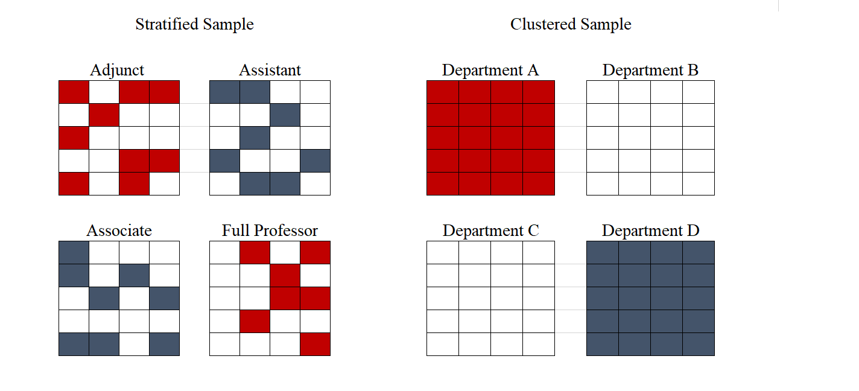
Stratified vs. Clustered sampling
Not all surveys use probabilistic sampling, and you should be very wary of these. One type of sampling method under this category is convenience sampling. As its name suggest, this method implies selecting individuals that are most accessible. Most online polls have this characteristic: the sample will be composed of people who accessed certain websites where the poll was posted and decided to take their time to answer it. A convenience sample could also consist of surveying your soccer team when your research is about soccer fans across the country. Snowball sampling is another type of nonprobability sampling. This method is usually used when studying certain vulnerable or hidden populations that are harder to reach through normal sampling methods (eg. people with AIDS). With this technique, a survey respondent will provide referrals who will be recruited to become part of the study.
Nonprobability samples suffer from a major problem called sampling bias. With these techniques, the resulting sample is far from reflecting the actual population. The online poll example will be a representation only of those people who are exposed to the poll and who feel compelled to answer it, which has been shown to be nonrandom. Deciding to only survey your soccer team will yield biased results as well. You will be representing only a certain age group, from a certain neighborhood who probably share socio-economic status and educational level. The results from this poll will not provide any information on soccer fans across the country, but only of one limited, unrepresentative portion of them.
Although the risks of falling into sampling bias is much lower with random sampling, this might still occur. For instance, while it used to be common to survey people through landline telephone surveys, this will nowadays exclude a significant part of the population. For this reason, pollsters such as Pew Research Center combine random sampling from both landline and cellphone numbers. This method ensures that practically all of the U.S. population will be covered (according to Pew, only 3% of households have no phone access).
There are other types of biases that researchers must be aware of, both for random and nonrandom samples. One of these is non-response bias, referring to subjects that do not wish to participate or answer certain questions, or when subjects cannot be reached. The differences between those that chose to respond and those that do not are usually nontrivial. For instance, people who participate in a poll of a given subject tend to have stronger feelings for it. If a pollster is calling people at 10am, people who are at work will probably refuse to answer, and the differences between their opinions and non-working people opinions are usually not random. This is why pollsters attempt contact at different times of day and different days of the week. Other types of biases can arise from question wording, social desirability or respondent fatigue. You can learn about these in the chapter on surveys.
Finally, no matter how well designed your sampling method is, your results will always have some sampling error. Sampling error accounts for the fact that your results do not correspond to the population, but to your sample. Inevitably, there exists variation between these two. The sampling error is also called margin of error, and it depends on how many subjects are in your sample and on how dispersed our data is. As mentioned previously, the law of large numbers states that, the larger the sample, the closer the estimate will be to the actual population value. Note, however, that usually around 1,500 observations is large enough to represent a country. In fact, most of the regional survey mentioned above, such as Afrobarometer and Latinobarometer, survey between 1000 and 1200 subjects in each country. Though the margin of error continues getting smaller as the size surpasses 1500, the gains are usually not worth the costs of surveying more people. On the other end, the margin of error does vary substantially for lower sample sizes.
Since we can never be 100% confident that our result is exactly the same as the population value, we must always calculate the margin of error to represent the uncertainty of our estimates. Failing to consider this uncertainty is one of the most common ways of misinterpreting survey results. Going back to the example of your survey of university professors: imagine your sample size is of 200 cases, with a margin of error of 8 percentage points. Your estimates show that, among tenured professors, the average score of student evaluations is of $72\%$ , while for non-tenured professors it is 78%. This could lead you to erroneously conclude that non-tenured professors have higher student evaluations. In reality, given such high margin of error, we cannot claim any difference between the scores. Our estimate of non-tenured teacher evaluations are actually between $71\%$ and $86\%$ ($78\%±8$), while tenured professor evaluations are between $64\%$ and $80\%$ ($72\%±8$).
In sum, surveys are an essential tool in data collection, but must be designed carefully in order to avoid common pitfalls. First, be aware of problems related to sampling. When encountering surveys, always evaluate if the sample on which the study was done is representative of the population for which conclusions are being drawn. A study performed on a sample of students from your cohort will only speak to the opinions of students from your university and your cohort. Finally, yet very importantly, recall that survey estimates will always have some variation from the actual "reality". You must take into account this uncertainty and evaluate the results with their corresponding margin of error.
Check-in question: The headline of a news article reads: "Candidate X will win the elections by a large margin: poll shows 52% of people support her, while Candidate Y is only backed by 43%." Why is this headline misleading? What key piece of information is missing to correctly interpret the difference in electoral support between the candidates?

Measurement
Another aspect we must take into consideration before data collection is specifically how our concept will be measured, or operationalized. Whichever our data collection process is, we must be certain that what we are measuring corresponds to the concept we wish to study. A good measurement must be reliable and valid. Reliability means that every time you measure you should obtain the same results. Validity refers to the fact that the measure actually represents the concept we are interested in. As the figure below illustrates, a measure can be reliable if all measures consistently capture the same phenomenon, yet not valid if this phenomenon is not the same as our concept. It can be neither reliable nor valid if it does not consistently measure the same thing and that thing is not our concept. A measure that is both reliable and valid will be correctly capturing our concept in every iteration.
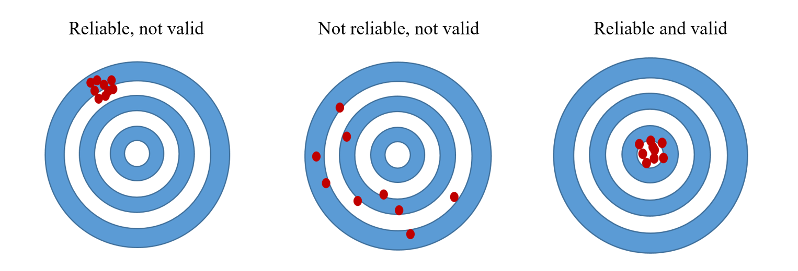
Validity and reliability
Problems of measurement are present beyond the use of surveys. Take the concept of democracy, for which we can find at least 10 different measures. The first differences among these measures is the way they are conceptualized, or defined. This step requires researchers to establish which attributes will be considered. Democracy measures usually include some combination of: political rights, political participation, freedom of speech, civil liberties, competitive elections, free and fair elections, etc. Then they vary according to which indicators they chose for each attribute. What piece of information do I consider to evaluate if a country has free elections? Will I code this as a simple dichotomous variable (free/not free)? Or will it be a numerical variable that captures the degree of freedom in elections? Lastly, since all measures of democracy are in the form of an index, there must be an aggregation rule. Are the scores of each attribute added or multiplied? Does each indicator weight the same? All of these decisions will yield different results. Table [table: data_democracy] below, adapted from (Munck 2009) illustrates how three different measures of democracy are constructed. Note that the table omits two further elements that distinguish the measures: the specific indicators chosen for each component and the aggregation rules.
Name of index | Attributes | Components of attributes | Measurement level
3*(alvarez1996) | Contestation |  | Nominal
(1)3-4 | 2* Offices | Election executive | Nominal
 |  | Election legislature | Nominal
6* (bollen1980) | 3* Political liberties | Press freedom | Interval
 |  | Freedom of group opposition | Interval
 |  | Government sanctions | Interval
 | \multirow{3}{*}{Popular sovereignty} | Fairness of elections | Interval
 |  | Executive selection | Interval
 |  | Legislative selection and effectiveness | Interval
52.5cm Polity IV (marshall2001) | Competitiveness of participation |  | Ordinal
 | Regulation of participation |  | Ordinal
 | Competitiveness of executive recruitment |  | Ordinal
 | Openness of executive recruitment |  | Ordinal
 | Constraints on executive |  | Ordinal
Table 4.1: Conceptualization and measurement of democracy, according to different authors, source: Adapted from (Munck 2009)
One concrete example of how a "small" change in measurement can substantially change a measure of democracy comes from Paxton (Paxton 2000), who analyzes scholarly literature that indicates when a country democratized. She scrutinizes authors’ definitions of democracy, which in most cases consider a country to become democratic when suffrage is universalized. However, these definitions are not always consistent with the dates coded as transitions, since female suffrage is introduced much later. Switzerland is one of the most clear cases: women were allowed to vote only in 1971, yet all of the authors contemplated in Paxton’s study consider it to have been a democracy since the 19th century.
No matter how careful we are in the operationalization of our concept, there will always be some error in our measurement. Yet, not all errors will have the same effect on our results. Systematic errors, or systematic bias, are the most damaging. Systematic bias occurs when we are consistently making a mistake in our measurement. In a scientific lab experiment, for instance, our experiment will have systematic bias if our measuring tool is not calibrated correctly, and so every single measure will be off to some extent. When conducting surveys, systematic bias results from errors in sampling (sampling bias), but also from factors such as question wording and order. This bias also occurs with other data collection methods. Following Paxton, if an author identifies a transition to democracy when suffrage is truly universalized, yet considers countries where women did not have the right to vote as democracies, then this is a case of systematic bias.
While systematic bias generally follows a pattern, random measurement error is due to chance. As opposed to systematic bias, random error does not have a distinct upward or downward bias, and thus it does not have a significant impact on our results. In other words, we might be off in our measurement, but our errors are randomly distributed throughout our data; they do not have a distinct upward of downward direction. Essentially, all or the errors should balance each other out and average out to zero. When we use Likert scales in surveys (e.g. "In a scale of 1 to 10, where 1 is strongly disagree and 10 is strongly agree..."), some might respond too high and others too low, but, on average, we will capture the spirit behind it. When we have an unreliable measurement, however, our amount of random error has become too large. What exactly is too much error is not clear, however.
Check-in question: A researcher wants to obtain a measure of average wages in a country. To do so, she collects data from the social security agency, which centralizes information from each company’s payroll. Yet, this country has a large informal economy, meaning many workers are paid "under the table", and thus will be left out of her measure. What type of error does this represent?

Measures of Central Tendency
Once we have collected our data, our first step is to become familiarized with it before doing any complex statistics. We need to get a picture of what the data looks like. A first way of summarizing data is through tables and graphs, such as frequency tables, histograms, bar graphs, etc. Effectively illustrating data is an enormous advantage. In this section, though, we will focus not on tables and graphs but on statistical measures that summarize data. The first family of statistics, the measures of central tendency, are useful to describe the center of the data, what a typical observation is like. There are three measures of central tendency: the mean, the median, and the mode.
The mean, also known as the average, is calculated by adding up all the values of that variable and dividing by the amount of observations. It is the most widely used summary statistic since it a balancing point in the distribution and gives a sense of where most values fall near. Of course, given that it involves a mathematical operation, it is only applicable to numeric variables, as opposed to nominal and ordinal ones. One disadvantage of the mean is that it is sensible to outliers. Outliers, or values that are substantially higher or lower than the rest, can pull the mean in that direction, thus resulting in a misleading representation of the typical observation. This is especially true as the sample gets smaller; the smaller the sample, the more each observation weighs. For example, lets consider the average income of the people in a small seminar. The ten attendees are students, whose monthly incomes range from $\$1,000$ to $\$2,600$. Yet, the speaker in the room is a famous businessman who earns $\$60,000$ a month. The average income of the room is $\$7,054$, yet all ten students earn less than $\$3,000$. In this case, the mean is not the most appropriate measure of the "typical" observation.
A second measure of central tendency, the median, could be a better fit for the above example. The median is the number that marks the center of the distribution when the values are listed in numerical order. It divides the distribution in exactly half. When the number of values is even, the two numbers at the center are averaged. To calculate the median from the above example, we first order the incomes from lowest to highest: $1,000, $1,000, $1,000, $1,100, $1,200, $2,300, $2,400, $2,500, $2,500, $2,600, $60,000. Then we identify the midpoint in the distribution: $2,300. This is a far better representation of the room’s average income. Thus, when a certain variable has outliers, the median is usually the preferred method to describe the center. Another advantage it has over the mean is that it can also be used to describe ordinal (but not nominal) data. However,in cases with few response categories, the median can give little information about a distribution. Two sets of numbers could have the same median yet different patterns.
The last measure of central tendency is the mode. The mode is the value that is occurs most often. This measure can be used with any type of variable, yet it is especially useful for categorical data. However, if the most common value is not a significant portion of the distribution, the mode might be trivial. Note that a distribution may have more than one value with an exceptionally high occurrence. In our example, the mode was 1,000. Bi-modal distributions are such cases, where the distribution will have two peaks at distinct values. Distributions can also be multimodal, or uniform in cases where all the values have the same frequency.
All three measures are complementary when describing the center of data. Furthermore, having these three measures provides a sense of how the data is shaped. If the mean, median and mode are similar, the distribution is symmetrical. When the mean is below the median and the mode, it means there are extreme values in the lower half of the distribution that are pulling the mean towards that end. This results in a negatively skewed distribution. On the contrary, high extreme values pull the mean towards the upper end, thus resulting in a positively skewed distribution. In addition, based on the number of modes, we have information on the modality of the distribution.
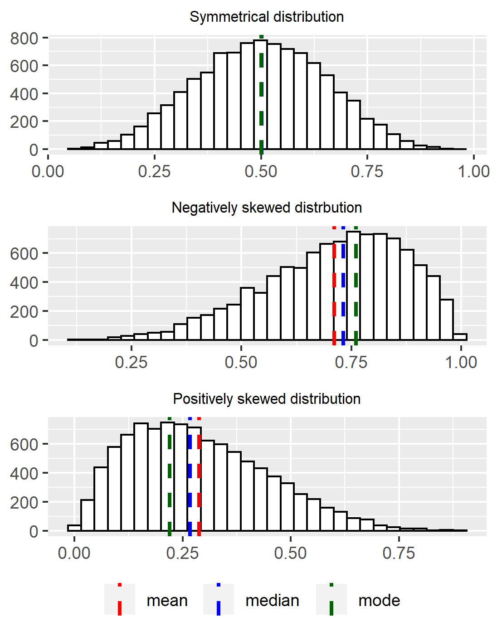
Types of distributions
Whereas the measures of central tendency give us insight into the center of the data and the typical values, measures of dispersion characterize how spread out the data is. One of such measures is the range. A range measures how far apart the highest and lowest value are. If votes for Party A are as low as 10% in one region and as high as 90% in another, the range is of 80%. If Party B obtains 25% in the least supportive region and 60% in the most supportive, its range is of 35%. Party B has less variability.
Two other measures of dispersion widely used in statistic are the variance and the standard deviation. The standard deviation, which is a slight transformation of the variance, is more widely used because it is easier to interpret. Simply put, they measure the average distance of each observation from the mean. Larger standard deviations indicate more dispersion in the data. Note that standard deviation must always be positive: there is no such thing as a negative distance. The calculation of the variance and standard deviation is straightforward, yet requires a few steps:
- Calculate the mean
- Subtract each observation from the mean, and square the result (${\left(x_{i}−\overset{‾}{x}\right)}^{2}$)
- Add up all squared deviations ($\sum_{i=1}^{N}{{\left(x_{i}−\overset{‾}{x}\right)}^{2}}$)
- Divide by the number of observations (n) when dealing with a population or by the number of observations minus 1 (n-1) when dealing with a sample. Up to this point, you have calculated the average distance from each observation to the mean, squared. This is what we call the variance ($\frac{\sum_{i=1}^{N}{{\left(x_{i}−\overset{‾}{x}\right)}^{2}}}{\left(n−1\right)}$). For a more intuitive interpretation, though, we add one more step:
- Take the square root of the variance to obtain the standard deviation ($\sqrt{\frac{\sum_{i=1}^{N}{{\left(x_{i}−\overset{‾}{x}\right)}^{2}}}{\left(n−1\right)}}$)
In sum, an essential description of any variable should include these basic measures to describe both its typical values and to describe their variation.

Broader significance/use in political science
The issues discussed in this chapter are encountered in every single research process. In Political Science, and social sciences in general, conceptualization and measurement are particularly contested issues. Given the nature of the discipline, most, if not all of our approaches to research have some degree of subjectivity. This does not mean, however, that they fail to be scientific. But in order to make legitimate and persuasive arguments, we need to make extra efforts to create robust measures of our concepts. These topics are so relevant that an important part of methodological training is focused specifically on them (Goertz 2006; Sartori 1970; Collier and Gerring 2009).
Sampling is also very tightly linked to the Political Science discipline. Particularly when studying individuals, you will frequently encounter research questions that refer to a broad population which is impossible to completely collect data from. This is why good samples are fundamental to the process. Valid and reliable results hinge upon well designed samples.

Conclusion
Data is (are) the building blocks of research. Without it, we cannot do science. Yet not all data is equally valuable, and no data is ever objective. Whichever the source of our data is we must be very well acquainted with it and be aware that every one of its characteristic will have different impacts on our results. Keep in mind all the types of bias data may have. Starting with concept formation, be wary that no concept is the same, and make transparent and thoughtful decisions as to why you chose to build and measure the concept the way you do. Also, pay close attention to how the data is being collected. Recognize that none of these choices are neutral, that they all have limitations, and that they will have different consequences on your research. Once you have your data collected, dedicate time to describing your dataset. This will reveal interesting trends and patterns that are valuable in and of themselves, as well as provide you with a useful guide for more advanced statistical analysis.

Application Questions
- Consider the distribution of poverty rates in Latin America. Calculate the measures of central tendency. Which do you think best summarizes the data? What happens if you exclude Haiti from your calculations? What happens if you exclude Uruguay from your calculations?
- Poverty headcount ratio at $\$3.20$ a day (2011 PPP), % of population.
- Country | - Poverty rate
- Argentina | - 2
- Bolivia | - 11.8
- Brazil | - 9.6
- Chile | - 1.8
- Colombia | - 10.8
- Costa Rica | - 2.7
- Dom. Rep. | - 5.9
- Ecuador | - 8.7
- El Salvador | - 8.5
- Guatemala | - 24.2
- Haiti | - 50.8
- Honduras | - 31.6
- Mexico | - 11.2
- Nicaragua | - 12.8
- Panama | - 6.3
- Paraguay | - 5.6
- Peru | - 9.8
- Uruguay | - 0.4
- A researcher wants to study ethnic diversity in the city of Chicago. Explain why each of these sampling strategies could work (or not) for this purpose:
  - Interviewing the first 200 people they see at their neighborhood Whole Foods.
  - Randomly sampling 2 neighborhoods in Chicago and interviewing all their residents.
  - Randomly sampling 100 people in each neighborhood of Chicago.
- Consider Paxton’s study referenced above. Are the measures of democracy that Paxton criticizes valid, reliable, both, or neither?

Key Terms
- aggregation
- bias
- cluster sampling
- conceptualization
- continuous
- convenience sample
- coverage bias
- cross-sectional
- dichotomous (dummy) variables
- disaggregation
- level of analysis
- longitudinal data
- margin of error
- mean
- median
- mode
- nominal
- ordinal
- panel data
- population
- sample
- sampling error
- sampling frame
- skewness
- standard deviation
- systematic measurement error
- time series data
- unit of analysis

Answers to Application Questions
- How could age be operationalized as different type of variables? Age could be a discrete variable if asked in whole years or it could be an ordinal variable if asked in intervals (eg. Under 18 years old, Between 18 and 50 years old; Above 50).
- Description of Uruguayan Survey. What type of data is this? A panel data. What is the population being studied? Children that attended first grade at public primary schools in Montevideo and urban areas in 2004.
- Why is this headline misleading? What key piece of information is missing to correctly interpret the differences in electoral support between the candidates? In order to accurately describe the difference among candidates we need to know what the margin of error is. If the margin of error is of 9%, for example, the support of each candidate would not be different. Support for Candidate X would be between $43\%$ and $61\%$ and support for Candidate Y would be between $34\%$ and $52\%$.
- If a researcher wants to measure average wages in a country with a large informal economy, yet she is only considering data from the formal economy, her measurement will have a systematic error because she is leaving out a large portion of workers. Her measure of average wages will probably be inflated, since informal workers tend to get paid less than formal workers.

  - Mean: $11.9$, Median: $9.15$, Mode: - , Range: $50.4$, Standard Deviation: $12.04$
  - By excluding Haiti, the mean lowers to $9.6$, the median $8.7$, the range to $31.2$ and the standard deviation to $7.7$.
  - By excluding Uruguay, the mean increases to $12.6$, the median to $9.6$, the range to $49$, and the standard deviation to $12.05$.
  - The case of Haiti is particularly disruptive to the mean. When it is included in the calculations, the median is a better representation of the typical poverty levels of the region.

  - Interviewing the first 200 people in the neighborhood Whole Foods is an example of a convenience sampling. This will surely bias the results for the study since there is low probability that the interviewees represent the ethnic heterogeneity of Chicago’s residents.
  - Randomly sampling 2 neighborhoods in Chicago and interviewing all their residents could work better than the first alternative, but it still has problems. Given that Chicago is such a segregated city, we run the risk of sampling two very homogeneous neighborhoods. Maybe we sample one neighborhood with mostly White residents and one with mostly Hispanic residents, in which case we would not be considering all other races and ethnic backgrounds.
  - Randomly sampling 100 people in each neighborhood of Chicago would be the best option. It would be the most costly, but the sample would probably include people from many ethnic backgrounds.
- If an author considers that a country’s transition to a democracy occurred when they had universal suffrage, yet they code cases as transitions where only male suffrage was universalized, then this is an example of a reliable, yet not valid measurement. It is reliable if every single case is measured the same way, but not valid because the concept they are measuring does not correspond to their definition of democracy.

Hypothesis Testing
By Zhihang Ruan

Introduction
Either in our daily lives or in scientific research, we come across a lot of claims. We may formulate our own hypotheses based on our knowledge, available information, or existing theory. These hypotheses can be descriptive, e.g., we may hypothesize that a certain percent of U.S. voters support the policy of universal basic income. Or the hypothesis can be causal, e.g., we may believe that education leads to stronger support for gender equality. The measures (for example, mean or standard deviation) used to describe a population distribution are called population parameter. If we have access to everyone among the population we are interested in, then we may easily tell whether our hypothesis of a population parameter is true or false (e.g., if we know every voter’s support for the policy of universal basic income, then we can prove/disprove our hypothesis concerning the support rate for the policy). But in many cases, we do not have access to the population to firmly prove or disprove our hypotheses. For example, it may cost too much to ask each U.S. voter about their opinions on specific policies. In these cases, statistical theory and methods provide us some effective ways to test a hypothesis, or more accurately, assess whether the observed data is or is not consistent with a claim of interest concerning the population. In this chapter, we will go through the idea of hypothesis testing in statistics and how it is applied in political science.

Background
There are different understandings of hypothesis testing. In this chapter, we will follow the Neyman-Pearson paradigm (Rice 2007, 331), which casts hypothesis testing as a decision problem. Within this paradigm, we first have a null hypothesis and an alternative hypothesis concerning the population. A null hypothesis is a claim or hypothesis we plan to test, or more specifically, something we decide whether to reject or not. It can be descriptive (e.g., the support rate for the president among all U.S. voters) or causal (education leads to stronger support for gender equality among all human beings). An alternative hypothesis is also called the research hypothesis, which is opposite to the null hypothesis. It is what we believe to be true if we reject the null hypothesis. Then with what we observe in a random sample from the population, we make a decision to reject or not reject the null hypothesis concerning the population. This approach does not enable us to say the exact probability that the null or alternative hypothesis is true. To do that, we need more information and maybe another paradigm (e.g., so-called prior probability within the Bayesian paradigm), and we will not go in details in this chapter. But, even though the approach we discuss in this chapter does not directly tell us how likely a hypothesis is true or false, the approach is very useful in scientific studies as well as daily lives, as you will see in this chapter.
As mentioned in the introduction of this chapter, the classic idea of hypothesis testing concerns a sample and a population. In the previous chapter, we learned what the terms population, random sample and random sampling mean. The techniques we discuss in this chapter mostly assume a random sample. Below, we will quickly review the idea of random sampling and random sample and explains how random sampling enables us to make inference about the population with what we observe in the sample.

Samples and Sampling
As mentioned in the beginning of this chapter, in many cases, we do not have the access to all the units of the population we are interested in. For example, if we are interested in the support rate for the president, it would be perfect if we know the opinion of every single person (i.e., unit of the population) in the U.S. However, it is almost impossible to get access to everyone’s opinion. In many cases, we can only get access to a small group of individuals, which we call a sample from the population. When the sample is randomly chosen from the population (i.e., everyone in the population has an equal chance to be selected, or at least has a specific chance known to the researchers before the sample is drawn), then we may learn about the population with what we observe in the random sample we have. More specifically, statistical theory enables us to make inference about the population from the random sample. In the next part, I will explain how we may make inference from a random sample to the population and test a hypothesis concerning the population with a random sample.

Magic of the Central Limit Theorem
Let’s say, we roll a fair die. We know the probability of getting 1 is 1/6. In other words, the probability that the mean of the number we get from one trial equals 1 is 1/6. Then, if we roll the same die twice, we get two numbers. We can calculate the mean of the two numbers. What is the probability that the mean equals 1? Is the probability still 1/6? No, because if the mean is 1, we have to get 1 twice, the probability of which would be 1/36 (which equals 1/6 times 1/6). Very likely, the mean we get is larger than 1. Similarly, if we roll the die three times, the mean of the three numbers we get would probably be larger than 1. If we roll the die many times (e.g. 1,000 times), it is almost impossible that the mean would be 1 or even close to 1 (since it means we need to get 1 in all or most of the trials). Then what would the mean be? The mean would not be an extreme number like 1 or 6. Instead, it would be very close to the expected value we get from rolling it once, which is 3.5, the average of all possible numbers we get. Among the 1,000 trials, the number of 1s we get would be close to the amount of 2s we get, or the amount of 3s, etc. If we take the average of all numbers we get in the 1,000 trials, we would get a number very close to 3.5, which equals (1+2+3+4+5+6)/6.
This is what we call the weak law of large numbers: the sample average converges in probability towards the expected value or the population average, or in other words, the average of the sample gets close to the population average when the sample size is large (e.g., when rolling the die 1000 times).
One step further from the law of large numbers, we can rely on something called the central limit theorem to make inference. The central limit theorem suggests that the mean of a sufficiently large number of independent draws from any distribution will be normally distributed. A normal distribution is a bell-shaped probability density. From the example above, we already know the mean of a large amount of draws is very close to the expected value of the population. But in most cases, the average of the draws will not be exactly equal to the expected value of the population (which is 3.5 in the example of rolling a fair die). The central limit theorem enables us to calculate/quantify the probability that the sample average falls into intervals around the expected value of the population. As long as the expected value and variance of a normal distribution is known, we can calculate the probability that we get a sample mean within a specified interval. For example, with some calculation based on the central limit theorem (which we will not go into details here), we know that if we roll a fair die 1,000 times, the chance that the mean of the 1,000 numbers we get falls between 3.394 and 3.606 is roughly 0.95 (or 95 percent).
What if, after rolling the die 1,000 times, the average of the 1,000 numbers we get is much smaller than 3.394 or much larger than 3.606? Then we may want to check whether there is some problem with the rolling process, or whether the die is fair. Similarly, if we hypothesize that the support rate for the president is 50 percent, but after interviewing 1,000 people randomly drawn from the population, we find that the support rate is much lower than 50 percent, then we may doubt whether the support rate is really 50 percent. This makes sense when the sample is drawn randomly from the population. But if the sample is not drawn randomly (e.g., all the people in the sample are drawn from a gathering of a specific party), then the result does not tell us much about the support rate among the population. This is like a magician who uses tricks and gets 1 every time rolling a fair die. We cannot learn anything about the die based on the mean the magician gets.
These examples show us how central limit theorem works and how it makes hypothesis testing possible. In the next part, I will explain more specifically how we may estimate the population average/expected value based on what we observe from the sample, as well as how to test a hypothesis.

Estimates and Certainty
Based on the central limit theorem, we can make inferences about the population with the data we observe. One way to estimate the population parameter is called point estimate, which is a sample statistic used to estimate the exact value of a population parameter. We may consider the point estimate as our best guess to the population parameter based on what we observe in the sample. For example, if we learn that the mean of a random sample from simple random sampling is 3.5, then we may say that the point estimate of the population mean is 3.5.
But in most cases, the point estimate does not equal the true value of the population parameter (e.g., the population mean can be 3.5001, 3.4986 or other number when the sample mean is 3.5). Another way to estimate the population parameter is interval estimation. With the information we learn from the sample, we may calculate an interval that may include the population average. The central limit theorem enables us to quantify how confident we are that the interval will include the population average. The interval is called confidence interval, which defines a range of values within which the population parameter is estimated to fall. If we want to estimate the confidence interval of the population mean, we need the sample mean, the estimated population variance, and the sample size. A 95 percent confidence interval for the population mean equals $\overset{‾}{X}±1.96*\left(S_{\overset{‾}{X}}\right)$. $S_{\overset{‾}{X}}$ is the estimated standard error of the sampling distribution of the sample mean. It is equal to the standard error (or the square root of the variance) of the population divided by the square root of the sample size. We can see from the formula that the range of the interval will decrease when the population variance is small, and the sample size is large. This makes sense intuitively because when there is little variation among the population, or when we have a large sample, the sample mean may be close to the population mean, and thus our estimation will be more precise.
In short, we can estimate the confidence interval of the population mean based on the sample we get. Similarly, if we have a hypothesis about the population average, then we can calculate an interval which the sample mean may fall into, and quantify how confident we are that the sample average will fall onto this interval.
It is intuitive to say that if we increase the range of our estimated interval, we are more confident that the interval will include the population mean. The trade-off is that our estimation is less precise. The likelihood, expressed as a percentage or a probability, that a specified interval will contain the population parameter, is called confidence level. For example, if we learn from a random sample (with a sample size of 1,000) that the support rate for the president is 52 percent, then a 95 percent confidence interval of the support rate among the population is between 50.5 and 53.5. And a 99 percent confidence interval is roughly 50.0 to 54.0 percent. As we can see, the confidence interval becomes wider (in other words, our estimation becomes less precise) if we want to be more confident that the population mean is within the confidence interval we estimate (i.e., we have a higher confidence level). More specifically, a 99 percent confidence interval for the population mean equals $\overset{‾}{X}±2.58*\left(S_{\overset{‾}{X}}\right)$. As we can see, the interval is wider than the 95 percent confidence interval, which is $\overset{‾}{X}±1.96*\left(S_{\overset{‾}{X}}\right)$, and the 90 percent confidence interval, which is $\overset{‾}{X}±1.64*\left(S_{\overset{‾}{X}}\right)$.

Steps of Hypothesis Testing
Hypothesis testing becomes more straightforward once we understand the central limit theorem and confidence interval. As mentioned earlier, if we have a hypothesis of the population mean, then we can calculate a confidence interval that the sample average will fall into. But if the sample average is very different from the population average we hypothesize, or in other words, falls outside the confidence interval at a specific confidence level, then we may reject the null hypothesis with a specific level of confidence. For example, if we hypothesize a die is a fair one, then the expected value (or the population mean) we get from rolling the die once is 3.5. However, if we roll the die many times (e.g., 1000 times), and the mean of all the numbers we get is 2.003, then we may be very confident to say that the die is not a fair die (i.e., we will reject the null hypothesis that the die is a fair one).
More specifically, there are four steps of hypothesis testing. First, we need to have a statement about a population parameter evaluated with a test statistic. The parameter can be the population mean (e.g., the average number of basketball games Americans go to), proportion (e.g., the support rate for the president among all U.S. voters), or some other characteristics of the population, like the variance of heights among all first-grade children. Any statement concerning the population implies a null hypothesis and an alternative/research hypothesis concerning the population. The research hypothesis is the hypothesis we’re putting forward to test, which reflects the substantive hypothesis. It is also called ‘alternative hypothesis’, but some prefer ‘research’ to convey that this hypothesis comes from an understanding of the subject area and is often derived from theory. The research/alternative hypothesis is in contrast to the null hypothesis, which is the ‘default’ one that we wish to challenge. For example, if most people believe that on average individuals in the U.S. go to more than 1 basketball game annually, and we hypothesize that on average Americans go to fewer than 1 basketball game every year. Then we can set our hypothesis as the research hypothesis and the common belief as the null hypothesis.
Then, we collect a random sample, calculate the statistic from the sample, and compare the statistic with the null hypothesis and the alternative hypothesis. What kind of statistic is calculated depends on the kind of hypothesis we have and statistical methods we use in hypothesis testing. For example, if we are interested in the population mean, then we need to calculate the mean and standard error of the sample.
Then we determine the rejection of the null hypothesis or of failure to reject the null. If the statistic we observe differs significantly from what we hypothesize, then we will reject the null hypothesis. Otherwise, we fail to reject the null hypothesis. As stated earlier, in most cases what we get from the sample is different from what we state in the null hypothesis. But we reject the null hypothesis only when what we observe in the sample is really weird or significantly different from the null hypothesis. What counts as weird, depends on the rule we set before, as well as common practices in the field. In social science, we usually take a pretty strict standard concerning the rejection of the null hypothesis. In many cases, only when the sample mean is outside the 95 percent, 99 percent or 99.9 percent of the confidence interval, do we reject the null hypothesis. This means, that we would expect to get a result as ‘weird’ as ours less than 5% of the time, if the null hypothesis is true. Since the probability is so low (e.g., 0.05), we reject the null hypothesis.
We tend to be conservative and decide not to reject the null hypothesis. Thus, failing to reject the null hypothesis does not mean the hypothesis is true, but just means that we do not have enough evidence to reject it. Similarly, rejecting the null hypothesis does not mean we prove that it is false, but it only suggest that we have pretty strong evidence (that we feel confident about) that it is false, if all the assumptions of the sampling process and statistical methods we use are met (e.g., the sample is a random sample from the population).

Types of Hypothesis testing
In our lives, we may have different types of claims or hypotheses. It can be a hypothesis about the mean of the population (e.g., the support rate for the president, the average income, etc.) or the variance of the population (e.g., the variance of people’s income). Or it can be a hypothesis concerning the difference between two groups, or a hypothesis about the correlation between two variables. Statisticians have developed different tests for different types of hypotheses. In this section, we will introduce some basic methods of hypothesis testing.

Single Mean Hypothesis Testing
The single mean hypothesis testing concerns the mean of the population we care about. In many cases, we are interested in the population average. For example, in an election, we may want to know the support rate for a specific candidate, which is important for the development of campaign strategy. We may hypothesize that the support rate for the candidate is a specific number, and we can test the hypothesis with a random sample we get from the population. If the support rate for the candidate among the sample is very different from the rate stated in our hypothesis, we may reject the hypothesis. If the rate we get from the sample is not very different from the number stated in the hypothesis, we may fail to reject the hypothesis.
Here is how a single mean hypothesis works. As we have discussed, the central limit theorem suggests that the mean of a random sample with a sufficiently large sample size is normally distributed. The normal distribution of the sample mean is an example of sampling distribution, which is a theoretical distribution of all possible sample values for the statistic which we are interested. For example, when we have a sample (with the sample size of 1,000), we can calculate the sample mean. If we do the sampling multiple times (e.g., 1 million times), we get 1 million samples and 1 million sample means (each sample still has 1000 cases). From the central limit theorem, we know that the 1 million sample means follow a normal distribution. This distribution is the sampling distribution of the sample mean, for samples with the sample size of 1,000.
If we get a simple random sample (explained in the previous chapter), the expected value of the sampling distribution of the mean equals the population mean, and the variance of the sampling distribution is determined by the population variance and the size of the sample. When there is less variation among the population, or we have a larger sample, the variance of the sampling distribution is smaller, which means the sample mean is expected to be closer to the population mean.
Since the sampling distribution of the mean is a normal distribution, we can calculate the probability that the sample mean falls into a specific range given the hypothesis is true. If the sample mean we get is very different from the hypothesized population mean, we may think there is some problem with the null hypothesis and we may reject the null hypothesis. Statisticians have learned a lot about the normal distribution, and we know that if we randomly draw a number from a normal distribution, we have roughly 95 percent chance of getting a number within two (or more accurately, 1.96) standard deviations (which equals the square root of the variance) away from the expected value of the normal distribution. Since the sampling distribution of the sample mean is a normal distribution, the chance that the distance between the sample mean we observe and the expected value of the normal distribution is more than two standard deviations of the normal distribution is roughly 5 percent. Thus, if we observe a difference between the sample mean and the hypothesized population mean that is larger than twice the standard deviations of the sampling distribution, we may reject the null hypothesis at the significance level of 95 percent. It is weird (e.g., less than 5 percent chance) to get a sample mean as extreme as the one we have if the null hypothesis is true, so we decide to reject the null hypothesis. We can also set a stricter standard (e.g., a significance level of 99 percent, or 99.9 percent) and reject the null only when the difference between the sample mean and the population mean is more extreme.

Difference of Means Hypothesis Testing
Sometimes, we are not interested in the mean of a single group, but more interested in the difference of means between two groups. Testing the difference of means is especially useful when we aim to make causal inference with an experiment. It can also be useful when we compare two groups without aiming to make causal inference. For example, in an election, especially an election within the majority system, we may be interested in whether one candidate has a higher support rate than another candidate. In this case, we are dealing with a hypothesis concerning the difference of means. The hypothesis may take the forms of $A>B$, $A<B$, $A=B$, or $A−B=c$. If our research hypothesis is $A>B$, the null hypothesis would be $A<B$. Then we test the hypothesis with what we observe in the random sample. For example, if the null hypothesis is that Candidate A has a higher support rate than Candidate B and we get a random sample in which Candidate A has a support rate much lower than Candidate B, then we may reject the hypothesis.
Similar to the single mean test, testing the difference of means hypothesis requires the standard deviation of the sampling distribution. We observe the difference of means among the two samples (groups), and then compare the difference to the standard deviation of the sampling distribution. If the difference is much larger than (e.g. more than two times) the standard deviation, then we may reject the null hypothesis that there is no difference between the two groups and suggest that there is statistically significant difference between the two groups.

Regression Coefficients Hypothesis Testing
In other cases, we are not only interested in describing the population, but analyzing the correlations of different variables concerning the population. We may want to test whether two characteristics or variables within the population are correlated with each other. To test the correlations, we may put them into a regression model, which we will discuss more in later chapters on regressions. Here we can briefly explain how testing regression coefficients works.
A bivariate regression model is like this.
$$Y=β_{0}+β_{1}X$$
If there is no correlation between a variable X and another variance Y, then any change of X will not be correlated to any change of Y. Thus, $β_{1}$ in the regression model should be 0, which implies the value of Y will not change with the value of X. When we do the hypothesis testing, the null hypothesis is that the coefficient is 0. Then we put the data we get from a random sample into the regression model. The model will provide us an estimate of the coefficient. Then we do statistic tests (e.g., $t$ test which compares the difference with the standard deviation) to see whether the coefficient estimated differs significantly from 0. If it differs significantly from 0, we may reject the null hypothesis and suggest that there may be some correlation between X and Y.

Conclusions you can draw based on the type of test
Based on the type of tests we conduct, we may draw certain types of conclusions. For example, with the single mean test, we may reject the null hypothesis that the single mean is a specific number or within a specific interval. With the test of the difference of means, we may reject that the null hypothesis that there is no difference between two groups. Based on the test of the regression coefficient, we may reject the null hypothesis that there is no correlation between two variables. But as stated above, in many cases we may fail to reject the null hypothesis. This does not suggest the null hypothesis is true, but that we do not have strong enough evidence to reject it.

Applications
The single mean hypothesis testing is very straightforward in statistics and one of the basic tools in social science research. Once we get a random sample and get the sample mean and sample variance, we can easily estimate the confidence interval for the population mean, e.g., the public opinions on specific policies. Then we can compare the null hypothesis with the sample mean or the confidence interval, and decide whether to reject the null hypothesis or not. The main challenge in these descriptive works is not statistical theory or method per se, but the sampling process. As we emphasize earlier in this chapter, to make inference about the population with a sample, we need to first have a random sample from the population, otherwise it is like trying to make inference based on magicians’ tricks. But it is extremely difficult to get a random sample in real lives. Many factors, like the non-response rate, lack of access to specific groups, financial and time constraints, make it unlikely to get a perfect random sample from the population. Researchers have tried different techniques to get a representative and random sample from the population. To test whether a sampling method is reliable, one way is to compare the findings we get with the new technique with census data or others authoritative data. In an article by Ansolabehere and Schaffner, they compare three sampling techniques (over the Internet, by telephone with live interviews, and by mail) with other data sources (Ansolabehere and Schaffner 2014). Comparing the confidence interval estimated from the sample with validating source, provides us some inputs on whether the sampling process provides a good enough (though not perfect) sample.
Testing hypotheses concerning the difference of means and regression coefficients are even more widely used in political science. In most studies in political science nowadays, researchers care about correlations or causal relations between different variables. Different methods, like regression and experiments, have been developed to explore the relations between different variables in the world, e.g., democracy and economic growth (Boix and Stokes 2003), social network and welfare provision (Tsai 2007), media frame strategy and public opinion (Bonilla and Mo 2018), etc. In these works which aim to explore relations between different variables, we often have a null hypothesis that there are no correlations between two variables, and researchers aim to find strong evidence to reject the null hypothesis.
More specifically, in an experiment, the null hypothesis is often that there are no difference between the treatment group and the control group. If we find statistically significant difference in the means between the treatment and the control groups, we may reject the null hypothesis and suggest that there are some difference between the two groups. And since the two groups differ in getting the treatment or not, researchers may suggest that the treatment is the cause for the difference between the two groups. Here is an example for of an experiment. As some may know, the general support for aid to foreign countries is low among U.S. citizens. This is a descriptive finding. But what explains the low support? Some researchers (Scotto et al. 2017) suggest, one reason is that people in the United States and other developed countries tend to overestimate the percent of government budget spend on overseas aid. To test this research hypothesis, they designed an experiment in the United States and Great Britain, in which one group of people (i.e., the control group) are provided the amount of dollars/pounds spent on foreign aid each year, and the other group (i.e., the treatment group) of people are provided the amount of money as well as the percentage of government budget on overseas aid. Then they ask the two groups of people about their opinions on foreign aid, and test the difference of means between the two groups. They find out that the group of people informed the percentage as well as the amount of overseas aid are less likely to think that the governments have spent "too much" on foreign aid. The difference is statistically significant at the confidence level of 99 percent, which enables them to reject the null hypothesis that there are no difference between the two groups and argue that overestimating the percentage of budget spent on aid is one cause for the low support for foreign aid.
In many cases, we cannot randomly assign people into different groups and change the treatment they get. Other techniques, like regression discontinuity designs (RDD), may be used for testing whether there are differences between groups that were similar before the treatment. For example, some researchers are interested in whether advantaged individuals may see the world through the lens of the poor after engagement with disadvantaged populations (Mo and Conn 2018). To do that, they surveyed top college graduates who were accepted into Teach For America program and those who were not. The former group of students had selection scores just above the threshold score and the later group had scores fall just short of the threshold score. Since the two groups differed only slightly in the scores, so it may be reasonable to suggest that the two groups were similarly to each other, and then we can see whether the experience in the program changes how the students view the world.
When we use regressions based on observational data instead of experiments, the idea of hypothesis testing is similar. Researchers often have a null hypothesis that the coefficient for a specific variable $X$ is 0, which implies no correlations between the explanatory variable $X$ and the outcome variable $Y$. If from the sample we find that the estimated coefficient differs significantly from 0, then we may decide to reject the null hypothesis and suggest that there is some correlation between $X$ and $Y$. Whether the correlation implies causal relations, requires a closer look on the research design, but is not something hypothesis testing can tell. For example, a study explores the correlation between anti-Muslim hostility and the support for ISIS in Western Europe; on Twitter, ISIS followers who are in constituencies with high vote shares for far-right parties are more likely to support ISIS. But the correlation does not necessarily mean that anti-Muslim hostility causes the support, and thus the researcher looks closer into the tweets before and after major events related to ISIS to show that the support is indeed linked to the anti-Muslim hostility (Mitts 2019). Another example is from the field of American politics; a researcher tests whether people whose family members are arrested or incarcerated become mobilized to vote or not (A. White 2019).

“Is it weird?”
The idea of hypothesis testing can be formulated as some kind of "Is it weird" question. We start from a hypothesis concerning the population, then we observe the data from a sample, and ask ourselves, someone with training in statistical methods, "is it weird that we get a sample like this, if the null hypothesis is true?" If it is weird (AKA statistically unlikely), in the sense of statistical method, then we will reject the null hypothesis. Otherwise, we decide not to reject the null hypothesis, though that does not mean we prove or accept the null hypothesis.

Broader significance/use in political science
The Neyman-Pearson paradigm of hypothesis testing may be a bit obscure if we have not gone through the idea behind it. Students without a firm understanding of the statistical theory behind may make mistakes when interpreting the result of hypothesis testing. In recent years, there have been some heated discussions on whether we should continue this paradigm and use some jargon with this paradigm, e.g., $p$ value, statistical significance, et al. (Ziliak and McCloskey 2008; Amrhein, Greenland, and McShane 2019). One concern with this paradigm is whether we should set a threshold value (e.g., the confidence level of 95 percent) to reject the null hypothesis and suggest there is statistically significant correlation once the threshold is met, since this may mislead someone without much training in statistical methods to think that we are more than 95 percent confident that the alternative hypothesis is true. Another concern is that the paradigm of hypothesis testing may not tell us much about substantial relationship. When the sample size is very large, it may be very easy to reject the null hypothesis and suggest that one variable may have statistically significant correlation with another variable, but the effect/correlation may be trivial. Besides, the paradigm may bring the problem of publication bias. Researchers and journal editors may tend to report findings that show statistically significant correlations, but not findings that do not show significant correlations. This may make our understanding of the world biased.
Other than that, for studies that do not involve random sampling, how the Neyman-Pearson paradigm of hypothesis testing works is not very clear. For example, when we have a sample which is not randomly drawn from the population, we cannot test a hypothesis concerning the population with the sample we have. And if we have access to information concerning every unit of the population (e.g., if the unit of interest is country, then in many cases we get access to the whole population as long as we learn specific information of all countries in the world), what hypothesis testing means and how the method we introduced above tells us about the population is less clear.
Other paradigms of hypothesis testing, like Bayesian approach, may provide more intuitive ways for us to understand and explain hypothesis testing and quantitative results to new learners and the general public. But these paradigms are not necessarily incompatible with the paradigm introduced in this chapter. The main issue is when we use this approach of hypothesis testing, we should be clear what each step and the results mean, and what we can and cannot say with our findings.

Conclusion
Hypothesis testing is a basic tool in contemporary political science studies, especially in quantitative political science. In the following chapters, we will introduce specific methods that explore the relations between different variables in our society. Hypothesis testing is the basic idea behind most of these methods. Understanding how hypothesis testing works will make it easier for us to understand experiments, large-N analysis and other quantitative methods.

Application Questions
- Before an election, a political analyst argues that the support rate for a candidate is above 60 percent. With a sample from all voters (assuming the sample is a random one), researchers find that the 95 percent confident interval of the support rate for the candidate is between 56.2 percent and 58.9 percent. Does this provide strong evidence that the analyst is wrong? Why or why not?
- In an experiment, 80 students are randomly divided into two groups. The first group of students are asked to read a news article on the negative effects of climate change on peasants in developing countries, and the other group of students are asked to read an article on a new electronic device. Then both groups of students are asked about their opinions on the role of the United States in fighting climate change. Researchers find compared to the second group, the first group of students show slightly higher support for the U.S. government to take more responsibility in fighting climate change, but the difference is not statistically significant at the level of 95 percent. Does it mean that reading the news article on climate change has no effects on students’ opinions on U.S.’s responsibility in fighting climate change? Why or why not?
- A student is interested in the average amount of courses Northwestern undergrads took last quarter. In total, there were 8,231 Northwestern undergrads last quarter. With a random sample from all Nothwestern undergrads, whose sample size is 196, she learned that on average, a student took 4.0 courses last quarter. With the sample, she estimated that the population variance is 1.21. Can you calculate a 95 percent confidence interval for the average amount of courses Northwestern undergrads took last quarter?

Key Terms
- Central Limit Theorem
- confidence interval
- mean
- null hypothesis
- population
- population parameter
- point estimate
- quantitative data
- random sample
- regression coefficient
- research hypothesis
- sample
- standard deviation
- standard error
- statistically significant difference

Answers to Application Questions
- Yes. This provides strong evidence that the analyst is wrong. The confidence interval of the support rate among the population suggests that we are 95 confident that the support rate will not be higher than 58.9 percent or lower than 56.2 percent. Since the prediction of the analyst (higher than 60 percent) is well beyond the confidence interval we calculated from the random sample, we are pretty confident the prediction is wrong. But this is based on assumptions that the sample is a random one, respondents in the survey tell their true preference for the candidate, etc. If these assumptions are not met, the sample does not tell us anything about the population and we cannot tell whether the analyst is right or wrong.
- Finding no statistically significant difference between the two groups makes us fail to reject the null hypothesis, which is that there are no difference between the two groups. However, it does not tell us that the null hypothesis is true. We can only say that we do not find enough evidence to show that there are difference between the two groups based on one study, but we cannot say the difference is exactly 0.
- A 95 confidence interval is $\overset{‾}{X}±1.96*\left(S_{\overset{‾}{X}}\right)$. The sample mean is 4.0. The estimated standard error of the sampling distribution equals the square root of the population variance divided by the square root of the sample size, which is $\sqrt{1.21}/\sqrt{196}=0.0785$. Thus the 95 confidence interval is $\overset{‾}{X}±1.96*\left(S_{\overset{‾}{X}}\right)=4.0±1.96*0.0785=\left[3.846,4.154\right]$.

Surveys
By Irene Kwon

Introduction & Background
Topically, political science deals with regimes, policies, elections, parties, and most importantly, the people. The majority of countries now have democratic political systems; people choose their own leaders, and politicians choose their policy platforms to serve the needs of the people. In doing so, surveys provide a useful means to navigate through individuals’ opinions and preferences regarding various issues. However, surveys are more than just asking people about their opinions. A good survey is surprisingly hard to design and implement. In this chapter, we will examine each stage of a survey research, how to design and implement a good survey, and how surveys have been used in political science studies. We will also take a look at the advantages and disadvantages of the survey method.

Brief History of Survey Research
Survey research is a quantitative and qualitative method with two important characteristics: (1) the variables of interest rely on respondents’ self-reported measures rather than surveyors’ observations, and (2) sampling plays an important role in survey research (Price et al. 2015). Surveys can be used to describe single variables (e.g., the percentage of Americans who support abortion), or to explore statistical relationships between variables (e.g., the relationship between income and partisanship).
Although the concept of survey has long been around, most developments in surveys began in the early to mid-20th century. Groves identify the three eras of survey research: the Era of Invention (1930-60), the Era of Expansion (1960-90), and 1990 to the Present (Groves 2011). The basics of survey research were established in the First Era: survey designs, data collection methods and designs, and institutions conducting surveys in various sectors. For example, the now-widely used Likert-scale responses were invented in this era. However, due to the limited technology back then, the primary means of data collection was limited to face-to-face interviews and mailed questionnaires.
The Second Era witnessed a vast growth in the use of the survey method. Academically, quantitative social sciences began to grow; the U.S. federal government increased the funding for social sciences; and technological development allowed a cheaper and easier data collection via CATI (computer assisted telephone interviewing). Telephone played an essential role in data collection – automated telephone calls replaced human-administered surveys, while telephone directories were also used as sampling frame (which were often limited to certain populations).
In the next era, from the 1990s onward, technology has presented both opportunities and challenges to survey research. On the one hand, mobile phones began to replace the use of traditional telephones, landline telephone registries declined in coverage, and caller identification services further declined the response rates. On the other hand, the rise of new communication media, notably the Internet, provided new means of data collection. With most people now having access to the Internet, online surveys have increasingly substituted telephone or mail surveys. Also, volunteer Internet panels arose as an alternative to the telephone registries. In sum, throughout each era, survey research methods have adapted to changes in the society and have exploited new technologies.

Designing a Survey Research
Whether it is to explore American public opinion about same-sex marriage or to explore Swedish public’s thoughts about immigration policies, surveys provide a good means to infer what our population of interest have in mind. A survey research consists broadly of four stages: (1) developing the survey, (2) sampling, (3) fielding the survey and (4) analyzing the results.

Developing the Survey
The first step of a survey research is to outline the big picture of the survey. Before writing the survey questions, we have to think about the following questions first: what is the purpose of the survey? What are we trying to uncover through this survey? Whose opinions are we interested in? How could we best ask them?
Often, surveys ask about specific issues or topics. Therefore, the first step to be taken in designing a survey is to specify what it is we are making inferences about. This process of defining our variables of interest is called conceptualization. For example, assume that we are interested in exploring the relationship between globalization and democracy. Although we use both terms frequently in political science courses and in our everyday lives, they are open to different interpretations. To prevent confusion and even reaching different conclusions, we have to first clearly establish what we mean by globalization and democracy. By globalization, are we interested in economic or cultural integration? What do we mean by democracy – would the presence of popular voting suffice? Or should we consider more substantive elements of globalization, such as competition between candidates, check-and-balance principle, or free speech and press? Depending on our own research questions, theories, and hypotheses, we can either narrowly or broadly define the key concepts and variables.
To empirically examine the relationship between variables, it is also important to define our variables in a manner that can be measured. This process of operationalization turns an abstract or qualitative concept into something empirically measurable. That is, operationalization is what enables measurement. For example, suppose that we define democracy as the presence of regular and effective elections. We might then want to operationalize democracy as a binary variable, so that 0 refers to non-democracy whereas 1 indicates democracy. Alternatively, we could operationalize democracy as a continuous variable such that the larger the variable value is, the more robust democracy it has; the lower the value is, the closer it gets to authoritarian regimes.
After we clarify our research topics, key concepts and how to operationalize/measure them, we then write survey questions. Keep in mind that poorly worded questions can affect responses, and therefore, it is important to write clear, understandable, and answerable questions. Following are some criteria for good survey questions:
- Understandable: all respondents should be able to understand the question in the same way. Otherwise, it is impossible to aggregate, analyze, and compare the responses. Avoid ambiguous expressions; if you have to use ‘jargon’ in the question, provide definitions and explanations for the term so that everyone can be on the same page. Also, ask only one question at a time – avoid double-barreled questions. For example, rather than asking “do you like cats and dogs?”, ask “do you like cats?” and “do you like dogs?” separately.
- Clear: questions should also be clear. Write the questions in simple and plain words. Make the questions specific enough so that only one kind of answer is possible. For example, it is better to ask how the president is handling the job in each specific issue area rather than simply asking whether the president is handling his/her job well. Instead of asking “do you approve or disapprove of the way President Trump is handling his job as a president?”, specify the questions: “do you approve or disapprove of the way the President is handling domestic economy?" or "do you approve or disapprove of the way the President is handling foreign policy issues?" These specific and hence clearer questions enable you to better get at the concepts you are trying to measure through the survey.
- Answerable: keep the questions answerable – for one thing, avoid asking hypothetical questions. The goal of a survey is to measure attitudes or opinions of the respondents; however, hypothetical questions generate hypothetical answers, which do not provide clear, consistent data that represent real opinion.
Besides the three criteria mentioned above, it is also important to avoid leading questions, and be cautious of asking sensitive questions. Leading questions might force people into answering people in a particular direction. Faced with leading questions, respondents are more likely to give biased answers or even drop out of the survey, and we cannot capture accurate opinions of the respondents. An example of a leading question would be: “how stupid do you think President Trump’s immigration policy initiatives are?” Note that this question already has a negative word (stupid) in it, pushing people to think of President Trump’s immigration policy negatively. Instead, use neutral wording: “how much do you approve of President Trump’s immigration policy initiatives?”
Moreover, sensitive questions might also discourage people to give honest answers. People might be pressured to give an answer that comports with socially desired norms rather than their honest opinions (i.e., social desirability bias). To minimize social desirability bias, ask sensitive questions in the end so that respondents feel more comfortable in answering the questions, and emphasize the anonymity and confidentiality of the survey.

Sampling
After we conceptualize and operationalize our key variables of interest, we choose whom to ask the questions. Although in some cases we do survey the whole population (e.g., the Census), it is logistically implausible to conduct the population survey every time. Instead, we rely on a sample to infer about the population.
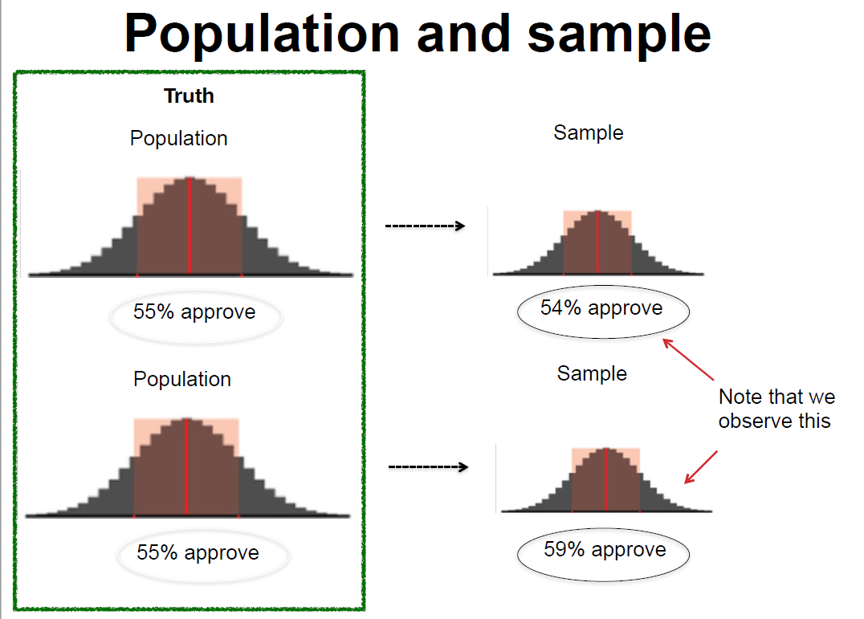
Population and Sample
A population refers to our entire target group that we are trying to understand. For example, if we are trying to understand how adult Americans feel about same sex marriage, our population would be U.S. adults. On the other hand, if we are interested in American college students’ opinions about same sex marriage, then our population would only include college students in the United States. In drawing the sample, then, researchers must first be clear about the population that they wish to make inferences about. In order to get at the population, we often infer from a subset of the entire population: a sample. A sample consists of one or more observations drawn from the population. Therefore, to draw a meaningful inference about the population, it is important to have a reliable sample representative of the population. Ideally, the sample is a miniature version of the population.
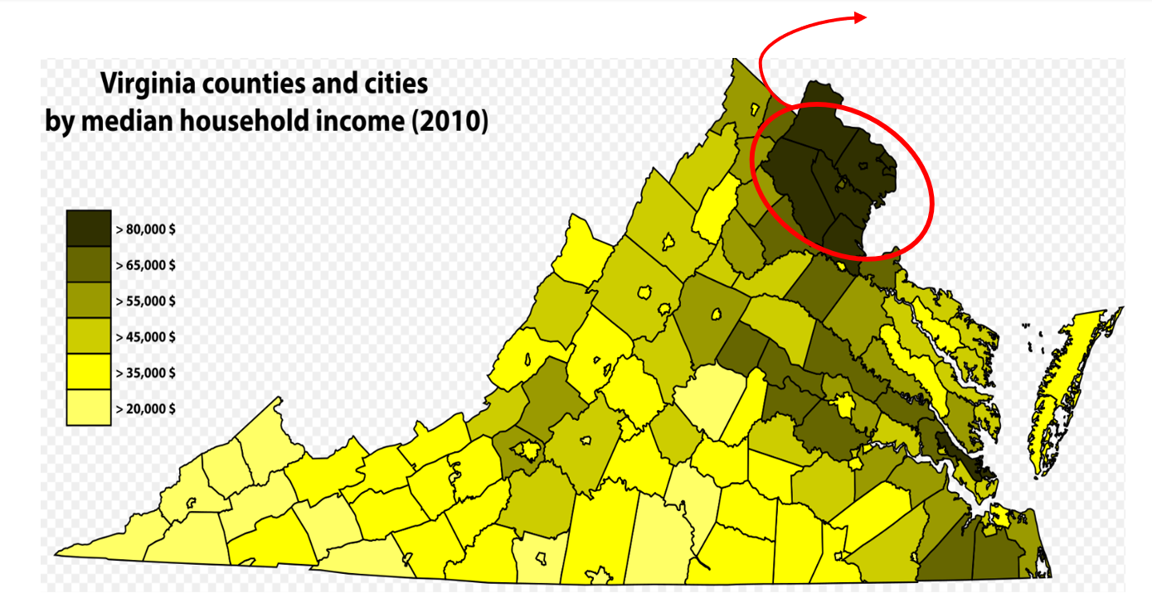
How Sampling Can Go Wrong
Figure 2 presents the map of Virginia counties by median household income. The upper, darkest counties include some of the richest counties in the United States, notably Loudoun, Arlington, and Fairfax. Interested in American public opinion towards tax policies, let’s say that a professor at George Mason University, located near Fairfax, obtains a convenience sample of nearby residents (n=50) to conduct a survey about income property tax. Could you say that the results from this survey reasonably represent an average American’s preferences and opinions about tax policies?
Probably not! As you can see from Figure 2, even within the same state, counties vary tremendously in their income levels. It is highly likely that those living in the western-southern part of Virginia are more likely support higher tax on the rich and more generous welfare benefits. Also, the survey responses of only fifty people do not provide enough data to render correct inference about average Americans’ attitudes about tax policies. In sum, this sample of fifty people from the rich Virginia counties is not a miniature version of the U.S. population. Using such skewed samples prohibits us from reaching a correct conclusion.
Then how do researchers select samples? Recall from Chapter 4 that there are two major sampling methods: probability sampling and non-probability sampling. SRS, stratified sampling, and cluster sampling are all the examples of probability sampling.

Simple Random Sampling (SRS)
Simple random sampling (SRS) is a sampling method to ensure that (1) every member of the population has an equal probability of being chosen, and that (2) every combination of N member has an equal chance of being chosen. SRS is an intuitive and simple technique to extract a sample from the population of interest. Lottery or random number generator-based sampling is an example of SRS. If we draw a sufficiently large sample, then we can reasonably assume that the sample will be somewhat representative of the population (i.e., law of large numbers). With a large enough sample, random sampling guarantees that our sample will be like the population on all variables. As a rule of thumb, a sample size of 1,000 is large enough to make meaningful inferences about American population.
Then why do we not just always use simple random sampling Why do we have all these different ways of probability sampling? First, we often face budget constraints. Or, even though we have enough budgets, our research questions sometimes dictate that it is better to use other sampling methods than simple random sampling. For example, there are cases when if we just take the simple random sample, it is hard to ensure a large-enough observations for certain groups of people. Then researchers oversample certain subgroups to ensure sufficient observations to draw meaningful inferences. In exploring the role of race and ethnicity in political participation in the United States, Leighley and Vedlitz used oversamples of African Americans, Mexican Americans and Asian Americans in Texas (Leighley and Vedlitz 1999). Similarly, in examining how racial group categorizations influence individuals’ policy attitudes in the United States, Masuoka and Junn also used an oversample of Afro-Caribbeans (Masuoka and Junn 2013).
Stratified Sampling
Stratified sampling differs from SRS in that it first divides the entire population into smaller homogeneous sub-groups of strata. That is, each stratum is composed of similar observations – e.g., based on income, educational level, race or gender. Then, we take the random samples from each stratum and pool them together. If we have distinct subgroups based on shared characteristics, we might use stratified sampling to highlight these inter-group differences.
Stratified Random Sampling. Note: The population is grouped into strata based on shared characteristics
Because stratification takes into characteristics of the original population, stratified sampling can better capture the key population characteristics in the sample. Through stratified sampling, researchers can ensure that certain subgroups are include in the sample. Moreover, stratification gives a smaller error in estimation and greater precision than SRS especially when the inter-group differences are large. For example, in surveying Americans’ racial perceptions and policy attitudes, Masuoka and Junn used stratified sampling to recruit minority respondents (Masuoka and Junn 2013), as SRS possibly would not have guaranteed sufficient number of Asian or Latino participants. Likewise, YouGov also uses stratified sampling to ensure that the survey sample resembles the composition of the American population; age, race, gender and education are typically used as stratification variables. Cassesse et al. used YouGov’s Cooperative Congressional Election Study, which used stratified sampling of 50,000 Americans, to examine how white Americans’ racial attitudes affect anti-gender discrimination policy supports (Cassese, Barnes, and Branton 2015).
Despite its strengths, stratified sampling cannot be used when stratification is simply impossible – e.g., when there is very little information available about the population or when there are only few distinct characteristics (not enough features) in the population so that we could not divide it into various subgroups.
Cluster Random Sampling
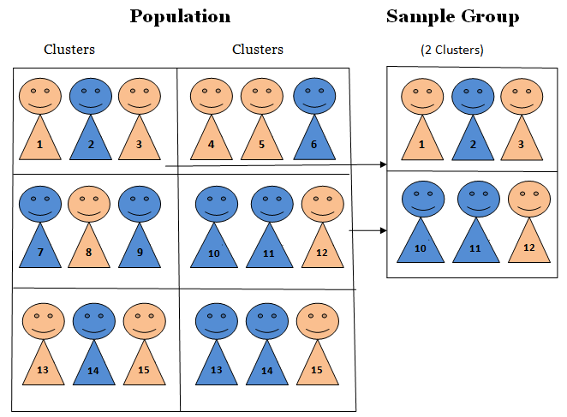
Cluster Sampling. Note: Here, the population is divided into several clusters; note that the entire cluster is sampled
As in stratified random sampling, the population is divided into sub-groups, this time called clusters. Unlike strata, however, clusters are not made up of homogeneous observations. After clustering the population into various subgroups, we now take the random sampling of the groups (i.e., clusters). In cluster sampling, each cluster is treated as the sampling unit; in other words, sampling is done on clusters. Therefore, all the observations in the cluster are selected in the sample.
The biggest advantage of cluster sampling is that it is relatively cheap and easier to implement. Intuitively, it is cheaper and easier to observe the units in a cluster (e.g., based on geography – like a town or a city) than observe the sample dispersed across the state. Also, unlike stratified sampling where researchers are required to have enough information about the population, cluster sampling can be used even when we cannot obtain sufficient information about the population as a whole. For example, it would be tremendously costly or even impossible to construct a complete list of the entire college undergraduates in the United States. However, it would be possible to randomly select a subset of the population based on geographical unit – e.g., by states, by cities, etc. – and then conduct surveys on them. Moreover, as we survey more clusters, we can accumulate the results to get at the knowledge about the target population; that is, cluster sampling permits accumulation of samples.
Nevertheless, compared with SRS or stratified sampling, cluster sampling has the largest possibility of generating biased/skewed samples. Depending on how you cluster the population, cluster sampling can result in a sample that does not adequately represent the population. For example, suppose that you are interested in Illinois residents’ opinion towards free trade. Because of the constraints in time and budget, you did cluster sampling; the clusters you surveyed were from Evanston and Winnetka (a wealthy town located at the northern part of Evanston). Can we be confident that our results well represent the opinion of the entire Illinois residents? Probably no! Chances are, those clusters might have included one of the wealthiest and/or best-educated people in Illinois.
Alternatively, we might choose to use non-probability samples. Convenience samples are a notable example. Rather than being a representative subset of the population, a convenience sample simply consists of the cases that are easily available. Our political science department’s research pool, made up of Northwestern undergrads taking political science courses, is an example of a sample of convenience.
Compared with probability samples, convenience samples provide a relatively cheaper and easier access to survey implementation. For this reason, before they field the experiment on a representative sample, researchers often “pilot” their survey on convenience samples to figure out whether there are errors, or logistical and administrative problems in the survey design and implementation.
Nevertheless, researchers should keep in mind that convenience samples tend to be skewed – e.g., student samples are more liberal, largely Democrats and more politically aware compared to the entire American adults. Likewise, since these samples are most likely not representative of our population of interest, we cannot say that survey results from convenience samples provide accurate insights about the population of interest.
Check-in question: what is probability sampling? Is probability sampling better than non-probability sampling? What are the pros and cons of each probability sampling method?*

Fielding the Survey
Now off to implementing the survey! Traditionally, surveys have been conducted via mail, over (landline) phone, or in person. Although these platforms are still being used, with the wide reach of the Internet, we are now able to implement surveys more cheaply and effectively online.
Each survey method has its own pros and cons. The methods where a surveyor is involved in implementation are usually more expensive but have higher response and completion rates, whereas self-administered surveys are cheaper but may have lower response and completion rates. Researchers should decide how to implement their surveys given their research questions, population and sample, and each method’s tradeoffs. Is our biggest expected problem respondent fatigue or low response rates? Who is our target population: e.g., Chicago residents or all Americans nation-wide? How big is our budget? If the response rate is a bigger problem than budget constraint, then we might consider employing trained surveyors; if our surveys contain questions touching upon sensitive information, then we might want to employ a method to better ensure anonymity.
Face-to-Face Survey:
- Pros: because this implementation method involves personal interactions, it yields higher response and completion rates. Also, researchers can monitor/observe participants and ensure that respondents followed the instructions. It is also easier to make sure that respondents understood the questions. Moreover, this method is particularly suitable if we want to include a specific set of sample – e.g., the elderly, the disabled, or the illiterate who cannot easily access to online surveys.
- Cons: because it involves the interaction between the respondents and the interviewer, the principle of anonymity is compromised. Therefore, it is more prone to social desirability bias. Also, compared with self-administered surveys, this method is more expensive and logistically harder to administer. If the sample is geographically dispersed, researchers need extra coordination to implement a face-to-face survey.
Telephone Survey
- Pros: along with face-to-face surveys, telephone surveys also have higher response rates and completion rates than self-administered mail surveys. Compared with face-to-face surveys, telephone surveys provide better anonymity because respondents do not have to directly meet the implementer.
- Cons: as the survey is implemented via phone, it is not suitable for lengthy surveys. Also, respondents included in the sample might simply choose not to pick up the call – leading to lower contact rates.
Online Survey
- Pros: even via online, researchers can employ various sampling methods – e.g., SRS or stratified sampling. Through online, we can also reach out to a huge sample quickly and cheaply; moreover, we are able to reach out to the sample widely dispersed. It guarantees better anonymity because respondents do not have to personally face the interviewer (and often, they are given de-personalized identification numbers). Researchers can get creative with the survey – online surveys allow researchers to include audiovisual components more effectively.
- Cons: because it is a self-administered survey, researchers are not able to monitor the compliance and the completion of the question. Fatigued respondents might just give “straight-line” answers. The quality of responses might not be as great as that from a face-to-face survey or a telephone survey. Also, online survey requires access to a website and computer literacy, yielding the net sample of “computer-literate people.” Often, old, disabled people may not be able to conduct the survey.
Mail Survey
- Pros: as with an online survey, a mail survey also guarantees better anonymity than face-to-face surveys. It is relatively easy to administer; researchers send out mails with questionnaires, and after completing them respondents send those back. Also, respondents can take the survey at their own pace; computer-illiterate participants can take the survey as well.
- Cons: mail surveys take longer than other methods, and it has low response rates as well. There are limitations to employing audio-visual materials unlike as in online platforms.
Check-in question: suppose that we are interested in how the elderly (65 years and older) think about universal healthcare. We are interested in how political liberal-conservative ideology of the elderly is correlated with their support for universal healthcare. How would you field the survey, and why?

Analyzing the Results
In analyzing the survey results, we must keep in mind that we are trying to estimate parameters about the population with sample statistics. Because of the potential errors stemming from the sampling process, we cannot be sure the sample statics are exactly identical to population parameters. Hence, it is necessary to build uncertainty in our inference about parameters.
Margin of error quantifies the random sampling error. We cannot be one hundred percent confident that our sample statistic is the exact value of the population parameter; because we are using samples, any survey or poll will differ from the true population by a certain amount. Therefore, by constructing a confidence interval around a point estimate (i.e., sample statistic), we are acknowledging that there is room for error for our estimates. Margin of error is the range of values below and above the sample statistic in a confidence interval.
Confidence interval = sample statistic $±$ margin of error
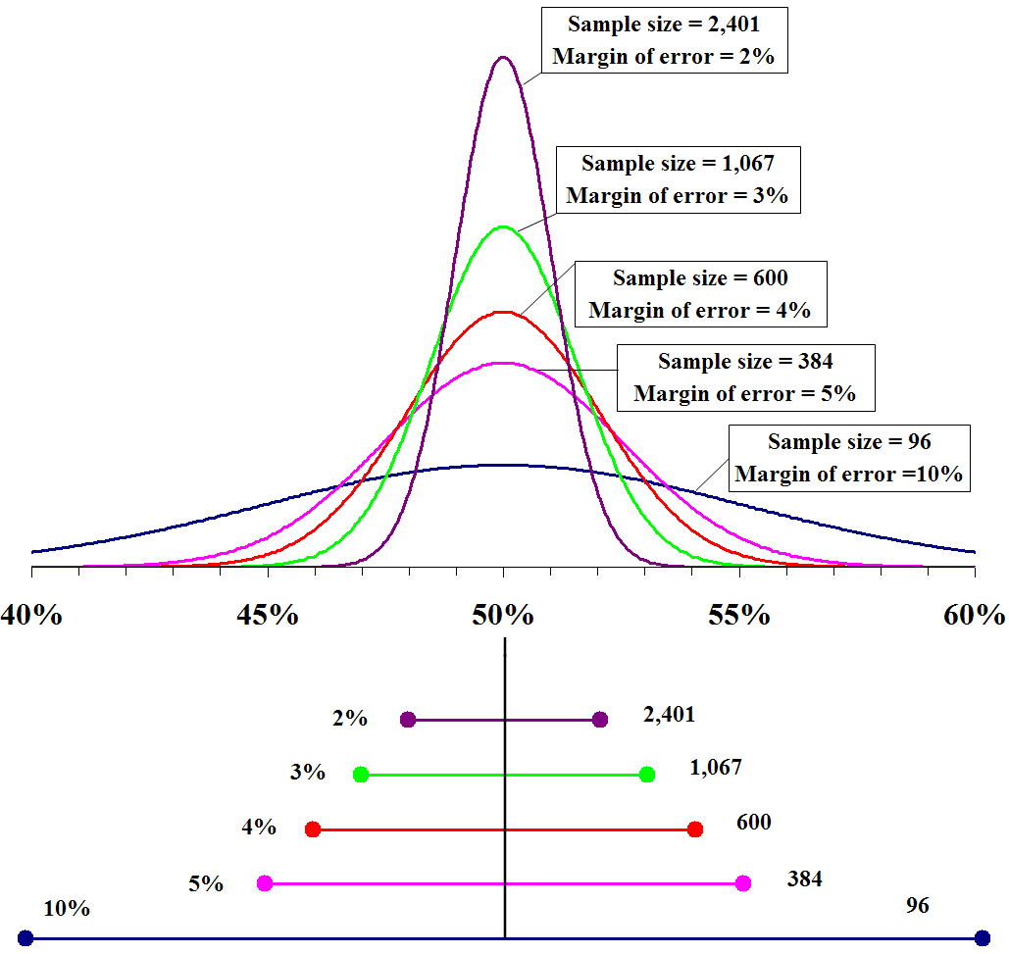
Margin of Error and Confidence Interval
As we have seen in the hypothesis testing chapter, confidence intervals mean that we are confident that the true parameter lies within that range. Conventionally, political scientists use 95 percent confidence level; this means that 95 percent of the time, the value obtained from a random sample will fall within this interval. Note from the Figure 5 that the margin of error gets smaller with a bigger sample.
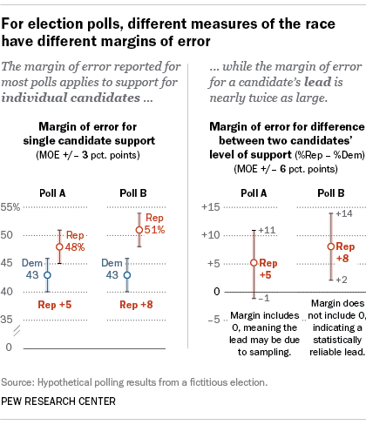
Confidence Interval in a Poll
Check-in question: Can we say that the Republican candidate is leading based on the two polls presented in Figure 6? If so, why? If not, then why not?
We have seen that margin of error takes random sampling error into account; however, margin of error and confidence interval do not account for systematic measurement error or systematic sampling error (Barakso, Sabet, and Schaffner 2013). Even if we took a random sample of the population, some subgroups might be overrepresented in the sample – e.g., Mechanical Turkers tend to be younger, more college-educated and liberal than average Americans. Or, because of the way the survey was implemented, there might be non-response errors – e.g., if we conduct an online survey, the elderly might be undersampled. In such cases, treating all the responses from an unrepresentative sample equally might lead to a failure to have a correct inference about the population.
Weighting is a technique to correct for the sample’s lack of representativity. Data can be weighted by various variables such as age, gender, race/ethnicity, or income, so that the sample could resemble the population, and ultimately, get at a more accurate population parameter.

Applications
We can see surveys everywhere. Companies conduct surveys for market research and customer satisfaction; newspapers and think tanks run surveys to see what the public thinks about different issues and policies.
Surveys can be large – as in ANES (American National Election Studies), GSS (General Social Survey), WVS (World Value Survey) and Eurobarometer. These surveys ask questions ranging from respondents’ values, life goals, to political and social issue salience, and to basic demographics. With the extensive lists of questions, these survey data can provide us with quasi-qualitative data about respondents. Similarly, WVS asks what respondents value as important qualities of a child, desirable traits of neighbors, essential features of democracy, and how much confidence they have in various institutions (e.g., Labor Unions or the Police), religiosity, etc. We can often see political science and sociology works employing these surveys; Kane and Whipkey, for example, use the General Social Survey to reveal the motivations behind the support for gender-related affirmative actions (Kane and Whipkey 2009).
Surveys can also be small, often as in polls. Note that by a “small" survey, social scientists are not referring to a survey with a small sample size but one with few questions. Gallup’s presidential approval rating polls, for example, has only one question! Such short surveys, often with just one or two key question(s), are called polls rather than surveys. Pew Research Center conducts polls for various topics, which are widely used in academic works and also quoted in the media.

Advantages of Method
A lot of political science theories are based on micro-level foundations. Political scientists are interested in uncovering how individuals think and feel about certain policies and social phenomena, and why they think so. Surveys are valuable for empirically examining these theories, since they allow the direct measure of public opinion and individual-level variables. For example, as Open Economy Politics scholars predict, does relative economic standing of an individual affect his/her attitudes toward free trade? Or are there more than mere economic factors, such as gender or socialization via labor unions, that determine trade policy preferences? Surveys allow researchers to directly investigate these research questions.
The use of surveys is not limited to asking respondents about their policy preferences or political ideology. Instead, surveys also allow us to explore various topics. GSS and WVS (as explained above) are notable examples – the range of questions asked is very wide; we can ask respondents’ moral values, environmental concerns, policy preferences and their issue salience via surveys. Moreover, standardized surveys over a long period of time can provide a valuable resource for time trend analysis.
Especially with the advancement of online survey platforms, surveys are often relatively easy – despite all the considerations to be taken before actually implementing the survey – to field. Researchers are able to reach out to a large number of respondents with fewer geographic limitations. Furthermore, compared to other data collection methods (e.g., in-depth interviews, case studies, archival research), surveys take less time. Moreover, with proper statistical analytical tools, surveys provide an effective, flexible way of generating knowledge.

Disadvantages of Method: Surveys, Easier Said than Done
However, even a well-designed survey could go wrong – sometimes for reasons outside the researchers’ control! In addition to errors pertaining to the sampling stage, there are other potential errors and disadvantages because surveys involve human responses.
Respondent fatigue: Because human beings have limited attention span, participants might become tired (and/or bored) of answering the survey questions, and as a result, the quality of their responses deteriorates. People might just click “don’t know,” give out random responses, or simply skip the questions and not answer at all. We can expect survey respondents to be fatigued especially when the survey questionnaire is lengthy.
Question wording and order effect: Depending on how the question is asked, respondents might give different answers. Even small differences in wording can alter the survey results (more in the Experiment chapter – framing effect). Pew Research Center’s surveys on American public opinion about the Iraq War provide a good example. When the question was worded “would you favor or oppose taking military action in Iraq to end Saddam Hussein’s rule?”, 68% of participants responded that they favored military action against Iraq while only 25% answered that they are against the military action. When the question was worded differently – “would you favor or oppose taking military action in Iraq to end Saddam Hussein’s rule even if it meant that U.S. forces might suffer thousands of casualties?” – the results changed substantially. Now, 48% of the respondents said they opposed the military action while only 43% said they favored it! Question order can also impact survey results. Schuman and Presser present an interesting example. In a survey during the Cold War, Americans were asked whether journalists should be allowed to travel between the US and the USSR. When they were first questioned whether Soviet journalists should be allowed to visit the U.S. to write articles for Soviet newspapers (and then were asked about American journalists), respondents showed lower support for cross-country travel of both Soviet and American journalists. However, when they were first questioned regarding American journalists traveling to the Soviet Union, respondents were more likely to support the reciprocal travel of Russians and Americans (Schuman and Presser 1996).
Limitation in human capacity to recall: People might not accurately recall past events, and simply because they failed to properly recollect the past, it is also likely that respondents could not provide their actual attitudes or opinions.
Conflict of incentives: Nowadays, researchers can easily recruit survey participants via online platforms such as Amazon Mechanical Turk (MTurk). These respondents are paid per task completed; therefore, their interests lie in maximizing the number of surveys completed. Contrary to the researchers’ incentives to ensure well-contemplated responses, these online survey platforms can encourage respondents to finish surveys as quickly as possible and move on to the next tasks, resulting in low-quality answers.
Social desirability bias: Respondents may also be pressured to answer questions in a manner that will be viewed ‘favorably’ by others. A famous example for social desirability bias is that when asked about the number of their sexual partners, women tend to attenuate their numbers while men tend to inflate theirs. Since health-related studies often rely on self-reported measures, it inevitably suffers social desirability bias Similarly, family planning is an area vulnerable to this bias; people tend to underreport the frequency of unprotected sex while overprotecting the contraceptive use (Stuart and Grimes 2009). They also found that people extensively underreport induced abortion. Hadaway et al. revealed that church attendance rates based on respondents’ self-reported responses substantially overstates actual religious attendance in the U.S. (Hadaway, Marler, and Chaves 1993). To mitigate social desirability bias, anonymous self-administration (e.g., via the Internet) might help – it can ensure that respondents do not feel directly and personally involved, and can decrease social desirability bias. Researchers can also emphasize that the responses will be kept confidential and anonymous and that the responses therefore will not be used against the respondents .
By nature, a survey is a large-N, observational study; in-depth exploration of the motivations behind the answers could not simply be observed via survey. Interviews might be more appropriate in this case. Alternatively, we can add open-end questions in the survey to ask “why” questions which would require other analyses such as text and/or content analysis. Inter-coder reliability is especially important for content analysis of open-end responses. Inter-coder reliability is the widely used term for the extent to which independent coders evaluate a characteristic of a message or artifact and reach the same conclusion (Lombard, Snyder-Duch, and Bracken 2002). For example, surveys such as ANES often ask respondents why they support certain candidates over others. Respondents provide various reasons for supporting specific candidates, and it is necessary to sort out what the most salient reasons are for the respondents. Inter-coder reliability in this context refers to the extent to which different coders classify the content of the answers into the same category. It is a critical component of content analysis – when it is not established, the data and interpretation of the data cannot be considered valid (Lombard, Snyder-Duch, and Bracken 2002).
Non-response bias: When respondents differ from non-respondents in meaningful ways. Unlike coverage bias, non-response bias occurs when some respondents included in the sample do not respond. This might be because the respondents refuse to participate, or the researchers failed to reach some participants. For example, if you are running a survey about immigration and assimilation, and if your survey includes a question about respondents’ legal status, it is highly likely that those who are undocumented would feel more uncomfortable filling out the survey and therefore, more likely to opt out. Although the research question was about how both undocumented and documented immigrants and their assimilation patterns, this survey will result in a net sample of legal/documented immigrants (which is different from the original sample). As expected, surveys asking for legally sensitive information are more sensitive to non-response bias; also, if the survey explicitly states that the government or organizations of authority are collecting the data, we might face more serious non-response bias.
Coverage error: This error occurs when there is not a one-to-one correspondence between the target population and the sampling frame from which a sample is drawn. A Sampling frame is the list of all the units within a population that could be sampled. It could include not only individuals, but also households, schools, companies or other institutions depending on our research question and unit of analysis. Ideally, the sampling frame perfectly coincides with the target population; but when it does not coincide, we have coverage error.
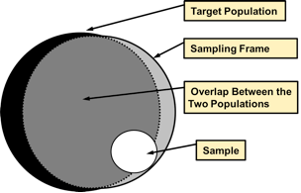
Coverage Error
Check-in question: what could be the solutions to social desirability bias or non-response for sensitive questions included in the survey? Be creative!

Broader significance/use in political science
When and how will we encounter surveys in political science? Almost all subfields – ranging from American Politics to International Relations – in political science have adopted survey research as their empirical strategy.
1. Use in IPE: What Determines Individual Support for Economic Openness?
International political economy (IPE) theorists, for example, use surveys to show the determinants of individuals’ economic policy preferences. Using cross-country surveys for Asian and European countries, Mayda et al. find that if individuals perceive risk (or instability) to increase along with trade openness, (s)he favors more restrictive policies such as tariffs or quotas. Using the same survey data, they also find that ideational factors, such as nationalism, also matter in determining individuals’ trade protectionism (Mayda, O’Rourke, and Sinnott 2007). In a similar vein, also using survey data, Mutz and Kim find that in-group favoritism influences Americans’ attitudes toward international trade (Mutz and Kim 2017). Rather than maximizing their own pocketbook gains, Americans tend to choose policies that maximize the well-being of fellow Americans. They also find that when Americans think that the trading partner country loses so that the U.S. achieves a greater relative advantage, trade policy garners greater support.
2. Use in American Politics
American politics scholars also use survey to study public opinion. For example, to reveal factors driving Trump’s electoral success in 2016, Ferguson et al. also use survey data (ANES); they find that (unsurprisingly) Trump’s populist rhetoric resonated with Americans’ economic concerns, racism and sexism. They reveal that the roots of Trump’s victory in 2016 lie in Americans’ economic and social concerns (Ferguson et al. 2018).
3. Use in Everyday Politics
In addition to their academic uses, surveys are also used for our everyday lives. Because their professional careers depend on reading public opinion accurately, politicians refer to various polls to grasp the public’s attitudes toward current policies and future policy options (Erikson and Tedin 2015). The American public is becoming more engaged in politics, leading them to increasingly follow the polls more closely. As they write, “academic polls advance our knowledge of public opinion, and commercial pollsters satisfy the public’s (and private clients’) curiosity regarding trends in public opinion.”

Conclusion
A lot of political science theories are either explicitly or implicitly based on micro-level foundations. Surveys provide a good means to directly probe how individuals think, allowing the empirical testing of political science theories. With the same survey questions repeatedly asked over a long time, surveys can provide insights about the trends in the public opinion. Surveys are also very versatile; they can be combined with other data collection methods and analysis techniques such as experiments and regressions. Surveys are important for politicians as well, since they rely on surveys/polls to base their electoral strategies and policy platforms. However, as social scientists, we should also remember that although the idea of survey research seems very intuitive, a good survey is surprisingly hard to design and implement as we have seen in this chapter. Errors can arise at every stages of survey design, and only with caution can we reap the full benefits from a survey research.

Application Questions
1. True or false?
- Surveys offer better external validity than experiments.
- Surveys offer better external validity than case studies.
- Surveys are particularly good at exploring subgroup differences and historical trends because they usually have large enough sample sizes.
2. Define and provide an example of each of the following errors.
- Sampling error
- Non-response error
- Measurement error

Key Terms
- conceptualization
- convenience sample
- coverage bias
- double-barreled question
- inter-coder reliability
- margin of error
- non-response bias
- response rate
- sample
- sampling frame
- validity
- weighting

Answers to Application Questions
True or false question: True, True, False

Experiments
By S.R. Gubitz

Introduction
Perhaps you have wondered what might have happened along a path you did not take. Or perhaps you have speculated about how differently history would turn out if some key event did not occur the way it did in reality. For example, if the Supreme Court of the United States in 2000 had allowed presidential election recount efforts to continue in Florida, might Al Gore have beaten George W. Bush to become president? Or, if you had not skipped breakfast this morning, might you feel a little less groggy right now? In practice, a path not taken is the same as one that never existed; we do not get to run history twice like a computer simulation to observe the path not taken. But, in some scientific contexts, you can observe both paths at once. This is the nature of an experiment; we get to cheat history, time, and space to observe the otherwise un-observable.
Political science finds experiments especially useful, because oftentimes the path not taken has serious political or societal ramifications. For example, what happens to voter turnout rates when political parties decide to ignore communities of color, and what might happen if they do not? In politics, many wish that they can turn back the clocks and run history twice. In political science, that is sometimes entirely possible in an experimental research design.

Background
The first recorded experiment occurred in 1835, in Nuremberg, Germany (Jamison 2019). The researchers conducting this experiment were interested in the effects of a certain homeopathic medicine: the inclusion of small amounts of salt in water. The researchers divided 100 local residents into a treatment group of 50 that received salt in a vial of water, and a control group of 50 that only received a vial of water. Participants were later examined to see the effect of the salt water on any physical ailments; the researchers found that the intervention had no effects.
It took nearly 100 years for political science to attempt its first recorded experiment (although the discipline was fairly new at the time, having just split off from history and economics). Harold Gosnell conducted an experiment around the 1924 US presidential election to test the effects of mailed postcards on voter turnout (Gosnell 1927). Gosnell sent out postcards to certain wards, randomizing which half of the ward would get the postcards and which would not. He found modest effects, setting the stage for future work on randomized get-out-the-vote (GOTV) efforts.
But Gosnell’s work was not immediately appreciated by political scientists, and it took nearly another 60 years before serious experimental work began to be taken seriously in the discipline. Shanto Iyengar, Mark Peters, and Donald Kinder invited participants to watch television news programs at the University of North Carolina, Chapel Hill (Iyengar, Peters, and Kinder 1982). What the participants did not know, however, is that they were randomly assigned to watch some newscasts that had been edited to emphasize certain stories over others. These manipulations resulted in the control group assessing the president’s performance differently, based on the issues they were exposed to in the television news program.
And from that point, experiments began steadily becoming a mainstay research method in political science. The figure below shows the number of experiments published every year in the American Political Science Review, one of the top publications in political science. As the figure shows, following Iyengar, Peters, and Kinder’s work in the 1980s, experiments started to be published in this journal at an increasing rate. However, it is important to keep in mind that experiments are not even close to being the dominant research method. If you have already read in the chapter on surveys, then you already know a good deal about the most dominant quantitative research method: surveys.
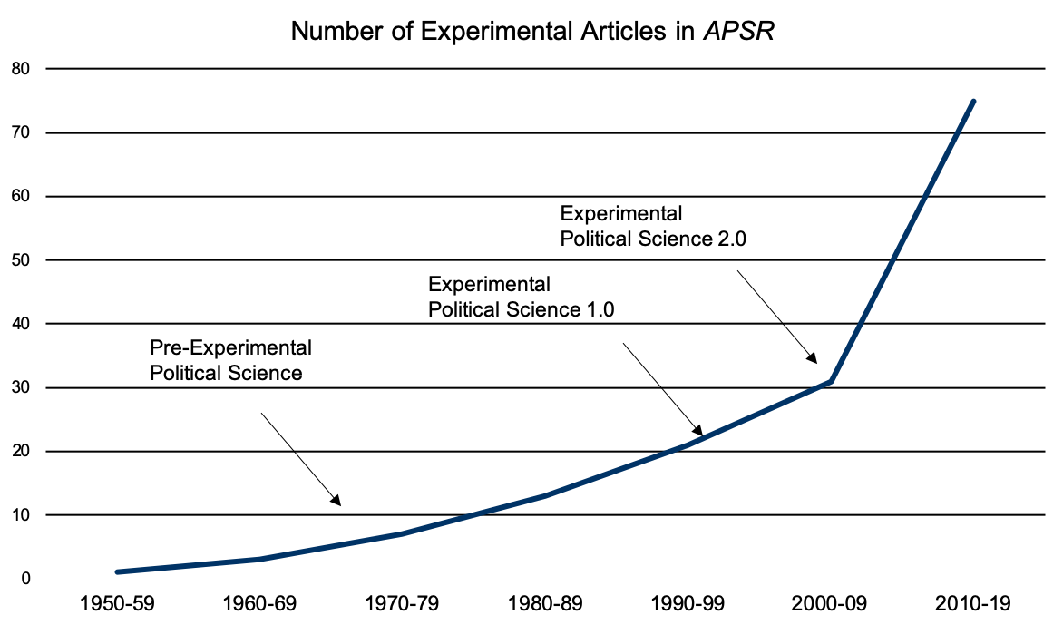
totals are aggregated per decade. Figure from (James N. Druckman and Green 2021)

Method: setup/overview
Experiments, or RCTs (randomized control trials) as they are often called, involve the randomized assignment of individuals into one of two groups (in the most basic design): a treatment group that receives some intervention; and a control group that does not. This design allows the researcher to determine the effect of some intervention (e.g., individualized tutoring) by comparing the value of some outcome (e.g., test scores) in the treatment group to the control group that did not receive the intervention. Do note, however, that most experiments have several treatment groups and some even have several control groups depending on to what they need to make their comparison.
It is important to differentiate the random assignment necessary to conduct an experiment from the random sampling you learned about in the chapter on surveys. In that chapter, it was explained that random sampling is when you randomly select individuals from some population you are interested in studying to be a part of your survey. But random assignment has nothing to do with that sampling technique. Rather, random assignment means taking your sample, however it was collected, and randomly assigning them to your treatment group(s) or control group(s). This random assignment is necessary to ensure that the treatment and control groups have nearly the same odds of being comparable to each other in terms of demographic characteristics of your overall sample. So, if you have 50 African Americans in your sample of 250 people, and you have four treatment groups and one control group, then random assignment should result in groups of near 50 people each, with 10 African Americans per group.
A consequence of this requirement that the sample be randomly assigned to experimental groups means that how the sample was collected is less important. This, again, is a deviation from what you learned about surveys earlier in this book, where sampling mattered a great deal. But a good experiment can rely on what is called a convenience sample, or a sample that is made up of easy to reach people. For instance, for much of the 20th century, researchers often placed newspaper advertisements to construct their samples. Nowadays, however, there are entire online services built around getting researchers participants for their experiments. But these convenience samples do not undermine the legitimacy of the experiment, unless the researchers are trying to generalize to a certain population. If you had a convenience sample of your friends and family, you would be hard pressed to say that any results from an experiment on that sample could generalize to the population of a country.
Check-in Question 1: Is "random assignment" another way of saying "random sampling" and vice versa? If not, how are they distinct from one another?

Method: detail (types of experiments)
As you can probably gather from the few examples provided so far, there are many different types of experiments. Each offer their own unique way of answering certain scientific questions that the others cannot. In the following sections, we will review four types of experiments and example from political science for each.

Surveys vs Survey Experiments
The growth of online survey platforms, such as Survey Monkey and Qualtrics, have resulted in a similar growth in the use of survey experiments. While you might already be familiar with surveys, it is important to differentiate survey experiments. That is, survey experiments are experiments that are embedded in surveys. Within such a survey, participants answer questions and read materials just as they would in any survey. But at some point, respondents are randomly assigned to a treatment or control group.
What is advantageous about experiments embedded in a survey like this is that it is extremely easy to do. Because the surveys are often disseminated online, that means the researcher does not need a physical space where the experiment will be administered. Further, survey respondents are quite easy to obtain while providing modest compensation. Survey firms like YouGov provide samples to respond to researcher-provided surveys for a few dollars a respondent; the samples can even be constructed in ways that resemble national representativeness without true random sampling. For the more-frugal researchers, survey experiments can be administered on Amazon’s Mechanical Turk (MTurk) service, which people perform various tasks online for monetary compensation; these are usually menial tasks like testing website functions. But, in recent years, political scientists have been using MTurk to disseminate their survey experiments, as the service is far more affordable than a professional survey firm.
For all of its advantages, survey experiments suffer from the limitations of their medium; that is, a researcher can only craft treatment interventions that can be disseminated via survey materials. Oftentimes, this means text-based treatments that require the respondent to read (a burden that any undergraduate student can sympathize with); this can be troublesome when the researchers cannot prove the respondents read the treatment text, leading to false conclusions about the effectiveness (or lack thereof) of the experiment. Also, survey experiments rely on self-reported outcomes to draw their conclusions, which means that the respondent was allowed to report how they felt or thought at that time. This is problematic if there is greater incentive to not be entirely forthcoming on the survey, or if people are simply bad at assessing certain psychological states (e.g., "how angry are you right now on a scale of 1-7?").
For example, Dingding Chen, Chao-yo Cheng, and Johannes Urpelainen (Chen, Cheng, and Urpelainen 2016) study how different ways of framing renewable energy in China affected Chinese citizens’ support for such programs. They disseminated a survey online to over 2,000 Chinese citizens collected by a professional company (i.e., this was a convenience sample). Respondents were assigned to one of eight groups (six treatment, two control) that varied the argument being used to support or oppose greater investment in renewable energy in China. They measured support for greater investment on a 1-5 scale, with 5 being the highest support. The researchers find that support was at its highest when respondents were exposed to a frame that presented greater investment in renewable energy as a means of energy security, rather than as a means of combating global warming or air pollution.
While this finding is only possible thanks to an experimental design, it is also only feasible with the sample size they had (n = 2,000) because of how cheap and efficient survey experiments can be. But, we should ask whether or not the weaknesses of survey experiments harmed the study in question. For instance, since support for renewable energy was self-reported, might there have been some degree of bias toward greater support, regardless of the respondents’ true feelings? But, because this is a survey experiment, we can never be entirely sure that the respondents were truthful in their responses. But simply, survey experiments remove a great deal of control from the experimenters.

Laboratory Experiments
While survey experiments lack control of the environment in which the experiment takes place, laboratory experiments exercise near-complete control. These experiments take place in controlled environments, or a laboratory. Usually, for university professors, this means some room that their department or university provided for that purpose. But, oftentimes, labs can be made out of just about any room, so long as the experiment is not disturbed. In fact, recent research has tried taking mobile labs to communities that have been traditionally difficult to reach, all in order to better study and understand those communities and the people living in them (Lewis Jr 2019).
The greatest advantage of the laboratory experiment is that the researchers have a greater degree of control than in survey experiments. They can ensure that treatment is administered correctly, and that the people participating in the experiment are actually people and not automated survey takers (a serious concern for some online surveys). Further, while survey experiments are limited to mostly text-based treatment designs, laboratory experiments can be far more inventive. One of the classic reasons to conduct a laboratory experiment is because the research question requires studying some complex social interaction. A lab allows for researchers to create a physical space in which they can observe nearly real-life social interaction. And one last benefit of this method is that researchers can directly observe and record real behaviors and speech, and are not limited to self-reported attitudes in the same way survey experiments are.
That being said, the inherent problem with lab experiments is finding the people to fill the lab. As opposed to ease in which a survey can be filled out, participants in a lab experiment must actually travel to and from the lab in order to participate. This may sound trivial, but imagine the difficulty and expense for some to travel to lab sites. In some international contexts, lab experiments can be extremely costly because proper compensation must sometimes cover people’s missed wages from a day’s work. The end result of this is that lab experiments usually have rather small sample sizes, usually somewhere between 100 and 200 participants. Compare that to the thousands of participants that a survey experiment can garner for roughly the same cost and you begin to realize the issue with wanting to exercise greater control. Smaller sample sizes often mean fewer people per experimental group, which means less statistical power to calculate meaningful effects.
Again, it is worth noting that some questions are answerable in a lab setting. For example, Ismail White, Chryl Laird, and Troy Allen (I. K. White, Laird, and Allen 2014) conducted a lab experiment two months before the 2012 presidential election between Barack Obama, a Democrat, and Mitt Romney, a Republican. This experiment took place in a historically black college/university (HBCU), which gave the researchers access to a somewhat unique sample of exclusively young African American living in a Black institution of higher learning. This was a boon for the study because they were interested in seeing whether economic self-interest could undermine these young people’s partisanship. African Americans in the United States are largely members of the Democratic Party (over 80 percent), but these researchers were interested in testing the limits of this partisan loyalty.
Participants were brought to the lab and instructed after a brief interview to allocate $100 between the two candidates running for President, Obama and Romney. What they did not tell the participants (aside from the money not actually being donated) was that some were randomly assigned to a cue that told them that for every $10 they gave to the Romney campaign, the participant would receive $1 for themselves, paid in cash. This meant that participants in this condition, if they gave all $100 to Romney, thus undermining their likely Democratic Party loyalty, they would receive $10. But what made this lab experiment unique was the inclusion of another treatment group, identical to the economic incentive condition, that stipulated that their donation amounts would be made public in the university’s student newspaper, thus revealing their behavior to their peers; this is the type of social interaction that is often impractical to replicate in a survey setting. Ultimately, those in the control group donated an average of $90 to Obama, while those in the economic incentive condition’s average was $68, and those with the additional stipulation had an average of $86. In short, because of the lab setting, the researchers could leverage the presence of a Black institution in the minds of young African Americans to potentially dissuade them from giving into their economic self-interest.
Check-in Question 2: What is the primary disadvantage of conducting a lab experiment, compared to a survey experiment?

Field Experiments
Oftentimes, researchers do not have the liberty of controlling where and when they want to conduct their experiments. For instance, if you want to conduct an experiment that tries to increase Asian American voter turnout in Los Angeles, that means that you necessarily have to conduct the experiment weeks or months before the election in question. These experiments are what are called field experiments, or experiments that take place in the physical location you are interested in studying.
The biggest advantage of this sort of experiment is that sometimes they are the only option and offer a unique means of gleaning certain information about the real world. That is, these experiments are much closer to observing real world behaviors and outcomes than survey and lab experiments, in most cases. However, a serious downside of a field experiment is that they are incredibly expensive to run, even more so than a lab experiment. These experiments often involve many researchers who must be compensated, and treatment materials that often bear an additional cost than simply an online survey. For instance, even if you have disseminating a survey in the field, you either have to print it and collect those finished surveys via pre-paid mail, or bring a tablet device for participants to use there. Needless to say, the costs quickly add up and the sample sizes can vary quite a bit depending on available resources.
But in those instances where there is no other option, a field experiment can find incredible results. For example, Victoria Anne Shineman (Shineman 2018) conducted a field experiment in San Francisco, CA during a 2011 local municipal election. Shineman wanted to study how voter mobilization efforts not only increased voter turnout, but also voter knowledge. She invited 178 subjects to complete two surveys, one before the election and one afterward, in exchange for $25. It was during the first survey that Shineman randomly assigned participants to receive different types of mobilization assistance (or none at all for the control), some of which included the necessary forms to register to vote. After the election, Shineman found that not only had mobilization been increased as is typical in these GOTV experiments, but that those exposed to mobilization efforts also exhibited greater political knowledge than those in the control, as measured by the second survey conducted after the election. Without being able to go into the field like this, Shineman could not answer the question of whether mobilization effects spilled over to political knowledge, as this would be impossible to glean from just a survey or in a lab. However, it is worth noting just how expensive this study was for the researcher; the amount of resources required to conduct a field experiment is a serious disadvantage.

Natural Experiments
The final major type of experiment to review is one that is the most infrequently used by political scientists, and not for lack of trying. Natural experiments are experiments that are not exactly conducted by the researcher; that is, the randomization process necessary to call it an experiment was done by someone or something other than the researcher. This could be an "act of God," like a natural disaster’s effects on voter turnout, or a local municipality’s property tax’s effects on desegregation efforts in the local school system. No matter how the randomization happened, if it was not the researcher who did it, then it is a natural experiment.
The advantage of analyzing a natural experiment (again, it is not accurate to say one "conducts" a natural experiment) is that the outcomes observed could not be any more realistic. In social science contexts, natural experiments produce effects on real people in the real world; the stakes are at their highest. However, there are a whole host of problems that come attached to a natural experiment. First and foremost, because natural experiments are conducted by nature or some third party, that means that you have to find the natural experiments that have already happened. This entails identifying the cause, some manner of measuring who was affected by the cause, and some manner of measuring the outcomes you are interested in. If any of that information is unavailable for any reason, you cannot analyze the natural experiment. Further, and again because of the nature of natural experiments, the randomization process may not be truly random, especially when it comes to policy decisions, which are informed by political processes that are hardly random.
Consider, for example, Maimonides’ Rule and its effects on educational outcomes. Maimonides was a rabbinic scholar in the 12th century who posited that the maximum class size was 40 students per instructor, as any more than that and the single instructor would be overwhelmed. Israel adopted this informal rule and codified it in its public school system such that any class with 41 students or more received an additional instructor. Joshua Angrist and Victor Lavy (Joshua D. Angrist and Lavy 1999) identified this as a possible natural experiment. After all, the difference between classes of 40 and 41 students was essentially random, but it had the potential to affect educational outcomes like test scores. It stands to reason that going from a 40:1 student-teacher ratio to a 20:1 ratio is a meaningful difference. the researchers, when comparing the test scores of these classes just on the cusp of the 40-student cutoff, found that test scores were higher for the classes just over the limit who had a better student-teacher ratio.
But, let us consider the potential issues with this research design. First, we need to ask ourselves, was the assignment treatment truly random? In this case, treatment was receiving the extra teacher while only gaining a small increase in the total number of students. What would happen if certain parents were able to take advantage of Maimonides’ Rule and bend the rules of their public school to get their child into these classrooms with a better student-teacher ratio? Randomization would be broken because students being assigned to the treatment group would likely be from families from better socioeconomic backgrounds (i.e., parents capable of moving their children to advantageous classes are more than likely well to do, financially). This means that the natural experiment was not really an experiment at all and that the researchers were finding a spurious relationship, or a relationship between treatment and outcome that was better explained by some confounding factor. Indeed, the same researchers went back to replicate their research and found that recent research that tried to replicate the original study have found artifacts of such manipulation of an otherwise clever natural experiment, leading to null effects once accounted for (Joshua D. Angrist et al. 2017).
Check-in Question 3: What steps must be taken to conduct a natural experiment?

Advantages of Method
What is hopefully made clear in the above review of the major types of experiments is that experiments are versatile; as long as you can randomize your participants into different groups and measure outcomes, you can conduct an experiment. And perhaps the greatest advantage of experiments over other methods of social inquiry is that experiments are the best at causal inference, bar none. Because of the randomized assignment process, you can often be confident that an analysis that compares the outcomes between treatment and control groups is measuring the causal effect of the treatment (the dependent variable) on the outcome (the independent variable). This means that experiments often have very good internal validity, or answering the question of whether the independent variable is actually affected by the dependent variable and not some unseen confound. However, as noted in the section on natural experiments, this is not always the case.
In short, no other research method in this textbook is quite as good as a simple experiment at assessing causality or at achieving good internal validity. Better yet, there are no complicated statistics necessary to analyze the results of experiments, in most cases anyway; just a simple comparison of averages.

Disadvantages of Method
That being said, there are plenty of disadvantages to be aware of when it comes to experiments. While they are often seemingly easy to design, the reality is less so. A great deal of work must be taken on the front-end to ensure good construct validity, or the ability of the experiment to actually speak to the theory or research question at hand. Just because you can design an experiment easily does not mean that it is necessarily the best approach or that it will provide good evidence for your hypotheses. The study of the effects of Maimonides’ Rule on educational outcomes is a great example of a clever experimental design that, upon closer inspection, is not actually measuring the effect of this rule on test scores; rather, it is testing the effects of wealthy parents’ ability to get their children into ideal classrooms.
Further, and most importantly, a flaw of experiments is their often weak external validity, or whether the experiment’s results can be generalized beyond the case being studied. Sometimes we have to seriously worry about the artificial settings we place participants in during an experiment. Consider the modal survey experiment: how often are you really assessing your own attitudes on certain political subjects on a 1-5 scale, or reading news articles about issues you may not really care about, like oil pipelines? Or, better yet, consider the lab experiment example discussed above: how often do you go into a strange room, and donate $100 given to you by strangers among two different presidential candidates, and how often are you being given cash payouts for supporting a particular candidate over another?
Few of the activities asked of experiment participants are realistic in any sense, but some types of experiments are inherently better suited to good external validity than others. As discussed above, field experiments and natural experiments usually have much better external validity than their counterparts because the effects being measured are on actual human behavior in real-world situations. Further, recent work finds that external validity may not be a serious concern for some survey experiment designs, as some findings from artificial settings have been found to better approximate real-world equivalents (Hainmueller, Hangartner, and Yamamoto 2015). In Table 1, you can compare and contrast how each major type of experiment we reviewed performs on construct validity, internal validity, and external validity; note how across all of them, construct validity varies because it is largely incumbent on the researchers to design good experiments that speak to what they are interested in studying.
 | Lab Experiment | Field Experiment | Survey Experiment | Natural Experiment
Construct Validity | depends | depends | depends | depends
Internal Validity | high | depends | high | low*
External Validity | low | high | high | high*
Note: * denotes a "maybe," as assessing these types of validity for natural experiments depends on a case-by-case basis.
:::
Check-in Question 4: What is the difference between external and internal validity?
:::

Broader significance/use in political science
Experiments, as you have seen throughout this chapter, are a flexible research method with some limitations. It is important to note how you will likely encounter experiments in your studies and in the real world. While experiments can vary in sample size, experiments are often only conducted once, and even when they are conducted again, it is rarely on the same sample as the first time. This means that experiments provide snapshots of political processes, results that are very likely time-bound in the moment and political situation in which they are captured. All of this means that you are unlikely to see the same experiment repeated over time. Some researchers mitigate this feature of experiments by using them to complement their other research methods conducted to answer the same question. For example, you could conduct a focus group to understand how a group of women engage with news media, and subsequently conduct an experiment to verify their stated behaviors and preferences. This means that experiments do not always need to be the only research method used in order to answer complex questions about politics.

Conclusion
We do not get to run history twice to see what might be different along a path not taken; that is just common sense. But, in some scientific contexts, we can effectively cheat history and observe both paths at once to determine the effect of some cause. This is thanks to the experiment, the best research method available to us to assess causal effects. It is a research design with as many forms as there are minds to imagine them, and with little exaggeration. However, that does not mean that experiments are always the best research method for the question at hand, and it does not mean that other research methods cannot perform better in some areas than an experiment. Experiments are deceptively easy to design and conduct, but great care must be taken in order to design a meaningful experiment that actually measures the effects it is supposed to, and can be generalized to the world outside an artificial setting like a lab or survey. What we, as scientists, are trying to do is study complex social interactions and the messy process of politics. Experiments allow us to answer some questions about those messy processes, but it is not a supplement for good theory and brilliant thinking.

Application Questions
Given what you know about the different types of experiments, what type of experiment was the first recorded experiment (the one on homeopathic medicine at the start of the chapter)?
The experiment on the effects of homeopathic medicine was primarily a field study, but one could argue that it was a lab experiment as well because treatment and control were administered in a controlled environment. So, in other words, this was a so-called "lab in the field" experiment. These are common in political science, especially in recent years as the need to study difficult-to-reach populations has increased.
Suppose you wanted to provide evidence that huge changes in average temperatures affected people's perceptions about climate change. Briefly describe how you would design an experiment using one of the four types discussed in this chapter in order to do so.
Example responses:
Survey experiment: providing some respondents with information about above average summer temperatures and below average winter temperatures and comparing their attitudes toward climate change to those who did not receive that information.
Lab experiment: put people in a particularly warm room on a hot summer day and see if their attitudes toward climate change are different than those in a different, air-conditioned room.
Field/natural experiment: go to areas experiencing huge shifts in average temperatures and compare people’s attitudes toward climate change in these areas to those in areas whose temperatures have remained stable over time.

Key Terms
Totally fine to add/subtract terms – just check with me as there are pre-designed quizzes to accompany the text!
- control group (x)
- construct validity (x)
- convenience sample (x)
- external validity (x)
- field experiments (x)
- internal validity (x)
- lab experiment (x)
- natural experiment (x)
- spurious relationship (x)
- survey experiment (x)
- treatment group (x)

Large N
By Maximilian Weylandt

Introduction
This chapter introduces the most common methods for working with ‘large-n’ data, or data where we have a lot of cases. If we want to study a phenomenon across more than 100 countries, or have a survey covering thousands of respondents, it’s simply not possible to look at them one by one in great detail. Even if we spent a lot of time and effort to do so, we would struggle to make a systematic comparison because it’s difficult to keep track of all the relevant information with so many cases.
Two techniques, discussed here, help us in learning about the relationship between variables across a large number of cases. First, we’ll discuss the concept of correlation, a term you will have heard before. It essentially describes if two variables ‘move together’: when one goes up, does the other one go up as well?
Next, we turn to regression, a more powerful tool for identifying associations between variables. Regression is the basic workhorse of quantitative political science (and many other disciplines as well), and understanding linear regression is important to understanding the many methodologies built as extensions of this basic method. We begin with a bivariate regression relating one explanatory variable to a response variable to look at the logic underpinning regression. The basic idea is that we find one equation that best describes the distribution of our data points, and therefore at a glance tells us how our two variables are related.
Then we move on to variations of regression, how to interpret regression results, and examples of how the method is used in political science.

Method: setup/overview

Correlation
You have two variables that you think might be related in a linear fashion. Let’s say you think that a country’s level of education (measured in expected years of education) will be related to its level of gender equality (we’ll use a points system based on the UN gender inequality index) . Using software, you can quite easily calculate a linear correlation coefficient for these two variables, denoted by $R$. For these two variables, we get the result $R=0.83.$ That number is a bit abstract but the graph below, visualizes what different correlations look like.
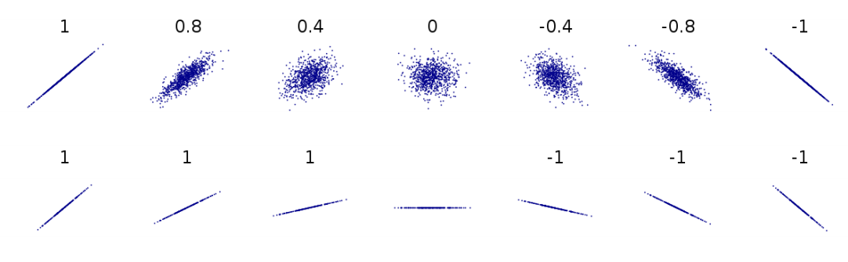
Different correlations, visualized. The numbers represent correlation coefficients. Based on Boigelot (2011), modified by Max Weylandt
Correlation coefficients can range from -1 to 1. Imagine that the different graphs above represent the different possible relationships between education (along the $X$-axis) and gender equality (on the $Y$-axis). As the top line of figure 8.1 shows, a correlation coefficient closer to either pole means a strong correlation while a number around 0 means a weak correlation. If $R=−0.8$, there is a strong negative correlation (at larger values of X, Y tends to have lower values). If $R=0.4$, there is a moderate positive correlation (at larger values of X, Y tends to have higher values). The correlation we got indicates that we have a fairly strong positive correlation. In other words, countries with higher levels of education tend to have higher gender equality overall.
But also note the difference between the two lines in the graph above. In the bottom line, every image represents a perfect correlation, even though the relationships between $X$ and $Y$ are clearly very different. On the first graph from the left, $Y$ increases a lot as $X$ moves from its lowest to its highest value. Two images over, $Y$ still increases as $X$ does, but much less so. They both move in the same direction perfectly (they have a correlation coefficient of $R=1$), but the slopes are different. This has implications for our findings: is gender equality slightly higher in countries with more education, or a lot higher? Correlation cannot answer that question. Later, we’ll see how regression accounts for this difference in slopes. By the way, it is always a good idea to visualize your data. The graphs in the figure below show three datasets that have almost identical means, medians, and correlations - yet look quite different when plotted.
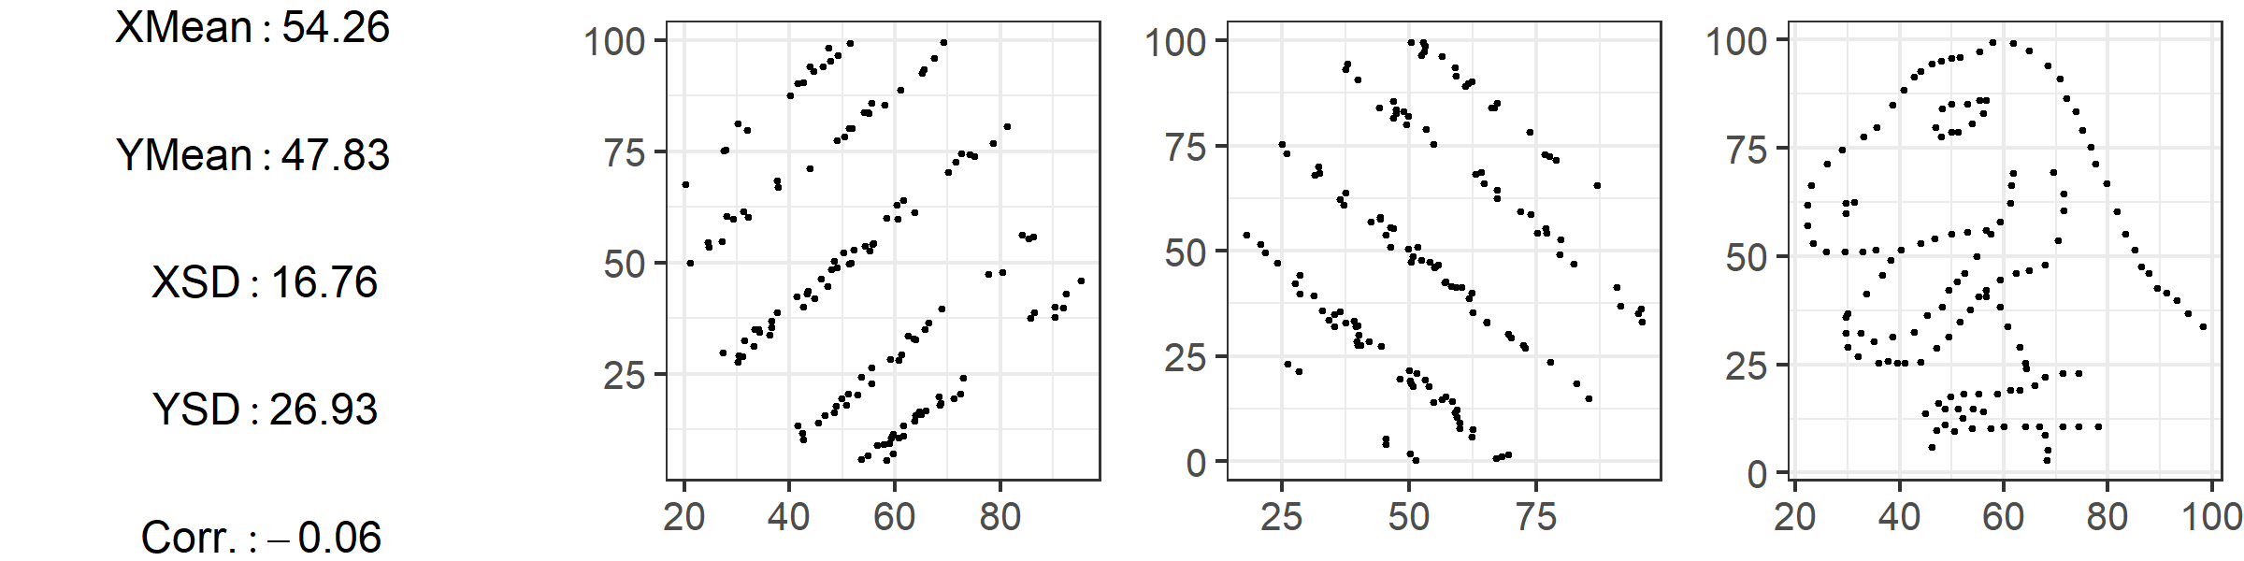
Based on the “Datasaurus Dozen” by Matejka and Fitzmaurice (2017)
Correlations can easily be calculated with statistical software, and the number of datasets available to researchers has exploded in recent years. This means that, now more than ever, you can conduct exploratory analyses with a large number of variables to see which ones are related to each other or the outcome you are interested in. This process, of looking at large number of variables and seeing how they relate, is sometimes called data-mining. Data mining can be an acceptable part of an inductive theory-building process (see “Causal Inference and the Scientific Method”), but it is a fraught process: when looking at a large number of variables you are bound to find some that show a relationship, and it can be tempting (even subconsciously) to write up only results that confirm our hypothesis rather than those that don’t.
What does a correlation coefficient tell us? What does it *not* tell us?
It tells us how strongly the variables in question are associated. It does not tell us how large that association is. For example, variables can show a perfect linear relationship, but we do not know if an increase in the first variable is associated with a tiny or a large change in the second variable.

Regression
Correlations are a useful first look at the relationship between two variables, but linear regression is far more powerful. The intuition behind linear regression is simple: we want to find the line that best fits all of our data points. This is because the line that fits the data best summarizes the relationship between variables, and we can use this line to learn not just the direction of an association (positive or negative) but also its strength: as $X$ changes, how much does $Y$ tend to change? Regression also lets us conduct significance tests to establish whether the relationship between variables actually exists or just appears to occur due to chance.
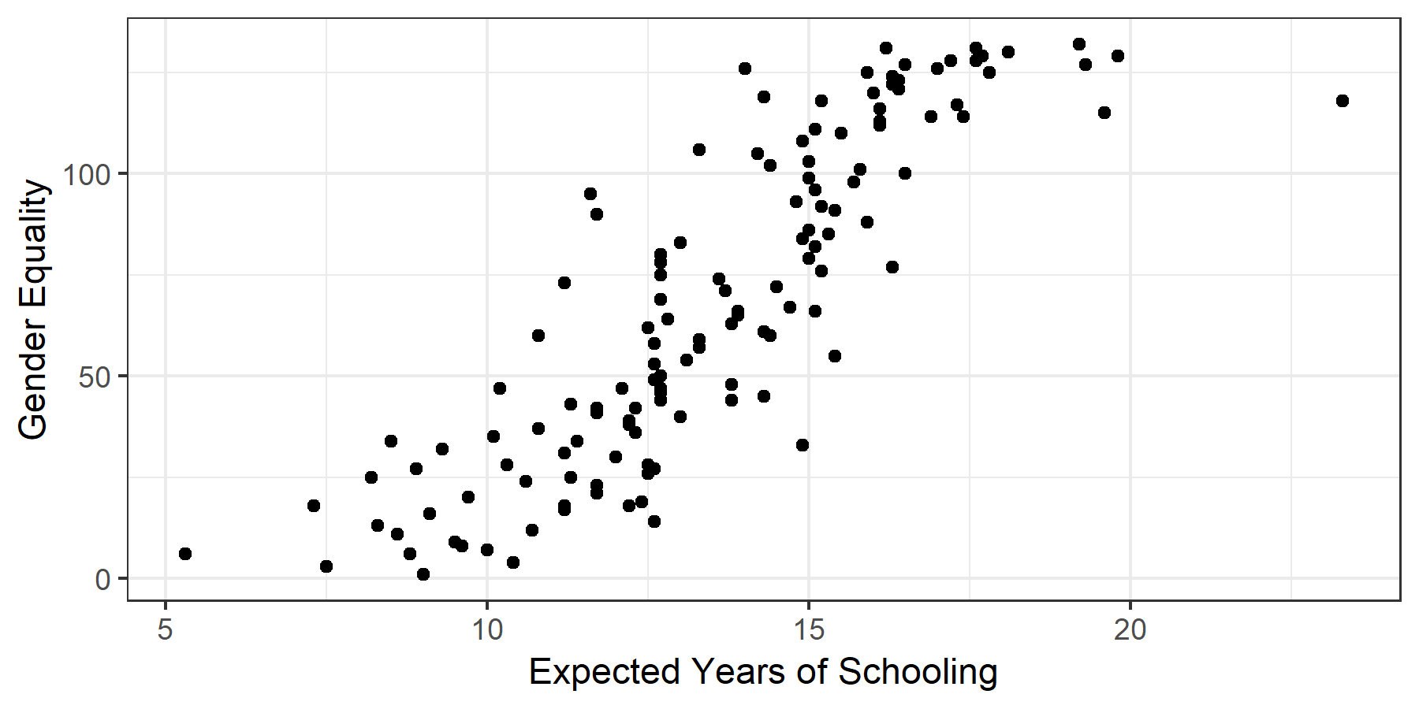
A simple scatterplot
Perhaps it’s best to start with an image. Figure “A simple scatterplot” charts the values for 147 countries’ expected years of education against their scores on the equality index, with each country represented by a dot. Just from looking at it, you can see that countries with a high level of education tend to have higher levels of overall gender equality, even if not all countries neatly fit that description. In other words, as predicted by our correlation coefficient of 0.85, it seems that there is a relationship between education and gender equality. But how strong is this association?
To answer the question, we draw the line that best fits the data points in the scatterplot. This straight line (this is linear regression after all) summarizes the relationship between the two variables we are interested in. Imagine we wanted to explain the relationship to someone else but couldn’t show them the individual data points. We could still show them the line and they would get a sense of how gender equality and education relate.
The regression equation takes the form:
$$Y=a+bX$$
Take a second to appreciate what we have done here. We’ve taken data on two variables for 147 countries, and summarized it with one line on the graph, which we can in turn express as this simple formula. The formula may look familiar to you, as it is simply the formula for a straight line. In the above equation $a$ is the intercept – the value $Y$ takes on when $X=0$. In other words, what is the level of gender inequality that a country with 0 years of expected schooling would have? $b$ is the slope. Remember the function the slope plays in a graphs: it gives you ‘rise over run’, telling you how much the $Y$ tends changes in relation to the $X$. This means that in a regression equation, the slope is very important, because it expresses the relationship between our variables: on average, a one-unit increase in the X variable (in our case, one year of extra expected schooling) is associated with a $b$-sized increase or decrease in the outcome variable (points on the gender equality index). The slope $b$ is often also called the regression coefficient. In the case of our regression line, $b=11.6$. As you will see below, we often encounter regressions with multiple variables, each of which has its own coefficient (i.e. change in the outcome variable associated with change in the independent/input variable).
In our example, the intercept $a=−89.2$. This is a good time to warn you about extrapolating using data from regression. That intercept is impossible, because the way our outcome variable is set up, there are only positive scores for equality. Yet because of the best fit line, our regression predicts an impossible value for $Y$ when $X=0$. Always remember that regression fits the line based on the data available. If you want to use it to make prediction about data points far away from the data you actually have, it is possible the prediction will be way off. (By the way, you can find the values for both $a$ and $b$ in Table 8.1 below. We’ll discuss how to interpret the table in more detail below, but feel free to see how much you can get from it right now).
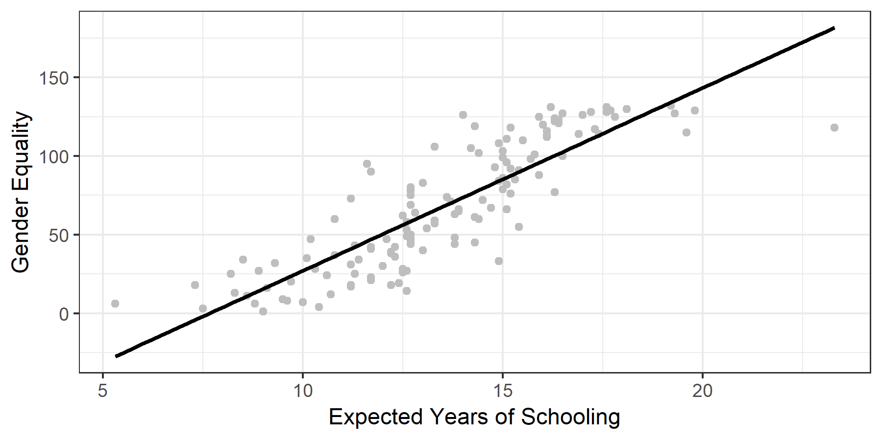
The regression line

Method: detail

Finding the Line of Best Fit
How do we find the line that fits the data best? Let’s restate our aim: we want a line where, given a certain $X$ value, the $Y$ value predicted by the line is really close to the actual value in the data. That seems like a reasonable definition of ‘good fit.’ Rephrased in mathematical terms, we want to be as small as possible. The thing we want to minimize is called a residual. For example, in “The regression line”, Serbia has an expected years of schooling value of $14.6$ and a gender equality score of $106$. Those are the actual values in the dataset. However, the regression line predicts that an education (i.e. $X$) value of $14.6$ is associated with a gender inequality score of $82.94$ [$Y=a+bX=−89.2+11.6⋅\left(14.6\right)=80.16$]. The residual amounts to $25.4$ [$106−80.16=25.4$], and is highlighted with a blue line in “Visualizing Residuals” below.
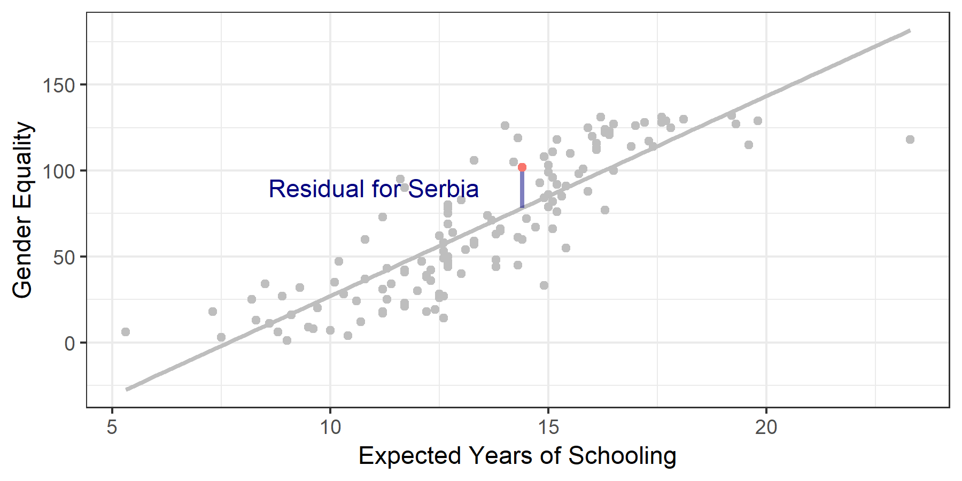
Visualizing Residuals
We take a cumulative look at all of our residuals to see which line fits best. There are several possible methods for doing this. Simply adding up the residuals would give us misleading results: some are negative and some are positive, and they would cancel each other out. To deal with this problem we square each residual. This makes all values positive, and has the added benefit of penalizing larger differences between our line and actual values. We find the line that best fits our data by minimizing the squared residuals. This procedure is called ordinary least squares.
The line you see in figure “Visualizing Residuals” is the line of best fit. Still, as you can also see, there are residuals. This is because in linear regression we are trying to find one single straight line to best predict the data, which always results in some points being off the line. A line that hits all points is possible but its equation would be so complicated it would be impossible to interpret. The key is that any other line would have residuals that are overall further away. The image below shows how different lines have drastically different squared residuals. For an interactive example that lets you adjust the line and see how the squared residuals change, check out the second image on this page.
As you can see, we can draw an infinite number of lines through our data, but the one where the squared residuals are lowest is the line of best fit – the line that best describes the relationship between our variables X and Y.
Why do we want to fit a line through our scatterplot?
The line that best fits the data gives us a simplified, approximate summary of the relationship between our variables.

Significance Tests
Regression lets us test whether the relationship between our variables is statistically significant. We begin by setting up a hypothesis test in the format with which you are already familiar. Our null hypothesis is that the relationship between variables $X$ (education) and $Y$ (gender equality) — AKA the coefficient $b$ – is zero.
$$H_{0}:b=0$$
$$H_{a}:b≠0$$
In our example, we find a beta that is not zero, $11.6$ in the bivariate regression we conducted. How weird is this? We can calculate how unlikely it is to get $11.6$, if $b$ is actually 0 like our null hypothesis stipulates. This calculation gives us a p-value for the coefficient. If the p-value is lower than a threshold we set ahead of time, we call the coefficient statistically significant. This just means that we have a high degree of certainty that $b$ really is not zero.
You can see the details of this calculation in the Mathematical Appendix.
Another way of approaching this issue is to calculate a 95% confidence interval for the coefficient – a range for which we have 95% certainty that the coefficient falls within its confines. In our example, the 95% confidence interval for the coefficient $b$, which captures the association between education and gender equality, is $\left[10.4,12.8\right]$. (You can see the calculation in the Mathematical Appendix. If the entire range is positive (as it is for us) or negative, it means that we are 95% certain that the true coefficient is not zero. The null hypothesis says that there is no relationship between $X$ and $Y$. But our interval is so far away from zero that we can feel safe rejecting the null hypothesis.

Multivariate Regression
As social scientists, the phenomena we investigate are usually very complicated, and we seldom deal with bivariate relationships alone. In terms of our above example, there are many factors other than education that could affect gender equality. For example, what if wealth is the variable we are looking for, not education? What if it’s simply countries where people are wealthier that have higher levels of gender equality?
A bad way of addressing this issue would be to simply run a second regression, looking at the relationship between wealth and gender inequality, and then compare the results. If we do this, we miss potential relationships between all of our variables. (You may remember this discussion from “Causal Inference and the Scientific Method”). Maybe wealth brings more education and also more gender equality, explaining why we think we see a relationship between education and equality. If we are just looking at the effect of education on equality, we are probably giving education credit for some of the variation in equality that is due to wealth. Education’s actual effect would be lower. This is a general rule: When we leave out variables that affect our main relationship, we tend to overestimate the regression coefficients of the variables in our regression. This is called omitted variable bias: leaving out relevant variables results in faulty (usually inflated) estimates.
Luckily, regression allows us to control for other variables. At this point it becomes harder for us to rely on graphs: representing two variables on a graph is easy, but once we add more we are dealing with too many dimensions to represent on a screen (or grasp with a human brain, at some point!). What you need to know is the following: we can remove the influence other variables have on the outcome variable and look at the effect of only our variable of interest. When you read a paper that talks about “controlling for” or “keeping constant" other variables, this is what they are doing – once we have accounted for the variation in the outcome explained by ‘control variables’, what is the relationship between the variable we care about and the outcome? The neat thing is that the output we get from running a multiple regression doesn’t just report on our main variable and the outcome, now controlling for other factors. Instead, it gives us the association between every single variable and the outcome, controlling for all the other variables included in the calculation. Thus including several variables in one regression is desirable for two reasons: first, because we simply want to know the effect of several variables, and second, because leaving out relevant variables would give us less accurate results.
A multiple regression with two explanatory variables can be written as:
$$Y=a+b_{1}X_{1}+b_{2}X_{2}$$
Academic papers will often use $β$ instead of $b$, $α$ instead of $a$, and sometimes even write variable names directly into the formula. In terms of our example we could write:
$$Ineq=a+β_{1}EDU+β_{2}GDP$$
Here, $α$ is the intercept (the value of gender equality we predict when both education and GDP are at $0$), $β_{1}$ tells us what change in gender inequality is associated with a 1-unit increase in education, and $β_{2}$ tells us about the association between GDP and education.
Why do we control for other variables?
For two reasons. First, we might be interested in how other variables relate to the outcome. Second, we want to hold constant the effect of other variables to avoid omitted variables.

Reading a Regression Table
When reading quantitative papers, chances are you will read a regression table. Reading regression results is a key skill for engaging with political science research. It will save you a lot of time, give you results at a glance, and help you critically compare the actual results of an analysis with the findings the authors present.
Let’s look at a regression table that shows the results of our analyses, Table 8.1. As you can see, each variable gets its own row – often the main variable of interest is in the top row. Also, each model gets its own column. Broadly, a model is a different way of looking at the statistical relationship between our variables. In our case, model just refers to different combinations of variables. Other times, different models can feature more complicated differences in statistical calculation. Column (1) shows the results of our first model, which is the simple bivariate regression we began with. Here, in the line for expected years of schooling, you can see the coefficient for the variable. You interpret this as discussed above: a one-unit increase in the variable (education) is associated with a 11.6 unit increase in the outcome variable (gender equality). In other words, one extra year of expected schooling is associated with an almost 12 point higher score on the gender equality index.
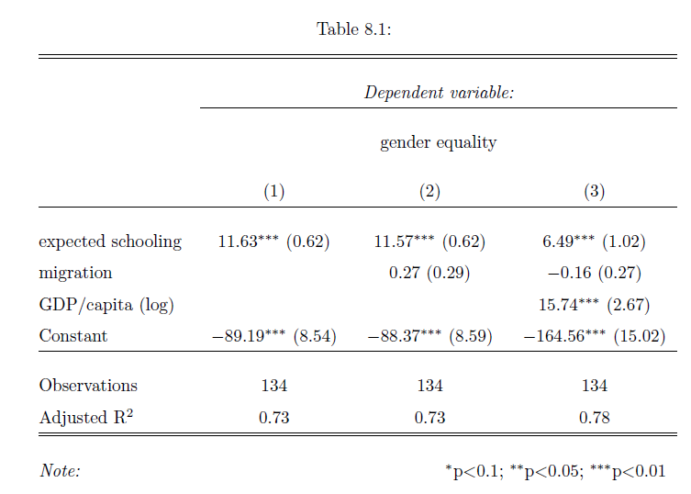
Table: 8.1
The little asterisk next to the coefficient is a very common symbol to denote statistical significance. A legend at the bottom of the table (as in our example) will explain what different symbols mean. You can see that education is statistically significant at the 0.01 level - we are quite certain the coefficient is not zero, and therefore quite confident that there is an association between education and gender equality. Right next to the coefficient and the asterisks is the standard error - our measure of uncertainty regarding our estimate of the coefficient.
Column (2) shows the results of a second model where we also add the net migration of a country. We can also read the association with this variable from the table: the ndicates that a 1-unit increase in the migration index results in a 0.27 increase in the gender equality index holding all other variables constant, but the finding is not statistically significant.
In Column (3) we add GDP/capita to account for different levels of wealth, and you can see that the s substantially lower than in the previous two models. The table indicates that a one-unit increase in education is now associated with a 6.5 point increase in gender equality, holding all other variables constant. This change in coefficient illustrates the problem of omitted variable bias. Before we explicitly looked at the relationship between wealth and gender inequality, we were giving education too much credit. It seems that GDP explains some of the variation in gender equality that we had previously attributed to schooling. Indeed the coefficient is sizable and statistically significant.
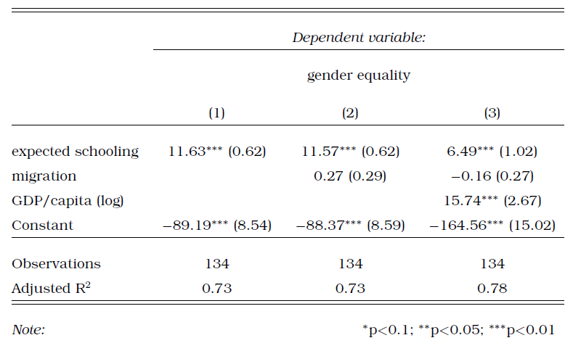
Table: 8.2
The coefficient of our main variable of interest - education - changes a fair amount when we change the model. When an association remains despite us changing the models around, we say that it is robust. If our variable remains significant across different models, it gives us more confidence that the association is actually there. If introducing control variables means that the main interest is not significant, we would question whether our association is actually there or not. There is no hard and fast rule for judging robustness. In our case, controlling for GDP did mean that the effect size of education went down by quite a lot. This is somewhat worrying. On the other hand, education did retain a statistically significant association throughout.
You’ll note that the variable is called GDP/capita (log). This reflects a common practice when dealing with GDP, which is to convert the values first before using them in the regression. This is statistically sound, but makes interpretation more difficult – see the Mathematical Appendix for more details if you are interested.
The final line among our variables, Constant, denotes the intercept. Sometimes this is at the bottom, sometimes at the top of the table. We already discussed how to interpret this: if all $X=0$, the regression line predicts that $Y$ will equal the value of the intercept.
Let’s move further down the table. The $R^{2}$ tells us how much of the variation in Y is explained by our regression line. The regression line above (model 1 in the table) has an $R^{2}$ value of 0.73. This is also referred to as “goodness of fit" (i.e. how well does the data fit the line?). This $R^{2}$ indicates that our regression line accounts for $73\%$ of the variation in gender equality.
It is tempting to simply scan the table to see which variables have stars associated with them, and conclude only they matter because they have statistical significance. But statistical significance is not everything. We also have to consider substantive significance, which is linked to the size of the coefficients. If a regression shows that a variable is significant at the .01 level, but it has a tiny coefficient, what does it mean? It means the variable may well be associated with a change in the outcome variable, but that this change is tiny. As social scientists, we are studying real-life phenomena and so we should care about the substantive impact of different variables on our outcome. We want to see effects that are perceptible in real life, not just in the data! On a practical note, however, do not be surprised by small effect sizes. The phenomena we study are complex and so it often makes sense that any given factor only has a small effect. As research methods have improved over the last decades, we have seen a decrease in effect sizes which suggests some older research suffers from omitted variable bias (remember that term?)
In short, here’s how to read a regression table:
- Begin with the first column and read it top to bottom. Note variables’ coefficient sizes and whether they are statistically significant.
- Move to the next column and do the same. See which coefficients change and in what direction. Which coefficients are no longer significant once other controls are added or the model changes in other ways?
- Track the main explanatory variable across models. Is it robust to the inclusion of controls and across different model specifications?
- Compare your impressions with the descriptions of the authors. Do they discuss all relevant findings, or do they leave something out?
In recent years, more authors have begun to display regression results in a graphical way. Consider figure 8.6 below, which displays the result of Dionne and Horowitz’s 2016 article (Dionne and Horowitz 2016). Their regression estimates the probability of farmers receiving agricultural subsidies. The dots represent the coefficient estimates from their regression, and the horizontal whiskers show the 95% confidence interval. At a glance, you can see that two confidence intervals do not contain 0, meaning we are 95% sure that the real value of these coefficients is not 0 – they are statistically significant. We also see that their value is negative, meaning that households with a female head and those that had seen death or illness were less likely to receive aid.
This figure also shows an example an example of something you should know called a dummy variable. The term ‘dummy’ bears no relation to what these variables do: they only take two values (yes or no, 1 or 0) and can be used to compare groups. When we include a dummy variable in a regression, the output tells us the difference in average Y values across the two groups. In this example, females receive aid at lower rates than males (the two values of these dummy variables). If you look at the variables in figure 8.6 you will see that many of them are dummies: they denote membership in ethnic groups, partisanship, and more. Rather than interpreting the coefficient as "a one unit increase in X is associated with a $b$ increase in Y," we think "being X rather than not is associated with a $b$ increase in Y."
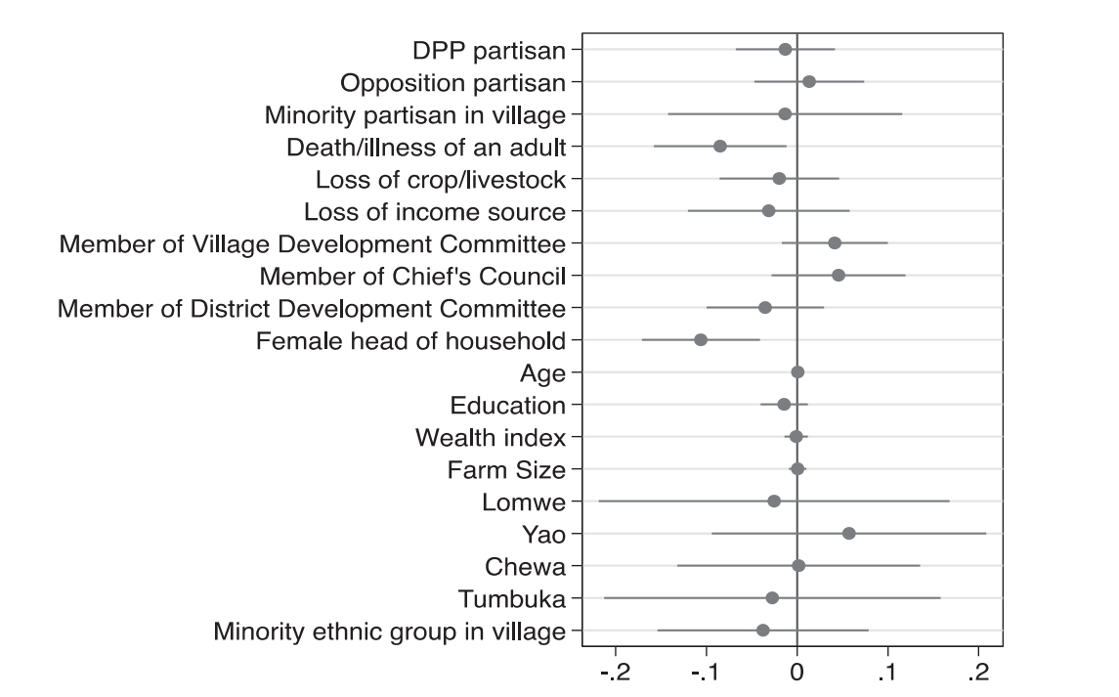
Adapted from Dionne and Horowitz 2016, 220

Applications

Correlation
Simple correlations are not as often found in recent scholarship as regression, mostly because regression is far more powerful and flexible than correlation, and hardly more difficult to calculate. Still, as noted above, correlations can be useful for an initial look at the data and when describing data. Take (Whitaker and Lynch 2011), who are trying to understand the success of the UK Independence Party at the 2009 European Parliament Election. The first thing they do is simply check whether support for UKIP correlates with support for the conservative or labour parties in the same geographical area, before moving on to a more sophisticated regression that relates support for UKIP to a number of demographic factors.
You will also encounter correlations in more technical sections of papers, when authors discuss which variables to use to measure certain concepts. For example, there are several different measures of democracy: Polity, the V-Dem Institute, and Freedom House all offer datasets that score each country’s level of democracy for a given year. In papers using democracy as a variable (be it outcome or explanatory), authors often pick one of them rather than running the analysis several times. They might note, however, that the indices are highly correlated – suggesting that results would be similar regardless of the dataset chosen. Below, we will look at a study by Kuenzi amd Lambright where the outcome is level of democracy. They write:
...the polity scores for these 33 cases are highly correlated with the other measures of democracy. For example, the polity scores are also highly correlated with the Freedom House total scores for 2000 (r = –0.88; higher values on the Freedom House measure correspond to a lower level of democracy). (Kuenzi and Lambright 2005, 428)

Regression
We are talking about large-N data in this chapter, and regression is most useful when applied to a fairly large number of cases. Some of this research takes data from different geographical or political units to look at a phenomenon across many cases, like the example about education and gender equality earlier on in this chapter.
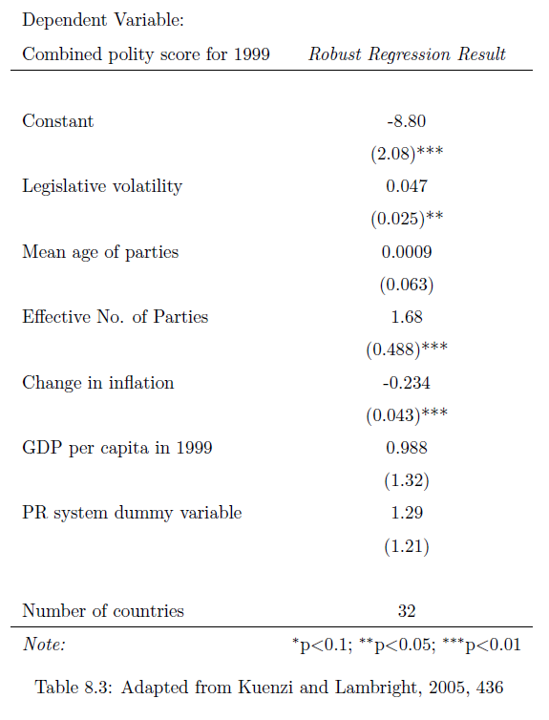
Table 8.3
Kuenzi and Lambright want to look at the relationship between party systems and the level of democracy along a number of African countries. Their outcome is a country’s score on the Polity scale, and their variables of interest are legislative volatility, the effective number of parliamentary parties, and the average age of parties (Kuenzi and Lambright 2005).
Look at Table 8.3 to get a sense of the results. Let’s interpret these coefficients. We can see that a one-unit increase in legislative volatility is associated with 0.047 more points on the polity index, holding all other variables constant. This is significant at the 0.05 level.
Interpret the coefficient for the effective number of parties. What does the coefficient tell us?
Looking across countries with different party systems, one additional effective party is associated with a 1.68 point increase on the polity score, controlling for the other variables in the regression.

Logistic Regression
Logistic regression is a type of regression where the outcome variable, $Y$ can only take on two values, 1 or 0. (Our discussion about dummies earlier was focused on explanatory ($X$) variables).
This is what Garcia (2006) (García-Rivero 2006) does, studying respondents’ feelings about the ruling party in South Africa, the ANC. The outcome variable is whether or not voters felt close to the ANC (1) or did not feel close to it (0). He looks at several demographic indicators to see which factors are associated with support for the ANC. You will find a lot of logistic regressions of this type in the study of elections, where voting intention is often a categorical variable.
Logistic regressions are slightly more tricky to interpret than regular regressions. To illustrate, let’s look at the main table from Ferree (2006) (Ferree 2006), who wants to understand why South Africa’s election results seem to have split along racial lines. The outcome variable is whether voters intended to vote for the ANC (1) or did not plan to vote for it (0). She looks at several exploratory variables, as you can see in Table 8.4.
 | Support for the ANC
Performance rating | 0.817
 | (0.431)
Believe DP is exclusive | -.196
 | (0.611)
Believe NNP is exclusive | 3.719**
 | (0.604)
ANC partisan | 3.026**
 | (0.582)
Female respondent | -1.454**
 | (0.547)
Age | 0.040
 | (0.126)
Low schooling (no high school) | 0.998
 | (1.016)
High schooling (post matric) | -4.400**
 | (0.713)
Political interest | .530**
 | (0.251)
Pseudo R2 | .85
N | 810
In the second column of Table 8.4, the coefficient for the variable ‘High schooling’ is -4.4. How do we interpret this? Clearly, we cannot do as we did above: we can’t say that having high schooling is associated with a 4.4 unit decrease in the intention to vote for the ANC, because the only possible values are either 0 or 1.
Instead we can do an anti-log on the coefficients to get odds ratios. What are odds ratios? If the odds of something happening are 50-50, the odds ratio is $\frac{50}{50}=1$, if they are 80-20, the ratio is $\frac{80}{20}=4$. These ratios are hard to interpret. We can convert them to probabilities, but these ratios change depending on the value of $X$. While the interpretation is tricky, know the basic intuition: the coefficients tell us whether the variable is associated with a higher (or lower) likelihood of observing the outcome.
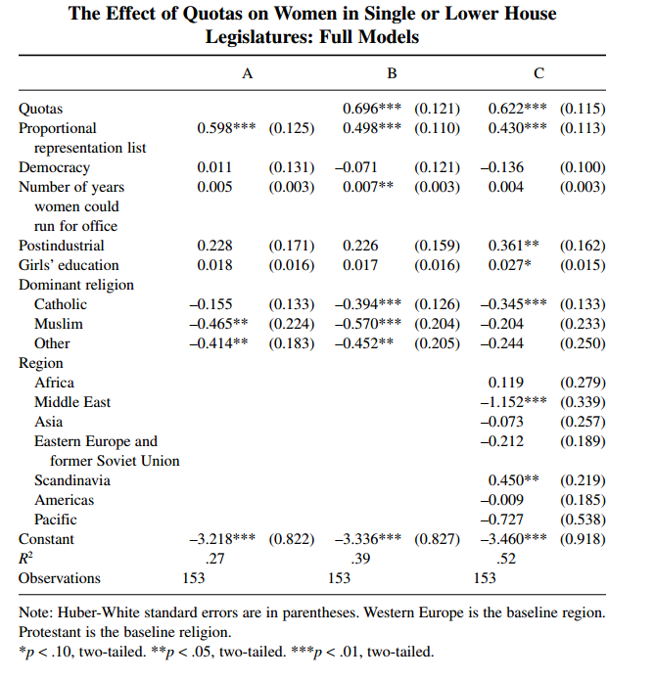
Adapted from Tripp and Kang 2008, 350

Experiments
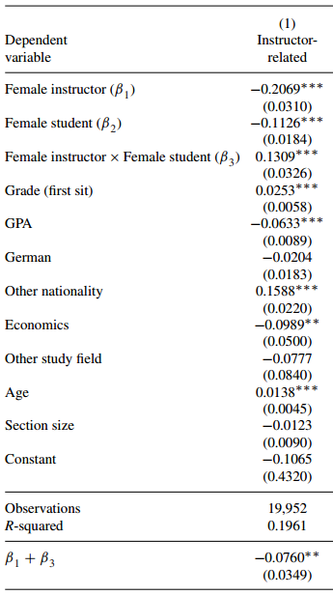
Adapted from Tripp and Kang 2008, 350
You will also likely encounter papers using experiments or quasi-experiments, which also use regression. As we discussed above, we can use dummy variables to compare means across groups. In experiments, this means we can use regressions to see how the treatment affected the treatment and control groups in the experiment, but also how the effects differ for different demographic groups, which we can add as control variables.
For example, Mengel, Sauermann, and Zölitz (2019) study how gender affects teaching evaluations. There are by now more than 70 studies indicating that women and people of color receive lower teaching evaluations than their colleagues, all else equal. Mengel et al. use a ‘quasi-experiment’: they look at data from courses where students were randomly assigned to sections that could be taught by women or men. They write that “female faculty receive systematically lower teaching evaluations than their male colleagues despite the fact that neither students’ current or future grades nor their study hours are affected by the gender of the instructor" (Mengel, Sauermann, and Zölitz 2019, 536) The regression table to your right provides more detail on controls: economics students, for example, tend to give lower evaluations than students in other fields, and students with high grades in the class tended to give higher scores. Overall, female instructors received lower scores, as indicated by the negative coefficient on the explanatory variable.

Advantages of Method
Regression is flexible, relatively easy to conduct, and intuitive. It enjoys many advantages:
- Results are generalizable. If the analysis is done carefully, we might be able to claim that the results we get from our analysis apply in other contexts too.
- Regression gives precise results. A regression output will give effect sizes, so not only do we know that one variable is associated with another, but also how large that association is. We can also construct confidence intervals for our estimates, giving us a sense of how certain we can be about the results.
- Regressions make it easy to control for other variables. We almost never deal with only bivariate relationships. Regression allows us to hold other variables constant while looking at the relationship we care about, minimizing our fear of omitted variable bias.
- Regression allows for iteration. Because of the relative ease of use of regression, other researchers can easily replicate research – and build on it.

Limitations of Method
- Measurement. One big problem of large-n quantitative research is that we can only compute statistics for variables we can measure. There are many things that have no measures (for example political will). On issues where we have measures, they are often controversial. For example, many scholars have tried to come up with databases that rate each country on a scale of democracy. But, as you have learned in the chapter on Data, coming up with a single measurement for concepts is extremely complicated and always involves trade-offs. What is a democracy in the first place? Which aspects of a society should we consider? How should they be weighed? Many subjective decisions have to be made, all of which can greatly affect the measure given – and therefore statistical results when entered into an analysis.
- Average effects. Regression is useful because it gives us a handy, simple output: for each variable it gives us a single coefficient that describes how much changing this variable affects the $Y$-variable. However, this is the average effect across all data points in our calculation. Look again at graph 1. The line, which gives us the regression coefficient, describes the data quite well (remember, we chose it because it is the straight line that does the best job of fitting the data!). Still, we can see that for some countries the line does a much better job at predicting the actual values than for other countries. In other words, on average an increase of one unit in education is associated with a $b$ increase in gender equality. But we should not conclude that this sort of relationship would hold for any one country we look at.
- Bad application 1: unrealistic claims of causal inference. The downsides of regression come often not from the method itself, but from how it has been used. Ironically, its ease of use has led to a large number of bad studies, because the ability to control for other variables has led scientists to feel a false sense of security. In reality, we often cannot control for all variables, either because we cannot measure them, or because it is difficult to think of all factors that might affect our outcome variable.
- There are many examples of authors claiming a multiple regression shows a causal relationship, using language about “the effect of" one variable on another, and so on. These claims are often unrealistic. As you learned in”Causal Inference and the Scientific Method”, it is difficult to show causality. To show causality, we need to deal with endogeneity, including reverse causality (does Y cause X?) and omitted variable bias (is a third variable Z responsible for the relationship between X and Y we see in the data?). Another thing that can help is evidence for a mechanism through which X might affect Y. In the absence of such evidence, regression cannot show that one variable causes another.
- Bad application 2: kitchen sink regressions. Another thing researchers can do is to investigate a large number of variables until they find some relationship that either confirms their preferred hypothesis, or is at least interesting enough to warrant publication. This is similar to the practice of datamining discussed above, and is sometimes also called ‘p-hacking.’ In fact, it is what I did to make figures 2-4 above: I was interested in a clear chart and regression table, and looked at different variables until I found a combination of variables that worked. With large datasets containing many variables so easily accessible, conducting a number of different regressions is dangerously simple.

Broader significance in political science
Regression is perhaps the most commonly used quantitative technique in political science. You’ve seen that the basic regression is very flexible and gives us important information – the strength of association between one variable and another, even holding other factors constant. This is very powerful! You’ve also seen one variation of it, logistic regression, but there are many more extensions of the basic concept for a variety of applications. Regression is used to analyze survey data, compare trends across place and time, and to interpret the results of experiments. If you will conduct research using large-N quantitative data, chances are you’ll use linear regression (or a method based on it). If you read research based on large-N quantitative data, chances are you’ll be reading a regression table. Hopefully, this chapter got you closer to being able to do so.

Application Questions
Explain the meaning of the coefficients $a$ and $b$ in the bivariate regression equation.
$a$ tells us the predicted value of $Y$ when all of the $X$-values are set to 0. On the scatterplot which visualizes the bivariate relationship, it is the intercept.
$b$ summarizes the relationship between $X$ and $Y$. It tells us how much of a change in $Y$ is associated with a 1-unit change in $X$.
You collect data on two variables and get the computer to calculate a regression equation for you. To check it, you plug an X-value from the dataset into your equation. The Y-value that results from this calculation is different from the Y-value in the dataset. Is it a problem if the regression's predicted values differ from the actual values in the data?
No. In linear regression we are trying to fit a straight line through a large number of data points. This means that one line will never perfectly fit all points. It’s fine if there is some difference - the importance is that we keep those differences (residuals) as small as possible, in a process we call ordinary least squares.

Key Terms
- bivariate regression
- data mining
- logistic regression
- multiple regression
- omitted variable bias
- regression coefficient
- reverse causality
- robust
- statistically significant relationship

Small N
By Justin Zimmerman

Introduction
The field of political science has traditionally focused on the importance of hypothesis testing, causal inference, experiments and the use of large n data. Quantitative methods in all its capacities is without a doubt important, but what can be lost at times is the value of small n methods of inquiry within the field of political science. Researchers such as Kathy Kramer, Cathy Cohen, Reuel Rogers, and Jennifer Hochschild et. al. have all used small n methods to tell stories about particular groups that have rarely been highlighted in political science. Whether its identifying rural consciousness in Wisconsin (Kramer 2016), researching the secondary marginalization of the most disfranchised in the black community (Cohen 1999), explaining the unique political stances of Afro-Caribbean immigrants (Rogers 2006), or highlighting the politics of a new racial order (Hochschild, Weaver, and Burch 2012), small n data can allow for a researcher to discover new information not easily attainable through quantitative methods alone. Small n methods allow for a more in depth assessment of a particular area and people.
This chapter will focus on the importance small n research. The chapter will highlight the various methods for conducting small n research including: interviews, participant observation, focus groups, and process tracing, as well as the various procedures for determining case selection. First, the chapter will elaborate the differences and goals of small n research as compare to quantitative research.

Background
To be a well-rounded political scientist it is important to understand that not every question can be answered through quantitative methods alone. There are times when small n methods are the more appropriate option. Yet, how does a researcher decide when small n methods are appropriate for their research? The researcher must be able to identify the differences and purposes of small n qualitative research and quantitative research. First, quantitative research focuses on the effects of causes, while qualitative methods is focused on the causes of effects. In other words, quantitative research, especially with regards to causal inference, aims to figure out if a particular treatment causes a particular outcome, such as an increase in an individual’s education causes them to be more political mobilized.
Small n qualitative research on the other hand focuses on understanding how the outcome came to be. American Political Development (APD) scholars are a great reference to this line of thinking. APD scholars look to track why certain outcomes came to be, such as Paul Frymer’s work on Western expansion in the United States of America (Frymer 2017) or Chloe Thurston’s research on housing policy and how it has historically discriminated against women, African Americans, and the poor through the use of public-private partnerships (Thurston 2018). Small n qualitative research also includes oral histories such as those provided by Yolande Bouka concerning the Rwandan genocide (Bouka 2013) and the interviews and historical context to explain the coercive power of policing in Latin America as researched by Yanilda María González (González 2017). In short, small n qualitative research aims to tell a story of how an event or policy came to be, and what are the experiences of particular groups because of a particular event or policy.
Thus, a small n qualitative researcher must take care to ensure their work is able to satisfy three characteristics of good qualitative research. First, their research must emphasize the cause and the implications it has. Second, good small n qualitative theories must explain the outcome in all the cases within the population. Lastly, qualitative questions must answer whether events were necessary or sufficient for an outcome to occur, with the cause providing the explanation. To setup qualitative research it is important to that understand that qualitative methods are interested more in the mechanisms behind things. Small n approaches can help us explore the underlying process such as how institutions evolve and change by gathering data about institutions, but it can also be answered through looking at institutional change in one or two contexts. Small n qualitative research can be inductive as a researcher builds the theory and hypotheses from the data, or deductive by testing theories and hypotheses with the data. What is critical in building qualitative research whether inductively or deductively is case selection.

Case Selection
Case selection for small n qualitative research setup to use a small number of cases in order to go into a deep dive into a specific subject. For instance, a researcher may use a specific neighborhood to explain a specific political characteristic of the community. Reuel Rogers conducts this exact research when he interviewed Afro-Caribbean residents in New York City about their political preferences as new immigrants of the United States of America (2006). This case selection allowed for Rogers to assess the veracity of an age old claim that pluralism allows for immigrants to eventually assimilate into American culture and government participation by highlighting the complexity that comes from immigrants that are identified as black. Rogers finds that Afro-Caribbean immigrants suffer from discrimination that may hinder their ability to assimilate into American society. Yet, how does a researcher decide what cases to use? Seawright and Gerring provide some insight by identifying seven case selection procedures (Seawright and Gerring 2008). For the purposes of this text, this chapter will focus on four of these case selection procedures. The cases focused on will be most similar, most different, typical, and deviant. The chapter will also briefly describe extreme, diverse, and influential cases.

Most Similar
Seawright and Gerring instruct the use of the most similar case selection must have at least two cases to compare. Ideally, when using most similar cases all independent variables other than the key independent variable or dependent variable would be similar. For example, we may compare neighborhood with similar variables for income, religion, and education with the key independent variable such as race being the only difference. Thus, a researcher could use small n case selection to research differences or similarities that black middle class residents of particular neighborhood have with a white middle class neighborhood. It should be noted that matching any particular cases by exact characteristics is essentially impossible in the social science. Thus, this technique is daunting to say the least. Yet, part of the compromise of political science and social science in general is doing the best with the information you have and being honest about the limitations. This is especially important in the use of the most similar case selection procedure.

Most Different
Gerring and Seawright also identify the use of the most different case selection procedure. The most different case refers to cases that are different on specified variables other than the key independent variable and dependent variable. For instance, maybe there are class, education, and religion differences between two neighborhoods, but the key independent variable of race remains the same for both. Gerring and Seawright argue that this tends to be the weaker route to take in comparing two case but nonetheless it is an option to use for a small n researcher under the right circumstances.

Typical Case
The typical case refers to common or representative case that a theory explains. According to Gerring and Seawright, the typical case should be well defined by an existing model which allows for the researcher to observe problems within the case rather than relying on any particular comparison. A typical case is great for confirming or disconfirming particular theories. Referring back to the work of Reuel Rogers and his work on black Caribbean immigrants in New York City, Rogers was able to disconfirm Dahl’s argument on plurality allowing for the eventual full inclusion of immigrants by pointing to the racism and discrimination black Caribbean immigrants face that hinders their ability to be fully incorporated into the American polity. What is most important for understanding the typical case is that it is representative and that this representation must be placed somewhere within existing models and theories to be useful.

Deviant Case
Conversely to the typical procedure, the deviant case cannot be explained by theory. A researcher can have one or more deviant cases and these cases serve more as a function of exploration and confirming variation within cases. The deviant case is essentially checking for anomalies within an established theory and allows for the finding of previously unidentified explanations in particular cases. An example may be finding that liberalism is defined differently depending on certain populations which runs counter to Haartz’ assertion that liberalism assumes a certain amount of unity throughout the country. What is most important for understanding the deviant case is for a researcher to check for representativeness of a theory, which allows for much of the value of small n methods. A researcher can tell a story of a particular group that is often assumed to fit the general understandings of political science but through the use of qualitative methods is shown to be more complex than previously understood.

Other Selection Approaches
Along with the four main case selection procedures are other are three other approaches worth noting. The first being the extreme case. The extreme case is characterized by cases that are very high or very low on a researchers’ key independent or dependent variables. It can provide the means to better understand and explore phenomena through the means of maximizing variation on the dimensions of interest in the selection of very low and high cases (Seawright and Gerring, 2008). Unlike in linear regression, where extreme values can provide an incomplete or inaccurate picture, in small n approaches, extreme cases can offer the opportunity for deepening the understanding of a phenomenon by focusing on its most extreme instances. (Collier, Mahoney and Seawright 2004; 4-5)
Second, diverse cases highlight range of possible values. A researcher can choose low/medium/high for their independent variable to illustrate the range of possibility. Two or more cases are needed and this procedure mainly serves as a method for developing new hypotheses. These cases are minimally representative of the entire population
Lastly, influential cases are outliers in a sense that they are not typical and may be playing an outsize role in a researcher’s results. It is unlikely that small n methods will play a significant role as influential cases rely on large n methods.
Check-in Question 1: How should a researcher go about choosing a case selection procedure?

Method: setup/overview
Small n methods are characterized by an emphasis on detail. A researcher has to be able to see the environment that they are studying. The purpose of small n methods is to gain an in depth knowledge of particular cases. Field notes will be a researcher’s best friend. A researcher should take notes on the demographics, noises, emotions, mores, and much more to gain an accurate understanding of the population they are studying. Additionally, small n methods are about building rapport with the population being studied and constantly taking into account one’s own biases and thoughts as they conduct fieldwork. It is not uncommon for researchers to eventually live in the places they are studying. During her work on the black middle class, Mary Pattillo would eventually move into the South Side Chicago neighborhood of Groveland. The neighborhood was the subject of her book Black Picket Fences (Pattillo 2013). Pattillo would attend community meetings, shop, and cultivate lasting relationships with the community, which would guide her research. There is a level of intimacy needed to do good small n research. Not always to the extent of needing to live with one’s participants, but still a need for insight that goes beyond a shallow understanding of a particular community. Small n qualitative researcher gets at these insights through several methods.
Note: Take sometime to think about for your own research what you are noticing during your fieldwork? How is this informing your study?

Method: types
The typical methods used in small n research are interviews, participant observation, focus groups, process tracing, and ethnography. Each method has its advantages and disadvantages and a researcher can utilize more than one these methods depending on the aims of their research. In deciding on a small n method a researcher must consider the goals of the research, validity, and conceptual framework that will feed the researcher’s broader question. The diagram below illustrates that a small n qualitative researcher should be purposeful in their research design. They must consider their overall question. Specify the goals of their research, consider the theories that are driving the conceptual framework of their research, and consider the validity (does it make sense) of their research design.
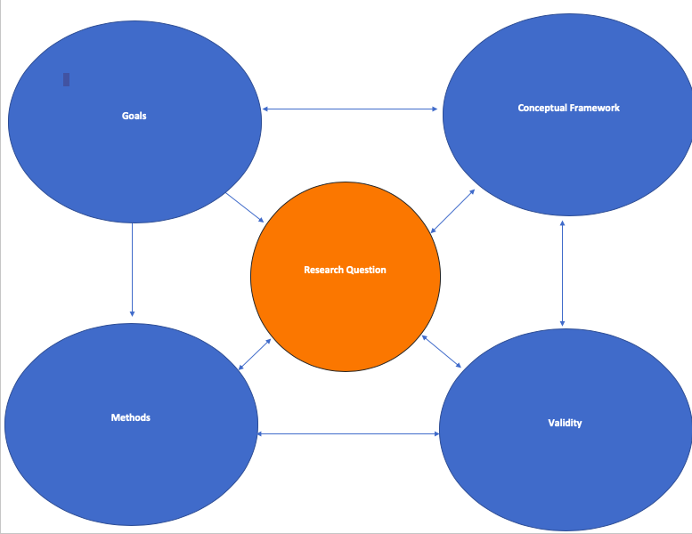
Research Methods Diagram
Focusing on the methods portion of the diagram, this chapter will discuss in further detail each small n qualitative method.

Interviews
Conducting interviews can seem like a daunting experience. A researcher has to develop a comfort in approaching diverse sets of people, many times in unfamiliar environments. A researcher has to be able to build rapport, get their questions answered within a limited amount of time and encourage the participant to elaborate and clarify answers. Interviews are challenging but the good news is there are ways to make the process smoother through organization, commitment, and earnestness.
Before contacting anyone for an interview, a researcher should take sometime to organize their interview guide and decide whether they want to conduct structured or semi-structured interviews. The interview guide highlights the questions and themes the researcher plans to cover during the interview. The format of the interview guide is determined by whether the researcher has a rigid structure of questions they plan to ask each participant (Structured Interview) or a more flexible interview strategy that allows for the researcher to deviate from questions and allow for a more exploratory conversation within the confines of the research question (Semi-Structured Interview).
Once a researcher has decided on an interview structure and completed their interview guide, they can decide who they want to recruit to participate in the interview. The researcher will need to consider the key informants and representative sample they want to recruit. Key informants are experts that can discuss the population of interest including but not limited to academics, community leaders, and politicians. The representative sample is the population that your research is based on. For example, Wendy Pearlman’s text We Crossed a Bridge and it Trembled: Voices from Syria has a representative sample of Syrians displaced during the civil war (Pearlman 2017). What is important to understand about the difference between the representative sample and key informants is that the sample is giving a firsthand account of their experiences, while a key informant is mainly given their observation and experiences of the representative sample from an outside perspective.
Moving on to recruitment, Robert Weiss’ Learning From Strangers lists several reasons that affect whether an individual is willing to participate in an interview including: occupation, region, retirement status, vulnerability, and sponsorship from others within their network (Weiss 1994). Unfortunately, there is no easy way to recruit but from experience face to face discussions with potential participants and immediate follow up are quite effective. Also use snowball sampling to use previous participants acquaintances and networks to participate in interviews. These strategies are not full proof but a layer of personal interaction through face to face contact or networks does have advantages in making many people more receptive to participating in interviews.
Lastly, when the day to interview finally arrives a researcher should have two recorders, tissue, interview guide, consent form, and a gift card for the participant if possible. The interview should not take any longer than an hour as a sign of respect for the time of your participant. A researcher should take meticulous notes during the interview. Also, the researcher must gain the permission of the participant to conduct a follow up interview if necessary.
Check-in Question 2: What is this difference between a representative sample and a key informant?

Participant Observation
Participant observation is a variation of ethnographic research where the researcher participates in an organization, community, or other group-oriented activities as a member of the community. Typically used in anthropology, it involves a researcher immersing themselves within a community. Participant observation requires that the research build a strong bond of trust with the observed community. A researcher (with the help of IRB) will need to decide if participation will be active or passive and whether it should be overt or covert. This can be a particularly sticky situation, as a passive and covert observation may mean community members have no idea they are being studied, while active and overt participation can lead to the environment changing as the community is aware of the presence and role of the researcher. Referring back to the work of Mary Pattillo, recall that she eventually became a citizen of Groveland and participated as any other citizen in community activities (Pattillo 2013). This included leading the local church choir, joining the community’s local action group, and coaching cheerleading at the local park. Pattillo saw her participant observations as essential to describing the black middle class in Groveland and even speaks of the parallels between the Groveland neighborhood and her upbringing in Milwaukee.
The key purpose of participant observations is to provide deeper insight into process and how things function. This exercise is good for ‘theory building,’ but it may be best to include another method, such as interviewing, to allow for the community to tell their story as well, a supplemental method Pattillo uses as well. What is most important when using participant observation (in qualitative methods in general) is to take meticulous field notes with attention to accuracy. A researcher should be cognizant of their own biases and constantly thinking through their analysis to make sure they a capturing an accurate story. In order to tell an accurate story a researcher should keep both mental notes and a notepad. After the end of an event it is important to write everything down while the researcher’s memory is fresh.
:::
Check-in Question 3: What are the advantages and disadvantage of covert and over participant observation?
:::

Focus Groups
Focus Groups, similar to individual interviews requires a researchers to set questions, recruit participants and follow up with participants as necessary. As with an individual interview, the researcher should have an interview guide to help structure the questions and themes of the focus group. The advantage of a focus group is that a researcher is able to facilitate multiple respondents at once, which can lead to additional details and information you might not get in series of single interviews. As seen in Melissa Harris Perry’s Sister Citizen, focus groups are great for spurring discussion about topics such as stereotypes (Harris-Perry 2011). A researcher should note impressions, points of contention, and general interactions within the group. Group dynamics and discussions can be used for theory building as well as getting a deeper understanding of a particular group of people.

Process Tracing
Process tracing is a method of causal inference using descriptive inference over time. Notably used by APD scholars, the goal of process tracing are to collect evidence to evaluate a set of hypotheses through the framing of historical events. There are four tests when discussing process tracing.
The first is the straw in the wind test. The straw in the wind test can increase plausibility but cannot determine that any event necessary nor sufficient criterion for rejecting. It can only weaken hypotheses. The hoop test establishes necessary criterion. Though the hoop test does not confirm any particular hypotheses, the test can eliminate hypotheses. The smoking gun test provides a sufficient but not necessary criterion for hypotheses. The test can give strong support for a given hypothesis and can substantially weaken competing hypotheses. Lastly, the doubly decisive test illustrates evidence that is necessary sufficient. Necessary being when the necessary causes occur when the effect occur and sufficient being when causes always occur after effects.
What is important to understand about process tracing beyond the numerous tests is that process tracing is a good way in political science to draw evidence for certain events and phenomena. Chloe Thurston uses process tracing to track the development of the public-private partnership with regards to housing policy (Thurston 2018). Through numerous historical text including archives, testimonial, and presidential records, Thurston is able to develop a story of how public-private partnerships led to home owning policies that discriminated according to gender, race, and socioeconomic status and how advocacy groups were able to combat these policies.
Thus, process tracing looks for historical evidence to explain certain events or policies.

Ethnography
Ethnography involves studying groups of people and their experiences (Emerson, Fretz, and Shaw 2011). As mentioned earlier with participant observations, the purpose of ethnography is for a researcher to immerse themselves in the environment they are studying. The researcher will need to develop relationships with the community and detail the environment through constant note taking and reflection. This is reflected in the work of many of the researchers already detailed in the chapter. Done correctly a researcher can document the emotions, attitudes, and relationships in a community that are sometimes impossible to capture in quantitative work.
In his text Wounded City: Violent Turf Wars in a Chicago Barrio, Robert Vargas is able to capture the fear, frustration, and empowerment felt by the residents of Chicago’s Little Village as they negotiate turf wars between gangs, police, and alderman [vargas2016a]. The insight he is able to gather cannot simply be surveyed, but must be observed in the environment in order to develop trust within the community.
Ethnography is about relationship building and allows for latent findings that may give proper context for understanding particular groups. This is especially important for underrepresented communities, where in depth research is often lacking and responsiveness to a survey may not be likely under less personal circumstances. Ethnography allows a researcher to take a more holistic approach in understanding a community.
Check-in Question 4: What should a researcher be looking for when taking ethnographic field notes?

Applications
The application of small n qualitative methods is based on a researcher’s question. Sociologist, Celeste Watkins-Hayes, explains that qualitative research is meant to tell specific stories about a community. Going back to the diagram displayed in the beginning of the chapter, a researcher should think of the story they are trying to tell and goals, whether the small n qualitative methods they want to use are valid, and how does all of this relate to the research question. Most importantly when applying small n qualitative methods, record keeping is of the utmost importance. A researcher should make sure that their field notes are detailed and capture an accurate depiction of the environment of study. This means not only self-reflecting on one’s own biases, but also using multiple small n and quantitative methods when appropriate to tell the most complete story possible. Lastly, a researcher needs a method of coding the themes and messages found through their study. Recording encounters and taking good field notes will go far in creating an organized system, which will allow for a researcher to tell an accurate story that captures the nuances and characteristics of a particular community.

Advantages of Method
Small n qualitative research thrives with gaining in depth information about a limited number of cases. This will allow a researcher to provide insight of a small number of communities that may be missing from large n studies. In this same breath, small n methods allow for theory building that many times is unique to many of the lessons taken for granted in the discipline of political science. It is one thing to ask an individual participant to check an answer on a question about immigration, race, or president. Yet, there is value is going deeper and wrestling with the values, contradictions, as well as the historic and present-day context that make up the politics of a particular people. It is through small n methods that researchers are able to get a better understanding of topics such as rural consciousness, neighborhood violence, and linked-fate. Small n methods allow a researcher to tell the stories that are often ignored, unheard, or misinterpreted through other methods.

Disadvantages of Method
The major disadvantage of small n methods is that a researcher is working from a small pool. This should not be confused with having less data. Interviews, field notes, and archives bring an abundance of data but the sources are limited. A responsible researcher will have to consider whether their case selection is representative of the broader community and how best to ensure that they are getting a diverse set of voices to hear from to avoid inaccurate assessments of a community. Thus, it is difficult (but not impossible) to generalize from the use of small n research. A researcher including quantitative methods or multiple small n methods in their study will go a long way in strengthening their arguments.

Broader significance/use in political science
As has been noted numerous times in the chapter, small n qualitative methods allow a researcher to explore groups that cannot necessarily be understood merely with a survey, experiment, or causal inference. Small n allows for a researcher to go into more detail about groups that cannot be fully understood through quantitative research either because they are too small or too unresponsive to quantitative methods. Additionally, small n qualitative research also allows for political scientist to consider context and history when developing claims regarding the political behaviors and institutions that shape society. This context can help a political scientist go beyond superficial understandings of particular groups. For instance, Michael Dawson’s text Black Visions uses quantitative methods to show that African Americans have a high support for Black Nationalism (Dawson 2001). This finding alone could be taken as example of mass black prejudice, as Black Nationalism has been associated most notably with the bigoted views of Louis Farrakhan. Yet, Dawson takes care to include the historical context, including testimonials by leading black thinkers, detailing the long history of debate concerning Black Nationalism, as well as the economic violence and discrimination committed against the black community, which leads to support of some forms of Black Nationalism. Small n qualitative research through the use of history, interviews, and ethnography allows for the telling of these stories, adding complexity and nuance to many of political science’s well established theories and perceptions.

Conclusion
Not all questions can be answered with a survey and experiment alone. Sometimes a deeper study into a community and event can lead to new and exciting insights in the discipline of political science. Admittedly, small n qualitative research can be met with some cynicism in certain parts of the political science community, but when done correctly through meticulous note taking, coding, and preparation small n qualitative methods can provide insights that have yet to be fully articulated in the discipline and assist in answering some of the most important questions of the day including policing, immigration, and race relations.

Application Questions
What are some materials needed to conduct small n research?
A researcher should have their interview guide prepared, tissues, and two recorders if conducting interviews or focus groups. Additionally, a researcher should have a notepad for field notes and consent forms if necessary. Business cards are also useful when trying to recruit participants from the field.
When in the field, how does a researcher build rapport with the community?
Rapport can be built through appearance including dress, race, gender, regional, and class markers. Most importantly, a researcher should present themselves as engaged and attentive to the participants. A researcher should remain professional and read the room, rapport building for a group of blue collar workers may be different than with college students. A researcher should remain cognizant of this distinction and look for openings to build connections when possible.

Social networks
By Erin Ochoa

Introduction
From microblogging with Twitter to leaving comments on YouTube videos, the use of online social media platforms has become a part of everyday life for many: as of January 2020, Kemp (2020) estimates that there are 3.8 billion active social media users—49% of the global population. With the inception of social media—the precursors of which arguably date to the 1970s, if not earlier—and its proliferation since the turn of the millennium, interest has grown around the theory and methods for analyzing data from such networking platforms. This type of research is a form of social network analysis.
Social networks among humans, however, have existed as long as humanity itself. This is because a social network exists whenever two or more social entities interact or otherwise relate to each another. Many such interactions and relations in contemporary society are fleeting: transactions between workers and customers in retail or service settings, strangers riding a train together, or students in the same class whose acquaintanceship ends along with the school year. Others may be formal, structured, deliberate, or otherwise durable: members of a given Senate committee serving in a given term of Congress, a hierarchy of workers in a company division, a marriage relationship between spouses, or kinship ties. It is these formal, structured, deliberate, and durable networks that are the primary focus of social network analysis.

What is a Social Network? What is Social Network Analysis?
A social network is a set of relationships among social entities. Social network analysis, then, is a body of methods used to evaluate the characteristics of social networks and their elements. To better understand what these terms mean, it is important to first address what a network is and what elements it comprises. We will also consider examples of networks and approaches to representing them.

Elements of a Network
A network is a set of entities and the relationships among them. The study of networks is rooted in a sub-field of mathematics called graph theory. From this perspective, a network is a data structure modeling a collection of units, which are represented as points called nodes or vertices, and the relationships among them, which are represented by links, called edges or ties, between the nodes. Two nodes that are connected by an edge are said to be neighbors. A network is also called a graph; here, both terms are used interchangeably.
Networks can represent many different types of real-world phenomena. Consider how a network could be used to model each of the following:
- The genealogical history of the Japanese royal family:
  - Nodes represent people; ties represent marriages and births.
- Email correspondence between workers in a corporation:
  - Nodes represent workers; ties represent emails exchanged between pairs of workers.
- Flights between all the international airports in the world:
  - Nodes represent airports; ties represent flights connecting airports.
- Predator–prey relationships among animals in an ecosystem:
  - Nodes represent different species; ties represent which animals prey upon others.
- Mentorship and advising among political scientists in academia:
  - Nodes represent scholars; ties represent mentor–student relationships among scholars.
- The order in which blocks of code in a computer program could be executed:
  - Nodes represent blocks of code; ties represent flow control between blocks.
- Advice-seeking relationships among all current federal circuit judges in the United States:
  - Nodes represent judges; ties represent whether a given judge has ever asked another judge for advice.
When the nodes in a network represent people, organizations, or another type of social entity, the graph can be called a social network.

Network Representations
There are different ways to represent a network. The two most accessible methods are sociograms and adjacency matrices. The sociogram in figure 10.1 and the adjacency matrix in Table 11.1 are representations of the same network.
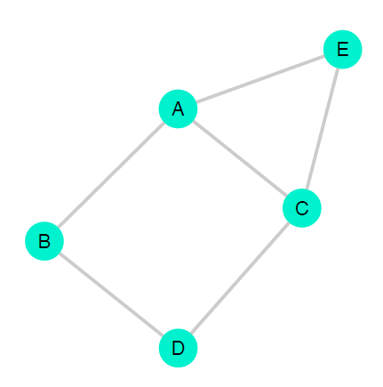
A sociogram for a network with nodes [A, B, C, D, E]. Each circle represents a node and each line represents a relationship between the two nodes it connects
Table 10.1: The adjacency matrix for a network with nodes $\left[A,B,C,D,E\right]$. Rows and columns represent nodes; $1$ denotes an edge between two nodes and $0$ denotes absence of edge, with dashes along the diagonal to demonstrate that a node cannot have an edge to itself. In this network, there exist relationships between nodes $A\&B$, $A\&C$, $A\&E$, $B\&D$, $C\&D$, and $C\&E$.
 | $A$ | $B$ | $C$ | $D$ | $E$
$A$ | — | $1$ | $1$ | $0$ | $1$
$B$ | $1$ | — | $0$ | $1$ | $0$
$C$ | $1$ | $0$ | — | $1$ | $1$
$D$ | $0$ | $1$ | $1$ | — | $0$
$E$ | $1$ | $0$ | $1$ | $0$ | —
A sociogram is a diagram that displays the nodes as points and the edges as lines or arrows.
To understand how an adjacency matrix works, first recall that a matrix is a rectangular data structure containing numeric values which are organized in rows and columns; the total number of cells or values in the matrix equals the number of rows multiplied by the number of columns. An adjacency matrix is a square matrix that represents the presence or absence of ties between pairs of nodes in a graph—it tells us which nodes are adjacent, that is, which nodes are neighbors. There exists one row and one column for each node, and each cell value identifies whether the nodes associated with that cell are adjacent.

Method: Set-up/Overview

Two Fundamental Network Attributes
The two most fundamental attributes of a network are whether it is directed and whether it is weighted.
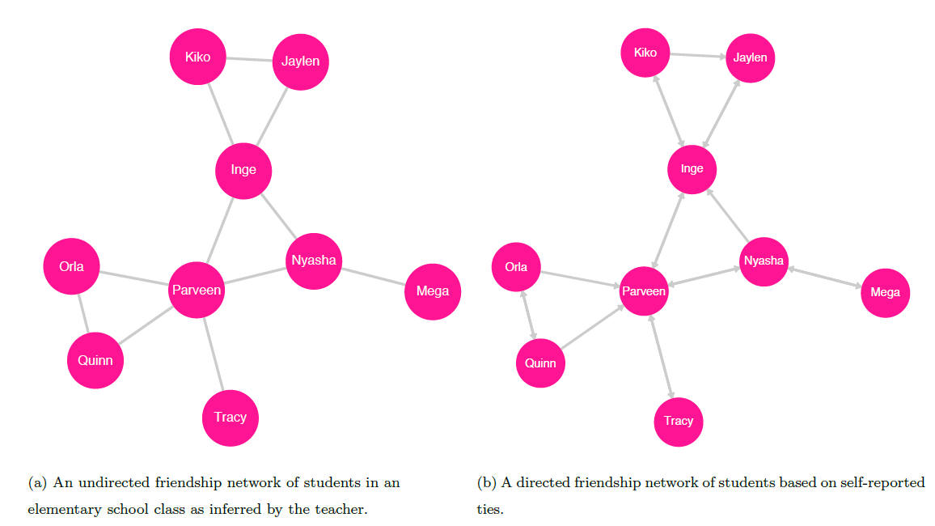
An undirected (left) and directed (right) graph of a friendship network among students. The ties in the undirected graph represent a mutual friendship between pairs of students. For example, there is a tie between Orla and Parveen, indicating that Orla is friends with Parveen and that Parveen is friends with Orla|their relationship is symmetric.
Note the arrows in the sociogram to the right; these indicate the direction of perceived friendship from one node to another. For example: the two-way arrow between Mega and Nyasha indicates that each considers the other a friend; the one-way arrow pointing from Kiko to Jaylen, however, indicates that Kiko considers Jaylen a friend, but also that Jaylen does not consider Kiko a friend –their relationship is asymmetric.
Undirected and Directed Networks
The first important attribute of a network is whether there is a direction associated with the modeled relationships between nodes. There are two types of graphs with respect to direction, undirected and directed.
Undirected Networks. The most basic type is an undirected graph, in which the edges represent symmetric, or reciprocal, relationships between nodes. The ties in an undirected graph are called undirected or symmetric ties. Such ties indicate that for any pair of connected nodes, both nodes have the same role in the relationship.
One example of such a graph is the friendship network of students in an elementary school class based on bonds observed by their teacher (see figure 10.2. In this network, an edge between two students means that their teacher perceives them to have a mutual friendship; note that a tie does not indicate any hierarchy among the connected nodes. If, for example, the teacher infers that Inge and Jaylen are friends, then an undirected tie exists between them in the graph. The edge between these two nodes means that to say Inge is friends with Jaylen is the same as saying Jaylen is friends with Inge.
Directed Networks. In a directed graph, each tie has a direction: the directed ties in a directed graph represent a one-way or asymmetric relationship between nodes. We can think of asymmetric relationships as those in which the roles of the source and destination nodes differ.
Earlier, we described a network to model mentorship and advising between political scientists (see figure 10.3). For each tie in this network, one node has the role of mentor and the other the role of student; note that each node can take on one role or the other, or even both depending on the direction of its ties to other nodes. Let there be eight scholars in the network: Akemi, Brett, Chi, Dani, Elvan, Farah, Gal, and Harvey. Akemi is the most senior scholar and was an adviser to Brett and Chi when they were graduate students. Later in their careers, Brett mentored Dani and Elvan, and Chi mentored Farah, Gal, and Harvey. In this network, the direction of the tie is a fundamental aspect of the relationship between two nodes: to say Akemi mentors Brett is not the same as saying Brett mentors Akemi.
A second example of a directed graph is the network of students in an elementary school class based on friendship ties identified by the students themselves 11.2: if Inge identifies Jaylen as a friend, then there exists a friendship tie from Inge to Jaylen; if Jaylen identifies Inge as a friend, then there exists a friendship tie from Jaylen to Inge. Kiko identifies both Inge and Jaylen as friends, so there exist ties from Kiko to Inge and from Kiko to Jaylen. Inge identifies Kiko as a friend, but Jaylen does not; thus, there exists a tie from Inge to Kiko, but there is no tie from Jaylen to Kiko—despite the tie from Kiko to Jaylen. The ability to denote such asymmetric relationships is the key feature of directed graphs.
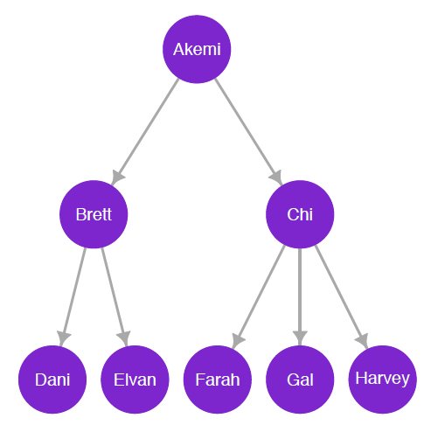
A directed network of adviser–student relationships between political scientists
Weighting
The second fundamental attribute of a graph is whether its ties are weighted. There are two types of graphs with respect to weighting, unweighted and weighted.
Unweighted Networks. In an unweighted graph, there are no values associated with any of the edges. The relationships represented in the network are modeled as equivalent, regardless of the circumstances surrounding each relationship.
Consider the earlier example describing a friendship network among elementary school classmates as observed by their teacher. In this undirected network, we can consider ties as dichotomous or binary: between two nodes, a tie either exists or not. Imagine that Inge and Jaylen have been neighbors, friends, and classmates for five years, and both are now friends with Loren, a new classmate who has recently moved to the neighborhood. In an unweighted representation of the friendship network, the tie between Inge and Jaylen is seen as equivalent to the tie between Inge and Loren: the network does not capture the strength, duration, frequency of contact, or other qualities of the friendship bonds, only whether the friendship bonds exist.
Weighted Networks. In a weighted graph, each edge has a numeric value or weight representing an attribute of the relationship between its two nodes. Depending on the network, the value can measure the physical distance between two nodes or some aspect of the strength or intensity of the relationship between them or perhaps of the frequency of an event that occurs between the two nodes.
A simple example of a weighted network is an undirected graph of several towns and the highways existing between them. In this network, the weight of each edge is the length of the highway connecting a pair of towns and thus measures the distance between them.
For a directed weighted graph, recall the earlier example of the email correspondence network among workers in a corporation. Consider the case of two workers, Stéphane and Tracy, each of whom has sent emails to the other. To make a directed weighted correspondence graph, assign to each edge the number of emails sent by the source node to the destination node: Stéphane has sent Tracy $11$ emails, so the weight of the tie from Stéphane to Tracy is $11$; Tracy has sent Stéphane $15$ emails, so the weight of the tie from Tracy to Stéphane is $15$. In this case, the edges represent the frequency and direction of email contact between the two workers.
It is possible to convert a weighted directed graph to a weighted undirected graph. This can be accomplished by summing the weights of ties between a pair of nodes and assigning the result to a single undirected edge between the nodes. For the email correspondence network, to replace the directed ties between Stéphane and Tracy with an undirected tie, we add Stéphane’s $11$ sent emails to Tracy’s $15$ and assign the value $26$ to the link between them. The edges now represent the frequency, but not the direction, of email contact between Stéphane and Tracy.
A Note on Node Attributes. Real-world social entities vary in their characteristics—that is, there are variables associated with social entities. For example, there exist many types of organizations, such as non-profits, for-profit corporations, government agencies, and intergovernmental bodies. Similarly, there are a plethora of aspects associated with individual people. For example, consider the following: In the United States, generally speaking, age cutoffs define the legal categories of child and adult; persons with high-school degrees belong to one category, while those who have not attained a high-school education belong to a different one; and those with certain criminal convictions are labeled as felons.
In general, each variable associated with a social actor measures a single aspect of that actor: it may measure height or weight, but not both, for example. These variables may be quantitative (a number, such as the count of armed conflicts that have taken place in a district, or the fuel efficiency of a vehicle in miles per gallon) or qualitative (a category, such as a nation’s form of government, or whether a state’s legal code allows for capital punishment). (For a thorough discussion of variable types, see chapter on Data.
We can represent the different values of a variable across the vertices in a network using node attributes. Here, we will only consider node attributes that represent categorical variables, either nominal or ordinal. A variable may take on a single value from a finite set of all possible categories (the categories are exhaustive), with each category being distinct from all the others (the categories are mutually exclusive). Note, however, that discrete and continuous variables can be converted to ordinal variables by subsetting the possible values into categories. Consider, for example, a variable that captures the count of shootings in a neighborhood with categories such as 0-9, 10-19, 20-29, and $≥30$; or the weight status associated with each range of BMI values as classified by the CDC ((Centers for Disease Control and Prevention 2017)): $≤18.5$ is classified as underweight, 18.5-24.9 as normal or healthy weight, 25-29.9 as overweight, and $≥30$ as obese.
In reality, social actors are associated with myriad characteristics, conditions, and states of being. A given scientific study may measure many such characteristics, with each constituting a single variable. While each variable can only take on a single value for a given observation, a node in a network may be associated with zero, one, or several variables. In the earlier example of a friendship network among elementary-school students as inferred by their teacher, there are no variables associated with any node: each vertex represents a student, and no vertex attributes are taken into account. In the case of organization types, each node has a type, the categories of which are (in this simplified case) non-profit, for-profit, governmental, and intergovernmental. As an example of a network with two variables, consider a graph of ally relationships between nation-states; the first variable captures whether the entity engaged in a military conflict during the previous ten years (a binary variable that takes the value $True$ or $False$), and the second captures total per capita military spending over that same period (an ordinal variable, with each category capturing a range of spending amounts measured in thousands of dollars, such as $[0,10)$, $[10,20)$, $[20,30)$, $≥30$).
To visualize node attributes in a network diagram, the physical aspects of a node’s presentation vary to represent different values; such aspects include color, shape, and size. Sociograms with elements to represent more than two attributes, however, become increasingly challenging to interpret with each additional variable.

Network & Node Measures and Special Graphs
Now that we have covered the foundations of graph elements, we can consider some concepts often implemented in the study social networks. We begin by describing key characteristics that apply to an entire graph, followed by definitions of node-specific measures. We then introduce some special types of graphs.
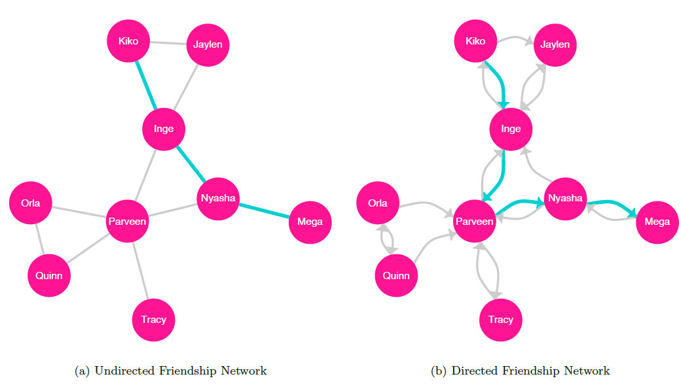
Sociograms for undirected (left) and directed (right) graphs with highlighted geodesics between Kiko and Mega

Graph Characteristics
Distance
There are many important concepts related to the traversal of a graph from one specific node to another. To traverse a graph from one node to another, we follow a path, a sequence of nodes connected by edges, spanning from an origin node to a destination node without repeating any nodes or edges (Wasserman and Faust 1994). For a directed graph, the path follows the direction of each edge. Note that for any pair of nodes in a network, there may exist multiple paths.
The path length is the number of edges in a given path between two nodes, and the shortest path between two given nodes is called their geodesic (Wasserman and Faust 1994). The sociograms in figure 10.5 highlight the geodesics between Kiko and Mega for both undirected and directed representations of the student friendship network.
The distance between any two nodes, also referred to as the geodesic distance is the length of their geodesic. For example, if nodes $A$ and $B$ are connected by an undirected tie, then their geodesic distance is $1$.
We can find the mean path length, also called the average path length or characteristic path length, by averaging the geodesic distances between all pairs of nodes in the graph (Watts and Strogatz 1998).
The diameter of a network is the maximum geodesic distance between any two vertices in the network (Wasserman and Faust 1994). Note that the path under evaluation is not necessarily the longest path between any two vertices, but the longest of the geodesic paths in the graph.
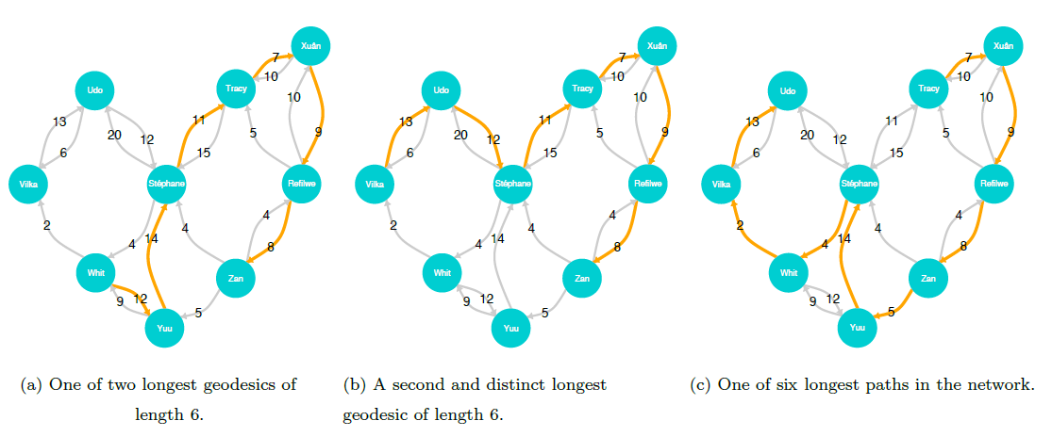
Sociograms for the two longest geodesics (left and center) in the directed weighted email correspondence network and one of the six longest paths (right). The path length of each of the geodesics is 6, meaning that the diameter of the graph is 6. Visiting each node only once, there are six longest paths, each of length 8. Note that because the graph is directed, the paths in each sociogram must follow the directions of the arrows
Subgraphs and Components
A network in which each node is directly connected to all the other nodes is called a complete graph (see figure 10.6; this is a special case of a geographic network, which we will describe later.
A graph in which each node can reach all other nodes via a path is called a connected graph (Wasserman and Faust 1994). The graphs shown in figures 10.1, 10.2, 10.3, 10.5, 10.6 are connected graphs. Note that while not every connected graph is a complete graph, all complete graphs are connected graphs.
If we take a subset of the nodes in a graph, including some or all of the edges among the subset of nodes (or, alternately, a subset of edges and all the nodes attached to those edges), the result, called a subgraph, is itself a graph (Wasserman and Faust 1994).
Wasserman and Faust (1994) define three main categories of subgraphs (based on the number of nodes they contain) with special names: isolates, dyads, and triads. An isolate is a single node that is not connected to any other nodes. A dyad is a subgraph of two nodes, either connected or not. A triad is a subgraph of three nodes; in an undirected graph, there may be zero and three edges among the nodes. Note that dyads and triads can include isolates.
If a subgraph is a connected graph—if every node is reachable from every other node—and there are no other nodes connected to the subgraph, then the subgraph is called a connected component. This means that a subgraph consisting of a single node—an isolate—is considered a connected component. Every graph has at least one connected component.
A disconnected graph is one in which at least one node is not reachable via a path from at least one other node (Wasserman and Faust 1994). An equivalent definition describes a disconnected network as one in which at least one connected component is not reachable from another. This means that a disconnected graph has at least two connected components. The network shown in figure 10.6 is a disconnected graph with three connected components.
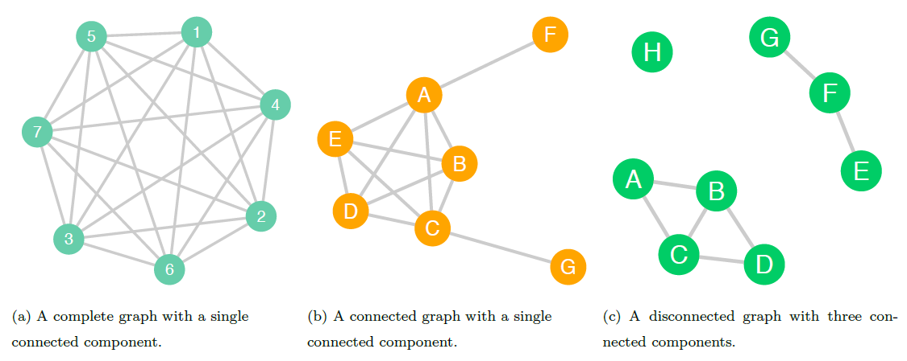
In the complete graph (left), each node is directly connected to all the other nodes; this graph is also a complete graph. In the connected graph in the center, each node is reachable from all other nodes in the graph. The disconnected graph (right) has three connected components; there is no way to get from some nodes to certain others

Node-specific Measures
Centrality
A node’s centrality can be used to gauge how important it is, for various conceptualizations of importance. There are many different measures of centrality; here, we will discuss three such measures: betweenness centrality, closeness centrality, and degree centrality.
Note that though these metrics can be computed for all nodes in a graph, they only make sense for nodes within a connected component; this is because the distance between nodes that are not connected is undefined. These node-specific measures are therefore only computed based on the other nodes in a given node’s connected component Recall, however, that a connected graph contains a single connected component in which each node is connected to all others.
Betweenness centrality. The betweenness centrality metric evaluates a given node’s ability to create connections between other nodes. According to Freeman, who formalized the definition of the metric, betweenness is important because “a vertex falling between two others can facilitate, block, distort, or falsify communication between the two; it can more or less completely control their communication” ((Freeman 1977, 36)). For a given target node, betweenness centrality is found by computing the sum, for all other pairs of nodes in the component, of the ratio of the number of geodesics between the pair of nodes that pass through the target node to the total number of geodesics between the pair of nodes (Freeman 1977). More formally, we can write the definition of betweenness for a node $v$ as:
$$Betweenness\left(v\right)=\sum_{i≠j≠v}^{n}{\frac{g_{ij}\left(v\right)}{g_{ij}}}$$
where $g_{ij}$ is the number of geodesics between node $i$ and node $j$, and $g_{ij}\left(v\right)$ is the number of such paths that pass through node $v$ (Freeman 1977). The graph below displays each node’s betweenness.
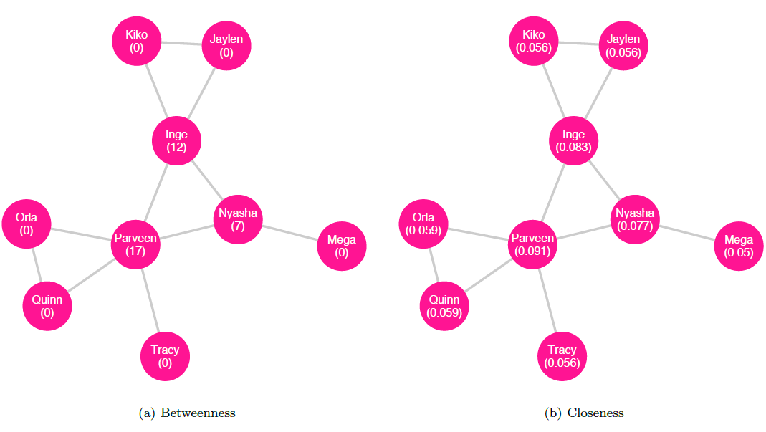
Betweenness (left) and closeness (right) for the undirected friendship network. Note that Parveen has the highest value for each measure
Closeness centrality. Closeness centrality measures how close a node is to others. For a given node in a connected component, closeness centrality is found by computing the reciprocal of the sum of all the distances between the given node and each other node in the component. We can write the definition of closeness for a node $v$ thus:
$$Closeness\left(v\right)=\frac{1}{\sum_{i≠v}^{n}{d}\left(v,i\right)}$$
where $d\left(v,i\right)$ is the geodesic distance between nodes $v$ and $i$ (Wasserman and Faust 1994). The network in figure 10.7 displays each node’s closeness centrality.
Degree centrality. A third measure of centrality is degree centrality, which considers important nodes to be those that have many neighbors. The degree of a vertex tells us its number of neighbors. To calculate the degree of a vertex in an undirected graph, we can simply count the number of edges it has (Wasserman and Faust 1994). Let us return to the example of an undirected friendship network among classmates as inferred by the teacher (shown in figure 10.8 with each node’s degree labeled); in this network, if Parveen is connected to Inge, Nyasha, Orla, Quinn, and Tracy, then Parveen has a degree of $5$.
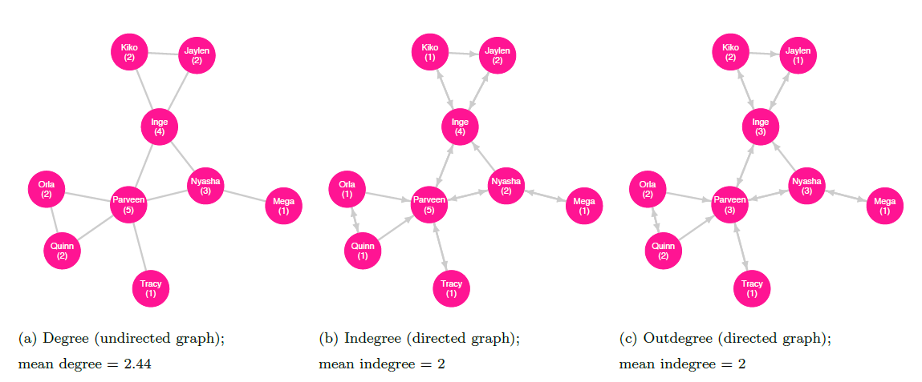
Degree as measured in undirected (left) and directed (indegree, center; and outdegree, right) networks
For a directed graph, a node’s indegree is the number of edges terminating there; the outdegree is the number of edges originating from the node (Wasserman and Faust 1994). As an example, we can consider the directed friendship network as described by the students (shown with indegree and outdegree labeled in figures 10.8 and 10.9, respectively). In this network, the students Inge, Nyasha, Orla, Quinn, and Tracy consider Parveen to be a friend, so Parveen has an indegree of $5$. Parveen, in turn, considers only Inge, Nyasha, and Tracy to be friends and so has an outdegree of $3$.
A network’s degree distribution describes the probability of a given node in the graph having a degree of a certain value. In practical terms, we can think of it as a set of numbers, where each reflects the count of nodes in the graph with degree of $0$, degree of $1$, degree of $2$, and so on. The degree distribution for the undirected friendship network is displayed in figure 10.9. The concept of degree distribution will be important later when we discuss power-law networks.
The mean degree of a graph is the mean average of the degrees for all the vertices in the entire graph (Wasserman and Faust 1994). For example, if an undirected network has four nodes with degrees $\left[1,1,2,2\right]$, then the mean degree for the network is $1.5$. If a directed graph has five nodes with indegrees $\left[0,1,3,3,3\right]$, and outdegrees $\left[1,2,2,2,3\right]$, then the mean of the indegrees is $2$ and the mean of the outdegrees is also $2$; note that these are equal because every edge extending from some node points to another (Wasserman and Faust 1994).
Clustering
In order to evaluate clustering within a network, we must first introduce the notion of a triple, sometimes called a triplet, which is a connected component with three nodes—that is, it’s a triad with at least two edges. If a triple forms a complete graph—that is, if each node is connected to both the others—then it is a closed triple, also known as a triangle; otherwise, one pair of nodes in the triple are not adjacent so it is an open triple. An ordered triple is one for which the vertex order is a characteristic of the triple; for example, if the vertices $\left[A,B,C\right]$ form a triangle, the ordered triples $ABC$, $ACB$, $BAC$, $BCA$, $CAB$, and $CBA$ are each distinct—but note that the triangles formed by each triple are all the same.
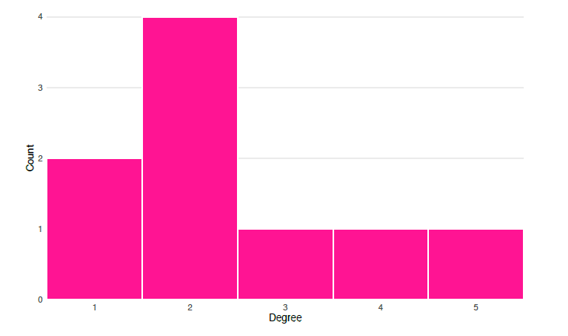
A histogram of the degree distribution for the undirected friendship network shows that there are two nodes with degree $1$, four with degree $2$, and one each with degrees $3$, $4$, or $5$
For our purposes, we will assume that all edges are undirected when considering triples, triangles, and clustering. Note that in many applications outside the scope of this chapter, this assumption will not hold.
We can now define, for any given node, its local clustering coefficient (also called the local transitivity) by taking the fraction of the pairs of the node’s neighbors that are in turn neighbors with one another—that is, the number of triangles including the node divided by the number of possible triangles (Watts and Strogatz 1998; Opsahl 2013). An equivalent definition given in Saramäki et al. ((Saramäki et al. 2007)) is to compute the ratio of twice the number of triangles that include the given node to the product of the node’s degree and one less than its degree:
$$Transitivity_{local}\left(v\right)=\frac{2×t_{v}}{degree\left(v\right)×\left(degree\left(v\right)−1\right)}$$
where $t_{v}$ is the number of triangles that include node $v$. (Note that for nodes with degree of 1, this results in a zero in the denominator, which means that local transitivity is undefined for such nodes. However, for the purposes of computing the average local clustering coefficient, these undefined values can be replaced with $0$.) This metric measures cohesion among a given vertex and its neighbors (Barrat et al. 2004). The local transitivity for nodes in the undirected friendship network is shown in figure 10.10 (with undefined values replaced with $0$).
We can compute the average local clustering coefficient for a graph $g$ by taking the mean across all nodes:
$$AverageLocalTransitivity\left(g\right)=\frac{\sum_{i=1}^{N}{T}ransitivity_{local}\left(n_{i}\right)}{N}$$
where $n_{i}$ represents a node identified by its index and $N$ is the number of nodes in the entire network (Barrat et al. 2004). According to Barrat et al. (2004), this measure “expresses the statistical level of cohesiveness measuring the global density of interconnected vertex triples in the network” (Barrat et al. 2004, 3750).
Finally, to calculate the global clustering coefficient, also called the global transitivity, for a graph $g$, we take the ratio of thrice the number of triangles to the number of all ordered triples—both closed and open—in the graph:
$$Transitivity_{global}\left(g\right)=\frac{3×Triangles\left(g\right)}{Triples_{ordered}\left(g\right)}$$
where $Triangles\left(g\right)$ is the total number of triangles in graph $g$ and $Triples_{ordered}\left(g\right)$ is the total number of ordered triples in $g$ (Opsahl 2013).
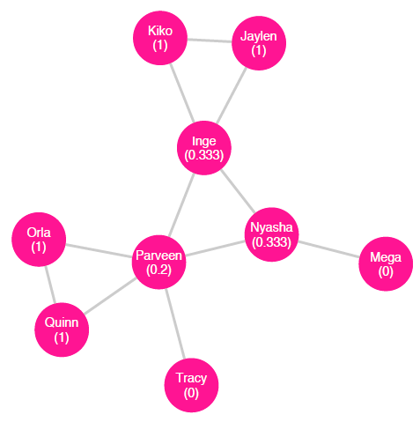
Local transitivity for the undirected friendship network (with global transitivity = $0.3913$ and average local transitivity = $0.5407$)
Density
The density of a network is the ratio of the number of edges it contains to the number of possible edges. For example, in a network of seven nodes, the number of possible edges is found by the combination $7C_{2}=\frac{7!}{2!\left(7−2\right)!}=21$. If there exist $12$ edges among the nodes, then the density of the network is $\frac{12}{21}=.57$ or $57\%$.

Special Graphs
Geographic Networks
A geographic network is one in which each node is connected to the k nearest nodes, with k ranging from $1$ to the total number of nodes in the network minus $1$. If k takes on the maximum value—that is, if each node is connected to all the other nodes—then the network is called a complete graph. figure 10.11 shows a geographic network with $k=4$.
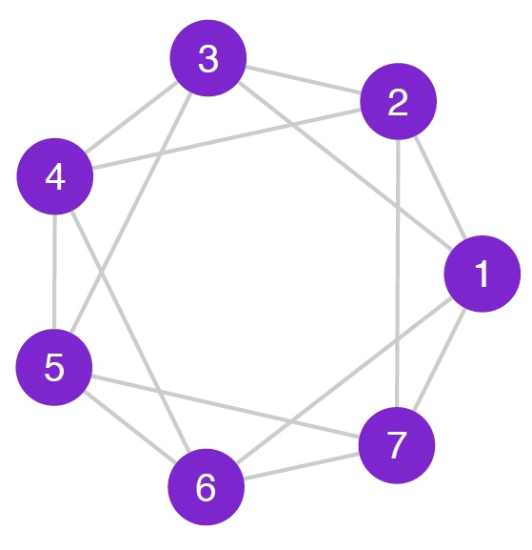
A geographic network with $k=4$. Each node is connected to its four closest neighbors
Random Networks
A random network is one in which, for each pair of nodes, there is a probability $p$ that there is an edge between them. This probability is a constant for the entire graph and can range from $0$ to $1$. The sociogram in figure 10.12 shows a random graph of $15$ nodes and probability $p=0.2$.
Small-World Networks
The small-world phenomenon describes the idea that in a large population, most people are connected to each other by relatively short chains of acquaintances. In a series of widely known experiments conducted within the United States, Milgram and Travers asked arbitrarily chosen participants to attempt to make contact with a specific target person by mailing or delivering a provided document to someone the participant knew on a first-name basis who was more likely to be personally acquainted with the target person; their findings in one experiment showed that among successful contacts, the average number of intermediaries between the initial participants and the target person was $5.2$ (Milgram 1967; Milgram and Travers 1969). Dodds, Muhamad, and Watts (2003) conducted an international email study in a similar vein, finding that successful contacts were transmitted across an average chain length of $4.05$ steps.; when accounting for attrition, they found a median chain length of $7$ steps.
These experiments show that the small-world hypothesis appears to be consistent with society at large: in just a few degrees of separation, one’s network of friends of friends grows very large.
Small-world networks exhibit two key characteristics: (1) the mean local clustering coefficient is high—that is, on average, a node’s neighbors are highly connected to each other (Watts and Strogatz 1998); and (2) the mean geodesic distance is low—that is, on average, the distance between nodes is short(Watts and Strogatz 1998). Given high average clustering, we might expect such networks to be dense, but in fact, they tend to have relatively few edges (Takes and Kosters 2011). Because they have a small mean path length, the diameter—the largest geodesic distance between any two nodes—is “exponentially smaller than the size of the network” (Kleinberg 2000, 845).
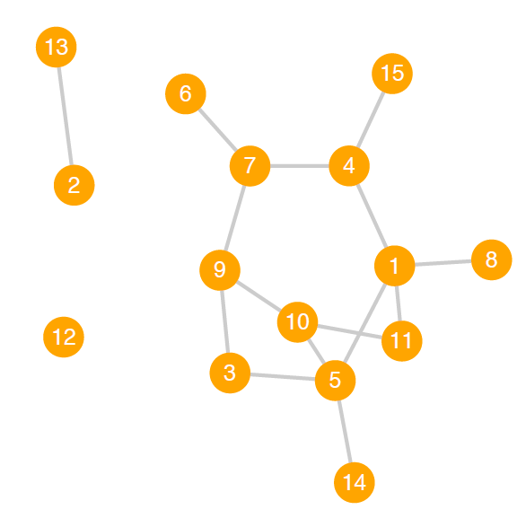
A random network with N = 15 and p = 0:2
The combination of these features results in a network through which information, preferences, and other conditions (such as infectious disease) can diffuse quickly (Watts and Strogatz 1998).
Figure 10.13 shows two representations of the same small-world network, one with a diameter of $4$, mean degree centrality of $3.1$ and a global clustering coefficient of $0.155$.
Power-Law Networks
A power-law function is a relationship between two variables, $x$ and $y$, of the form $y=cx^{a}$, where $a$ and $c$ are constants. This equation models $y$ as proportional to $x^{a}$; as $x$ changes, $y$ changes equal to the scale of $x^{a}$, which is $c$. The exponent $a$ can be any real number (though $a=0$ yields a horizontal line and $a=1$ yields a diagonal line).
Power-law networks are those in which the degree distribution approximates a special case of the power-law function where the scale constant $c=1$ (thus why such networks are sometimes called scale-free networks) and the exponent is negative: $P\left(x\right)=x^{−a}$. In power-law graphs, the degree distribution shows a large number of low-degree nodes (on the left side of the distribution) and a small number of nodes with very high degree (on the right side of the distribution). As Kadushin notes, for social networks following a power-law distribution, the exponent $a$ “generally lies between $2$ and $3$” ((Kadushin 2012, 114)).
Scientific studies across a variety of disciplines have indicated that power-law networks abound; Newman, for instance, comments on the “ubiquity of power-law behaviour in the natural world” (Newman 2005). In new research, however, Broido and Clauset challenge the general belief that power-law networks are as widespread as many have claimed, finding specifically that “social networks are at best weakly scale free, and although a power-law distribution can be a statistically plausible model for these networks, it is often not a better model than a non-scale-free distribution” ((Broido and Clauset 2019)).
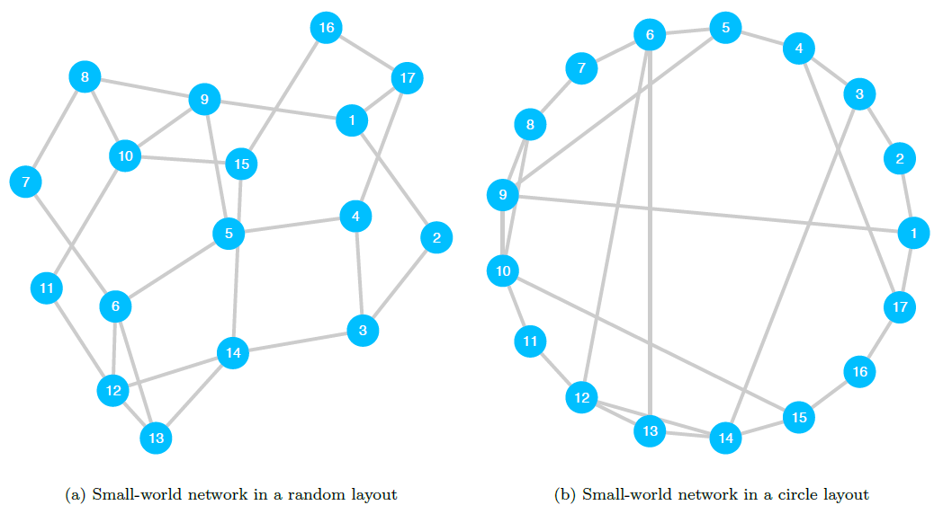
Sociograms of a single small-world network with N = 17 nodes. This graph has a diameter of 4, mean degree centrality of 3:1 and a global clustering coefficient of 0:155

Applications of Social Network Analysis
Here we describe in detail two studies of social networks in the domain of political science.

Detecting Political Homophily on Twitter
(Colleoni, Rozza, and Arvidsson 2014) analyze the networks of Twitter users in an effort to measure homophily—the extent to which nodes are linked to others with which they share a given characteristic—among Democrats compared to that among Republicans. Their primary research question (p. 317) focuses on the nature of online social news platforms: do these provide their users access to diverse political discourse (the public sphere scenario), or are they more likely to insulate users from others with differing political orientations (the echo chamber scenario)?
The authors implement a machine learning algorithm for an introduction to machine learning methods) to label a set of Twitter users (the egos) by their political leaning based on the content of their politically oriented tweets. Using the same classification method, they identify the egos’ neighbors based on outgoing ties—the users whom the ego follows on Twitter (the alters)—as either Democrats or Republicans (with alters found to be non-political excluded). The result is a directed ego network around each ego, with alters labeled according to their own political leaning.
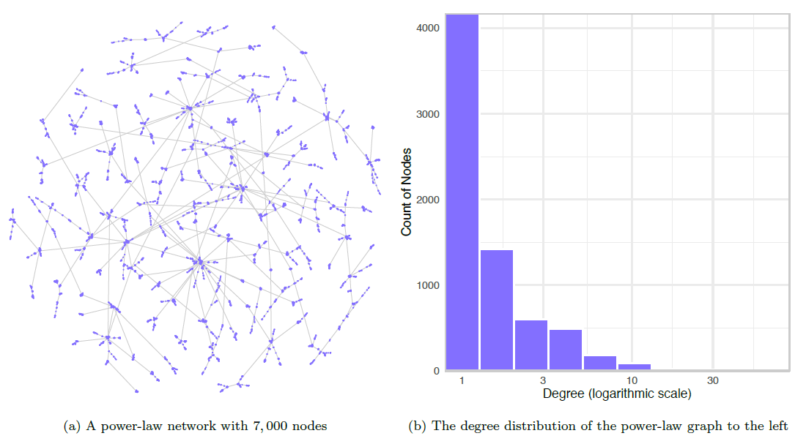
A sociogram and histogram of the corresponding degree distribution for a power-law network
Next, the researchers calculate each ego’s homophily thus: “the homophily rate is defined as the number of outbound ties directed to alters who share political orientation, divided by the overall number of outbound ties (i.e., directed to alters with similar political orientation plus directed to alters with different political orientation)” (Colleoni, Rozza, and Arvidsson 2014, 324). We can write their equation for homophily as:
$$homophily\left(ego_{i}\right)=\frac{alters_{i.s}}{alters_{i.t}}$$
where $alters_{i.s}$ is, for ego $i$, the number of alters with the same political orientation and $alters_{i.t}$ is the total number of politically oriented alters. Higher values of homophily (that is, greater than $0.5$) mean that a given ego is connected to a greater proportion of alters who share the ego’s political orientation compared to the proportion of alters with the other orientation.
Finally, the authors create two subgraphs: the first is a network of egos and their reciprocal alters (that is, the alters who also follow the ego); this graph represents Twitter as a social platform in which users form reciprocal relationships with other users. The second is a network of egos and their asymmetric ties (that is, the alters who do not follow the ego); this graph represents Twitter as a news platform in which egos follow accounts that disseminate information, while those accounts do not form a relationship with the ego (Colleoni et al. (Colleoni, Rozza, and Arvidsson 2014, 320–21)).
With regard to their main research question—is Twitter a public sphere or echo chamber?—the authors find that the results are contingent on whether Twitter is conceptualized as a social or news platform: “If we look at Twitter as a social medium we see higher levels of homophily and a more echo chamber-like structure of communication. But if we instead focus on Twitter as a news medium, looking at information diffusion regardless of social ties, we see lower levels of homophily and a more public sphere-like scenario” (Colleoni, Rozza, and Arvidsson 2014, 328). This means that the subgraph of reciprocal ties exhibits higher levels of users who are mutually connected to other users sharing their political ideology. The subgraph of asymmetric ties instead exhibits lower levels of homophily, indicating that users are being exposed to diverse political news and opinions.

Measuring the Effect of Centrality on Advocacy Output in a Network of Transnational Human Rights Organizations
(Murdie 2014) explores a network of transnational human rights organizations to assess whether an organization’s position in the network affects their level of political activity. The primary research question is whether an organization’s influence score affects its advocacy output. The author hypothesizes that organizations with high influence scores will engage in more advocacy events.
Murdie constructs a directed network based on inter-organization relationships self-reported by the human rights organizations themselves. She then computes each organization’s influence score, operationalized by a centrality metric called eigenvector centrality. (Briefly, eigenvalue centrality indicates the extent to which a node has many connections to other nodes which themselves have many connections; higher values for eigenvector centrality suggest that a given node wields higher levels of influence over its connections.) The outcome variable is the count of each organization’s advocacy events; one example of an advocacy event is participating in an official meeting with government officials ((Murdie 2014, 18).
Consistent with the author’s hypothesis, the results show that higher centrality scores are associated with greater levels of advocacy. Additionally, the findings indicate that free riders, those organizations that self-report many ties to others but are not in turn reported as connections by other organizations, are associated with somewhat lower levels of advocacy output. Murdie concludes that attempts to foster connections between organizations, particularly between those in the Global South as well as between those in the Global South and the Global North, could yield higher levels of advocacy output and further the organizations’ missions.

Advantages of Social Network Analysis
To discuss the purposes and advantages of social network analysis, we must first describe the different forms it can take. In that vein, Guille et al. (2013) propose a taxonomy of three general categories of social network analysis: identifying “bursty topics”, those that attract “bursts of interest” over a specific range of time; modeling the spread of information, opinions, behavior, or conditions through a network; finding nodes that effectively propagate such information, opinions, or conditions ((Guille et al. 2013, 19, 20, and 24, respectively)). Here, we use the example of the temporally bounded spread of politically oriented misinformation (sometimes called fake news or alternative facts) as a vehicle to explain the advantages of research within each category.
The first category, detecting topics that spike in interest over a given range of time, can be useful for identifying matters of concern to a population. These concerns, of course, could include those based on misinformation, and pinpointing such themes may well be critical to explaining—or even predicting—which topics surge in interest, when, and why. In a similar vein, modeling diffusion through a network—the second category of social network analysis—could inform both inference and forecasting with regard to where and how bursty topics emerge and propagate. In the last category, research focuses on identifying who effectively spreads misinformation, as well as their characteristics and position in the network.
Integrating misinformation research from all three categories could inform efforts to highlight the scope and focus of misinformation, prevent its emergence, or even combat its spread. These goals are especially salient given the proliferation of online bots, which, as Ferrara et al. (2016) describe in their review, can and have been used, either negligently or intentionally maliciously, to diffuse information—and misinformation—about politically oriented topics and in other critical arenas.
The ability to detect topics that spike in interest over a given range of time, combined with models that explain or predict (Ferrara et al. 2016) the diffusion of interest in such topics, could inform the study of fake news. As Ferrara et al. (2016) describe in their review, this is especially salient given that online bots can and have been used, either negligently or intentionally maliciously, to propagate information—and misinformation—about politically oriented topics and in other critical arenas. Scholarship in this area could inform efforts to prevent or combat the spread of such misinformation.

Disadvantages of Social Network Analysis
The benefits notwithstanding, social network analysis is not without its drawbacks. One critical area of concern is with the ethics of research on the widespread relations among a population. Consider, for example, the case of the now-infamous Tastes, Ties, and Time (T3) study (Lewis et al. 2008), which was conducted from 2006 to 2009 (Zimmer 2010).
In this study, T3 researchers accessed the private Facebook profiles of nearly all the students in the 2005 freshman class enrolled in a specific American university (Zimmer 2010), all of whom were members of a Facebook group for their class cohort (Parry 2011). Without the students’ knowledge or informed consent, the team collected data about users’ media preferences (such as music and literature) and friendship ties, once a year for four years, and analyzed changes in the students’ tastes and network ties over time (Zimmer 2010). Researchers then released an ostensibly de-identified version of the dataset as well as its accompanying codebook; these contained individual and aggregate information, respectively. Without even accessing the dataset, Zimmer (2008)—who was unaffiliated with the study—quickly identified the university in question as Harvard College, increasing public concern that individual students in the dataset could also be uniquely identified.
The research project placed its subjects at risk of being publicly identified and, perhaps most critically, linked to their preferences, some or all of which may only have been accessible via the private portion of their Facebook profile. At least one student has been identified and even named (Parry 2011). Such identification could put students at risk of further harm, depending on each student’s individual situation: if, for example, a given student’s preference for queer literature became known to their disapproving family, there could exist the potential for interpersonal tensions, restrictions on financial or other support, or, in an extreme case, bodily harm or even death.
At the very least, the fallout from T3 calls into question data de-identification practices as well as the expectation that any such method could be infallible. Ultimately, the study highlights the need for careful and ethical decision-making when planning, executing, and reporting on social network analyses.

Broader Significance of Social Network Analysis in Political Science
Studies in political science that employ social network analysis methods exist in a variety of forms; here we will consider three classes of studies, each categorized according to the level represented by its network’s nodes. Note, however, that these three classes are by no means exhaustive.
Perhaps most intuitively, nodes in social network analyses may represent individual persons. Some such studies focus on the effects a network may have on its members; Gidengil and Stolle (2009, see, for example,) on the effect of networks and their embedded resources on the political incorporation of immigrant women in Canada. Others consider how individual members influence the nature of the network itself, such as in the aforementioned Colleoni, Rozza, and Arvidsson (2014) Twitter study.
In another class of studies, nodes represent organizations. These may be transnational human rights organizations, as in Murdie’s ((Murdie 2014)) investigation, mentioned in an earlier section. Another is Fowler et al.’s ((Fowler, Grofman, and Masuoka 2007)) evaluation of job placement in a network of university political science departments across the United States.
A third class of inquiry focuses on intergovernmental relations in which nodes represent nation-states. Alcañiz’s ((Alcañiz 2010)) analysis of trans-governmental scientific collaboration among Latin American countries falls into this group.

Conclusion
Social networks exist nearly everywhere that social entities exist. We can analyze these networks to learn about their structure and processes, as well as about the characteristics of their members and the relationships between and among actors. This growing field of inquiry will continue to contribute to political science.
Technological innovations, in particular, have broadened the means by which we generate and manage social network data: in addition to traditional methods, we can now collect or access data with online surveys; from repositories containing datasets automatically produced by computational routines; as well as by combing through administrative, cultural, genealogical, historical, and other records stored in digital archives. Through these avenues, diverse datasets of increasing sizes are becoming more readily available to a larger audience of researchers. Political scientists and other scholars in the social sciences can ask an expanding range of research questions about social networks, and study these networks with an evolving body of methods.
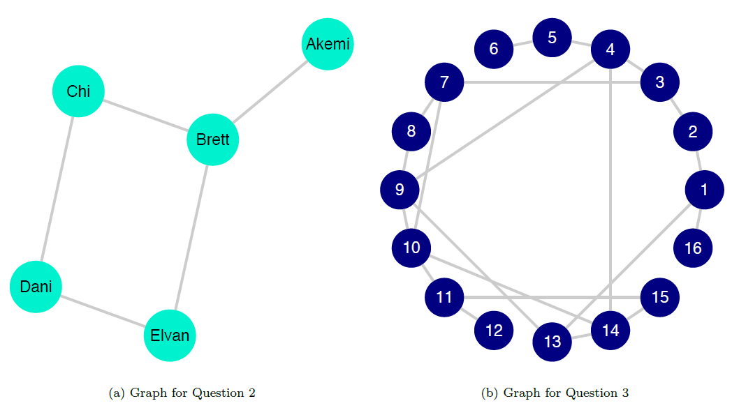
Sociograms for Questions 2 (left) and 3 (right)
Social network analysis has the potential to refine our interpretations of social relations and processes in the domain of political science. We can use it to confirm or challenge hypotheses; we can sharpen or complicate how we understand actors and relationships. By synthesizing established or contentious knowledge with new insight, we can develop political theory, thought, and practice—as well as advance political and social agendas.

Application Questions
- Which of the networks listed in [section 11.2.1] are examples of social networks?
- Using the graph in figure 10.15, compute the following:
  - The betweenness centrality for Akemi and for Dani
  - The closeness centrality for Brett and for Elvan
  - The degree centrality for each node
  - The network’s density
- Consider the graph in figure 10.15:
  - Is this an undirected or directed graph? How can you tell?
  - Is this a weighted or unweighted graph? How can you tell?
  - What is the minimum degree for this network? Which node or nodes have this degree?
  - What is the maximum degree? Which node or nodes have this degree?
  - Trace the geodesic between nodes $1$ and $7$. What is its length? What is this measure called?
  - Is the network depicted most likely to be a geographic network, a small-world network, a power-law network, or a random network with $p=.7$?

Key Terms
- adjacency matrix
- betweenness centrality
- centrality
- closed triple
- closeness centrality
- complete graph
- connected component
- connected graph
- degree centrality
- degree distribution
- diameter
- directed graph
- directed tie
- disconnected graph
- distance
- dyad
- edge
- geographic network
- indegree
- isolate
- local clustering coefficient
- matrix
- mean degree
- mean path length
- neighbors
- network
- network density
- node
- open triple
- ordered triple
- outdegree
- path
- path length
- power-law network
- random network
- small-world network
- social network
- social network analysis
- subgraph
- tie
- triad
- triangle
- triple
- triplet
- undirected graph
- undirected tie
- unweighted graph
- vertex
- weighted graph

Answers to Application Questions
- The following are examples of social networks: The genealogical history of the Japanese royal family; email correspondence between workers in a corporation; mentorship and advising among political scientists in academia; and advice-seeking relationships among all current federal circuit judges in the United States
- Using the graph in figure 10.5, we find the following:
  - Betweenness centrality:
    - Akemi: $0$
    - Dani: $0.5$
  - Closeness centrality:
    - Brett: $0.2$
    - Elvan: $0.167$
  - Degree centrality:
    - Akemi: $1$
    - Brett: $3$
    - Chi: $2$
    - Dani: $2$
    - Elvan: $2$
  - Network density: $0.5$
- Considering the graph in figure 10.15:
  - This is an undirected network. The edges do not have arrows to indicate asymmetric relationships, so they must be undirected.
  - This graph is unweighted. There are no weights associated with any of the edges, so it must be unweighted.
  - The minimum degree is $1$ and nodes $6$, $12$, and $16$ have a degree of $1$.
  - The maximum degree is $4$ and nodes $4$, $9$, $10$, and $14$ have a degree of $4$.
  - See figure 10.16 for the highlighted path. The geodesic, or shortest path, between nodes $1$ and $7$ is $\left[1,2,3,7\right]$ and has a path length of $3$. This metric is called the geodesic distance or simply the distance.
  - This network is most likely to be a small-world network because it has a large proportion of nodes with average degree centrality, and smaller proportions of nodes with low or high degree centrality. Furthermore: It can’t be a geographic network because degree centrality varies by node. It is not likely to be a power-law network because it has several nodes of the maximum degree (also, it’s unlikely that a graph with only sixteen nodes could follow a power-law distribution). It is not likely to be a random network with $p=.7$ because that would imply that approximately $70\%$ of pairs of nodes would be connected, which would, in turn, imply an average degree centrality of $p×N=.7×16=10.5$; we know, however, that the mean degree is much lower than that as the maximum degree is $4$.
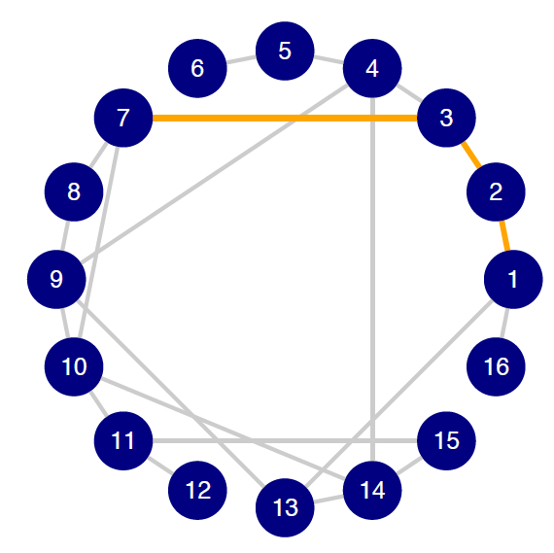
Highlighted geodesic between 1 and 7

Machine Learning
By John J. Lee

Introduction
These days, references to machine learning are almost ubiquitous. If you follow the news, you have probably heard that machine learning is used in a wide range of contexts: e.g., to detect fraudulent transactions, predict stock prices, perform facial recognition, customize search results, and even guide self-driving cars. But what exactly is machine learning? Machine learning is often conflated with related concepts including artificial intelligence, automation, and statistical computing. Part of this confusion and ambiguity is due to the reality that even among relevant experts in statistics and computer science, there is no single “correct” definition of machine learning. However, there are two well-known formal definitions. Both definitions were cited by Andrew Ng (Ng, n.d.), in his highly popular Stanford course on machine learning (available through Coursera).
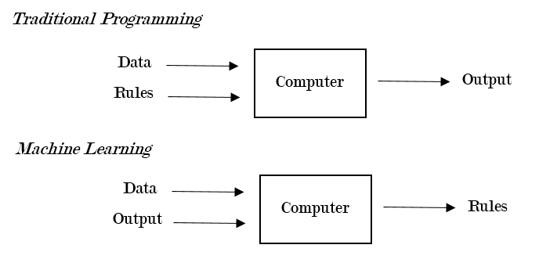
Traditional Programming v. Machine Learning
The first definition is by Arthur Samuel, a former researcher at IBM and early pioneer in machine learning. In his view, machine learning is a “field of study that gives computers the ability to learn without being explicitly programmed.” This definition is useful because it alludes to a central distinction between traditional programming and machine learning: i.e., in traditional programming, a computer takes in the data and the rules and generates the output; in machine learning, a computer takes the data and the output and generates the rules that describe the relationship between the input and the output. Figure 11.1 provides an illustration of this idea.
The second definition is more detailed and precise. According to Tom Mitchell, a computer scientist at Carnegie Mellon and the author of one of the first textbooks on machine learning: “A computer program is said to learn from experience E with respect to some task T and some performance measure P, if its performance on T, as measured by P, improves with experience E.” (Mitchell 1997). From the second definition, we can get a better sense of what machine learning generally entails: i.e., a computer gradually becomes better at performing a specific task (“what”) through experience (“how”); moreover, the computer’s performance is measured using some metric, which allows us to test whether performance has indeed improved over time. In this chapter, I will provide an overview of how machine learning methods work in practice and review some examples of how political scientists have used these methods in their research. Before proceeding, it is necessary to first explain several fundamental concepts in machine learning (for a more detailed treatment of this subject, see Hastie, Tibshirani, and Friedman 2017; James et al. 2013)

Background

A Brief Note on Notation
Capital letters refer to variables: e.g., $Y$ refers to the outcome variable, such as vote choice. Lower-case letters refer to the observed value of the variable for a specific observation (or subject), denoted by the first subscript: e.g., $y_{1}$ refers to the value of the outcome variable for the first observation. The subscript of a capital $X$ refers to the number of the predictor or explanatory variable: e.g., $X_{1}$ refers to the first predictor, $X_{2}$ refers to the second predictor, and so on. In addition, $x_{ij}$ refers to the observed value of the $j$th predictor for the $i$th observation. The ^ symbol indicates that we are referring to the predicted version or value of an object: e.g., $\hat{f}\left(.\right)$ refers to an estimated function, $\hat{Y}$ refers to the predicted value of the outcome variable.

The Structure of Prediction Error
Machine learning practitioners often talk about the best ways to $"$minimize the mean squared error$"$ or $"$optimize the bias-variance tradeoff.$"$ To understand how machine learning works, it is very important to understand the structure of prediction error. To illustrate, we can start with a simple example of a regression type problem with a quantitative outcome. Let $Y$ be a 0-100 point feeling thermometer that measures attitudes toward the U.S. president, with 0 being very unfavorable and 100 being very favorable. Assume we are predicting $Y$ using two predictors: ideology ($X_{1}$) and income ($X_{2}$). Formally, we can represent the relationship between $X_{1}$, $X_{2}$, and $Y$ in the following way:
$$Y=f\left(X_{1},X_{2}\right)+ϵ$$
In the equation above, $f\left(.\right)$ is also known as the target function, which represents the true systematic (i.e., non-random) part of the relationship between the two predictors ($X_{1}$, $X_{2}$) and the outcome $Y$. On the other hand, $ϵ$ is the random error term, which is assumed to be independent of the predictors and have a mean of zero. In reality, of course, we do not know $f\left(.\right)$, so we have to estimate it using the data. Estimating the true function means that we are estimating the model’s parameters (e.g., the coefficients in a linear regression) or structure (e.g., the shape of a regression tree). For example, suppose we have a dataset (e.g., $n$ observations) with the actual value of $Y$, $X_{1}$, and $X_{2}$ for each observation: $\{\left(y_{1},x_{11},x_{12}\right),...,\left(y_{n},x_{n1},x_{n2}\right)\}$. Next, we will split the dataset into at least two parts, so that we can estimate $f\left(.\right)$ using one subset of the data (typically called the training set), and then evaluate the prediction error using the second subset of the data (typically called the test set).
Many machine learning algorithms are designed to estimate (or $"$fit$"$) a model that minimizes the expected prediction error (EPE), defined as the long-run average difference between the predicted and $"$true$"$ (i.e., observed) values of the outcome variable. That is, the goal is to identify $f\left(.\right)$ such that $f\left(X_{1},X_{2}\right)$ is on average as close to $Y$ as possible. How can we measure EPE in practice? When the outcome is a quantitative variable, the algorithms are often designed to minimize the mean squared error (MSE): i.e., the average of the squared difference between $\hat{Y}$ and $Y$. The intuition here is that when the absolute difference between the predicted and observed values of the outcome variable is generally small, MSE will also be small.
$$MSE=\frac{1}{n}\sum_{i=1}^{n}{{\left(y_{i}−\hat{f}\left(x_{i1},x_{i2}\right)\right)}^{2}}$$
Assuming we have split the original dataset into the training set and test set, we can compute two different types of MSE: training MSE and test MSE. In both cases, we first fit $\hat{f}\left(.\right)$ using the training set. The difference, which is fundamental to machine learning, is the following: the training MSE (or training error, more generally) is then computed using the data from the training set, which contains the same data used to fit $\hat{f}\left(.\right)$. In contrast, the test MSE (or test error) is computed using the test set, which was not used to fit $\hat{f}\left(.\right)$.
Recall that we randomly assigned the observations in the original full dataset to the training and test sets. Thus, the two datasets are comparable: i.e., the true relationship between the set of predictors ($X_{1},X_{2}$) and $Y$ should be the same in both datasets. However, the two datasets are also not identical; these minor, non-systematic differences are due to random noise, which are represented by the $ϵ$ in Eq. 1. Given this context, it should be clear why we want to minimize test MSE instead of training MSE.
If we attempt to minimize training MSE, the algorithms are more likely to estimate highly flexible models that try to touch every data point in the feature space of the training dataset. This might initially sound nice, but it means that the model is overfitting to the training set: i.e., the model is attempting to capture both the real patterns due to the true $f\left(.\right)$, as well as the observed but spurious deviations from $f\left(.\right)$ that are due to the random noise ($ϵ$). The problem here is that this kind of highly flexible model tends to generate a lower training MSE, but performs poorly on the test set—which has the same underlying patterns due to $f\left(.\right)$, but different observed deviations from $f\left(.\right)$ because of $ϵ$. Figure 11.2 provides an illustration of this idea. In this example, the true relationship between $X_{1}$ and $Y$ is linear (see the graph in the middle); we know this for certain because these data were simulated.
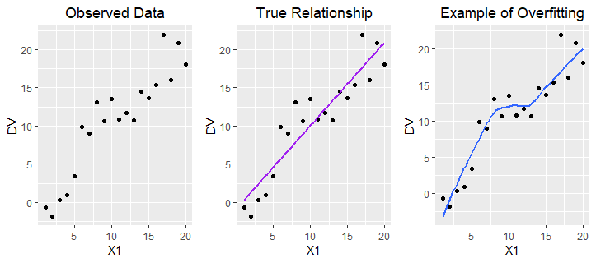
Modeling True Relationship v. Overfitting
Thus, it is a better idea to try and minimize test error. In order to generate a smaller test error, the algorithms need to estimate a model that is generalizable. That is, they need to estimate models that do a better job of capturing the true relationship between the set of predictors ($X_{1},X_{2}$) and the $Y$, while ignoring the random observed deviations from the $f\left(.\right)$ due to $ϵ$ (per Equation 1). Machine learning practitioners often refer to this approach as $"$focusing on the signal and ignoring the noise.$"$
Check-in Question 1: What is overfitting and how can we reduce this problem?
So how do we reduce the test error? The expected difference between $\hat{f}\left(X_{1},X_{2}\right)$ and $Y$ is due to two types of error (e.g., see James et al. 2013): (1) reducible error, (2) irreducible error. The first type of error is caused by a suboptimal estimate of the true function: i.e., the gap between $\hat{f}\left(.\right)$ and $f\left(.\right)$. As its name implies, the reducible error decreases as $\hat{f}\left(.\right)$ approaches $f\left(.\right)$. On the other hand, irreducible error is due to $ϵ$, and therefore it cannot be reduced by improving the quality of $\hat{f}\left(.\right)$. For example, let us assume that $\hat{f}\left(.\right)=f\left(.\right)$, and therefore $\hat{Y}=\hat{f}\left(X_{1}+X_{2}\right)=f\left(X_{1}+X_{2}\right)$. Even in this case, $\hat{Y}$ does not necessarily equal $Y$, because $Y=f\left(X_{1},X_{2}\right)+ϵ$. That is, even having a perfect estimate of $f\left(.\right)$ does not make the random error term go away.
Can we reduce $ϵ$? The random error term represents omitted variables as well as truly random noise. If there are variables that are both useful predictors of $Y$ and also largely independent of the existing predictors ($X_{1},X_{2}$), then by adding them into the model we can reduce $ϵ$. On the other hand, some of the $ϵ$ is ultimately due to random noise, and this component of $ϵ$ cannot be eliminated: e.g., perhaps some of the subjects felt particularly well/poorly the day they were surveyed, which affected how they responded to the survey questions.
To formally decompose the expected test error into its reducible and irreducible components, we can use the expected value (or long-run average) of the squared difference between $\hat{Y}$ and $Y$. The following proof requires knowledge of statistical theory (Larsen and Marx 2017; Rice 2007) and some basic algebra. To simplify the notation, let $X=X_{1}+X_{2}$.
$$E\left[{\left(Y−\hat{Y}\right)}^{2}\right]=E\left[{\left(f\left(X\right)+ϵ−\hat{f}\left(X\right)\right)}^{2}\right]$$
$$=E\left[{\left(\left(f\left(X\right)−\hat{f}\left(X\right)\right)+ϵ\right)}^{2}\right]$$
$$=E\left[{\left(f\left(X\right)−\hat{f}\left(X\right)\right)}^{2}+2ϵ\left(f\left(X\right)−\hat{f}\left(X\right)\right)+ϵ^{2}\right]$$
$$=E\left[{\left(f\left(X\right)−\hat{f}\left(X\right)\right)}^{2}\right]+E\left[2ϵ\left(f\left(X\right)−\hat{f}\left(X\right)\right)\right]+E\left(ϵ^{2}\right)$$
$$=E\left[{\left(f\left(X\right)−\hat{f}\left(X\right)\right)}^{2}\right]+Var\left(ϵ\right)$$
The first term, or the expected squared difference between $\hat{f}\left(X\right)$ and $f\left(X\right)$, represents the reducible error. The second term, $Var\left(ϵ\right)$, represents the irreducible error. Although a full proof is beyond the scope of this chapter, note that we can further decompose the reducible error into squared bias and variance.
$$E\left[{\left(f\left(X\right)−\hat{f}\left(X\right)\right)}^{2}\right]={\left[E\left(\hat{f}\left(X\right)\right)−f\left(X\right)\right]}^{2}+E\left[{\left(\hat{f}\left(X\right)−E\left(\hat{f}\left(X\right)\right)\right)}^{2}\right]$$
$$={\left[Bias\left(\hat{f}\left(X\right)\right)\right]}^{2}+Var\left(\hat{f}\left(X\right)\right)$$
In sum, the expected test error (or expected prediction error, EPE) is a function of three specific quantities: the bias of $\hat{f}\left(X\right)$, which indicates the gap between $\hat{f}\left(.\right)$ and $f\left(.\right)$; the variance of $\hat{f}\left(X\right)$, which indicates how much $\hat{f}\left(.\right)$ fluctuates depending on the training data; and $Var\left(ϵ\right)$, which is a measure of the non-systematic random noise in the data.
$$EPE=E\left[{\left(Y−\hat{Y}\right)}^{2}\right]={\left[Bias\left(\hat{f}\left(X\right)\right)\right]}^{2}+Var\left(\hat{f}\left(X\right)\right)+Var\left(ϵ\right)$$
The key insight is that the reducible error is itself a function of the squared bias and variance of $\hat{f}\left(.\right)$, or the estimated model. Thus, to minimize the reducible error (and hence the total EPE), we want to minimize the bias and the variance.
Check-in Question 2: What is the expected prediction error (EPE), and why does it matter?

Bias-Variance Trade-offs
In machine learning, bias is a measure of the size of the gap between $\hat{f}\left(.\right)$ and $f\left(.\right)$. The bias is smaller when the model does a better job of representing the true relationship between the set of predictors $\left(X_{1},X_{2},...,X_{p}\right)$ and $Y$. For example, let’s assume that the true relationship between $X_{2}$ and $Y$ is described using an inverted U-shaped curve. If the model we select imposes a linear functional form, then the bias will be larger than if the model allowed nonlinearity. Thus, to reduce bias, we often want to use a more flexible model.
However, it is possible for the model to be too flexible. Variance is a measure of the stability or consistency of the estimated model across training sets. If small changes to the training set (e.g., dropping a few observations) causes large changes in $\hat{f}\left(.\right)$, then the variance is high. A highly flexible model tends to reduce bias but also increase variance (hence the idea of a $"$trade-off$"$). Thus, the goal is to fit a model that is flexible enough to capture the true relationship between the set of predictors $\left(X_{1},X_{2},...,X_{p}\right)$ and $Y$, but not so flexible that it is also fitting to the observed deviations from $f\left(.\right)$ in the training set due to $ϵ$.
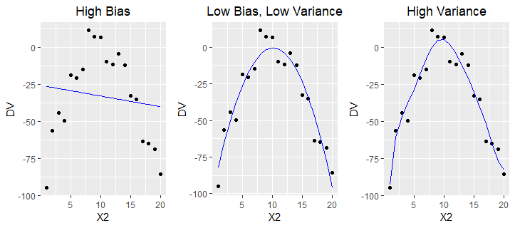
Bias-Variance Trade-offs
Figure 11.3 provides an illustration of this idea. The first model is not flexible enough, leading to high bias (also known as underfitting); on the other hand, the third model is too flexible, which leads to higher variance across slightly different training sets (overfitting). The second model imposes the ideal amount of flexibility, which optimizes the bias-variance trade-off and yields the smallest test MSE of the three alternatives.
Check-in Question 3: Explain why reducing bias can often entail an increase in variance.

Parametric v. Non-parametric Methods
Machine learning algorithms that make explicit assumptions about the functional form of the relationship between the set of predictors and $Y$ are known as parametric methods. A well-known example is the ordinary least squares (OLS) regression. Given two predictors, $f\left(X_{1},X_{2}\right)=β_{0}+β_{1}X_{1}+β_{2}X_{2}$. Thus, the regression equation in this case can be written as follows:
$$Y=β_{0}+β_{1}X_{1}+β_{2}X_{2}+ϵ$$
Parametric methods offer several key advantages. First, they simplify the task of estimating $f\left(.\right)$ by making an assumption about the functional form or shape of $f\left(.\right)$. In the case of an OLS regression, the algorithm assumes that $f\left(.\right)$ is linear with respect to the parameters (i.e., the coefficients and the error term), although not necessarily with respect to the values of the predictors. Thus, the only task is to estimate coefficients: $β_{0},β_{1},...,β_{p}$. Second, because of the functional form assumption, the $\hat{f}\left(.\right)$ tends to be more stable across comparable training sets (i.e., lower variance); put differently, the estimated model is more robust to minor fluctuations due to $ϵ$. Another advantage is that parametric methods also tend to score high on interpretability: e.g., we can easily interpret $β_{1}$ as indicating that a one-unit change in $X_{1}$ is associated with a change of $β_{1}$ in $Y$. Other examples of parametric methods include logistic regression, penalized regression methods (e.g., lasso, ridge), and linear discriminant analysis. The main disadvantage of parametric methods is the risk of imposing a functional form that is very different from the true $f\left(.\right)$, which can result in higher bias (or more prediction error). We can mitigate this risk by adjusting the parametric methods so that they are more flexible (e.g., by using higher-order terms in an OLS regression), but this may come at the cost of higher variance.
Non-parametric methods do not assume that the true relationship between a set of predictors and $Y$ follows a specific functional form; instead, they inductively attempt to estimate $f\left(.\right)$ such that it closely follows the training observations in the feature space. Well-known examples of non-parametric methods include tree-based methods (e.g., random forests, boosted trees), support vector machines (SVM), and K-nearest neighbor (KNN). The main advantage of non-parametric methods is that by design, they are very flexible; this means that they can be particularly useful when the relationship between the predictors and the outcome is highly complex. In such cases, non-parametric methods can outperform parametric methods by achieving lower bias, and ultimately, lower test error.
However, non-parametric methods also have a number of disadvantages. Since they do not make assumptions about the functional form, they often require much larger training sets in order to estimate $f\left(.\right)$. In addition, because they are highly flexible, non-parametric methods may also be subject to higher variance across training sets due to overfitting. This can be mitigated by properly tuning the models using cross-validation (CV), a model selection procedure discussed later in this chapter. Finally, it is also often more difficult to interpret the nature of the relationship between a specific predictor (e.g., $X_{1}$) and the outcome. This is why some especially complex non-parametric methods such as artificial neural networks (ANN) are often called $"$black box algorithms,$"$ since it is not clear exactly how the $f\left(.\right)$ is being estimated.
Given this discussion, which methods are preferred? It depends on the size of the available data, the complexity of the relationships among the variables, and the goals of the method. Machine learning practitioners are often interested in prediction or (causal) inference. If the goal is prediction, then we are less concerned about understanding the specific nature of $f\left(.\right)$. Instead, we are satisfied as long as we can estimate a model such that $\hat{f}\left(X\right)≈Y$. In this case, we should choose the parametric or non-parametric method that generates the lowest expected test error. On the other hand, if we are interested in understanding the specific nature of the relationship between a given predictor (or group of predictors) and the outcome, it may make more sense to select a parametric method, which produces results (e.g., regression coefficients) that are easier to interpret. While social scientists are often more interested in causal inference than prediction alone, they have used both parametric and non-parametric methods in their research. Several examples from political science will be discussed later in this chapter.

Supervised v. Unsupervised Learning
We can also classify machine learning methods according to whether they predict a specific outcome. In supervised learning, there is a clearly defined $"$correct answer$"$ – and the purpose of the machine learning algorithm is to correctly predict that answer. For instance, let us assume we want to predict whether a U.S. citizen will vote in the next presidential election. This is an example of a supervised learning problem; since the person either will or will not vote, there is clearly a $"$correct answer.$"$ There are two types of supervised learning, which are distinguished by the type of outcome predicted: (1) regression, (2) classification. In regression, the goal is to predict a continuous or quantitative outcome: e.g., test scores, stock prices, inflation rates, number of children, and so on. In classification, the goal is to predict a categorical or discrete outcome: e.g., religion, political party membership, vote choice, occupation, whether a person holds a four-year degree.
In unsupervised learning, the purpose of the machine learning algorithm is to examine the underlying structure of the data and identify $"$hidden$"$ patterns. It is not attempting to correctly predict an outcome. One well-known example of an unsupervised learning method is clustering: clustering algorithms (e.g., hierarchical, k-means) identify latent groups of observations by examining the relationships among the variables associated with the observations (Bryan 2004; Wagstaff and Cardie 2000; Witten 2011). In this case, we do not know ahead of time what the $"$correct$"$ or $"$true$"$ number of clusters is. Researchers can use clustering algorithms to identify more internally homogeneous groups of subjects (e.g., with respect to demographic characteristics, attitudes, preferences, consumption patterns). Figure 11.4 provides an illustration of how we may organize machine learning methods by type and subtype. Please note that the list of examples is not meant to be exhaustive.
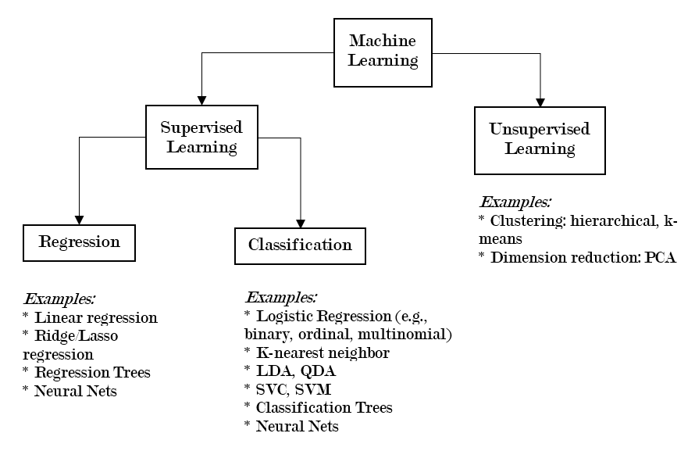
Types of Machine Learning Methods
Check-in Question 4: What is the main difference between supervised and unsupervised learning?

Method: setup/overview
There are definitely variations in how researchers and other practitioners organize their machine learning projects. However, the workflow tends to follow a general pattern. Assuming you already decided to use one specific method (e.g., lasso regression), the workflow may look something like this:
- Split the data into training and test sets
- With just the training set, use k-fold cross-validation (CV) to perform model selection (i.e., optimize the tuning parameters)
- Fit the final optimized version of the model (also called the candidate model) using the full training set
- Assess the candidate model by computing the test error
If you would like to compare the performance of multiple methods (e.g., boosted trees, random forests), then only a few modifications to the sample workflow above are necessary. Repeat steps 2-4 for each of the methods. At the final stage, you will have the test error for each candidate model: depending on your ideal trade-off between accuracy and interpretability, you can then select the most preferred model. For example, if the goal is causal inference, then you may be willing to select the candidate model with a somewhat higher test error because it scores much higher on interpretability.

What is Model Selection?
The performance of machine learning models is often highly dependent on their tuning parameters. We can think of tuning parameters as levers of the model that allow us to customize or adjust how it operates. Model selection refers to the process of identifying the tuning parameters that yield the lowest expected test error; this is also referred to as $"$optimizing the tuning parameters.$"$ For example, consider the lasso regression, which is a powerful method when we know that most of the predictors are probably not useful for predicting the outcome. If a normal OLS regression is used in this situation, the coefficients that should actually be zero may remain at non-zero values—which increases the likelihood of the model overfitting to the training data.
The algorithms for the OLS and lasso regressions are similar, except that the optimization process for the latter is subject to an additional constraint. Basically, this extra constraint imposes a penalty for the sum of the coefficients for the $p$ predictors in the model. The size of the penalty is controlled by $λ$: the bigger the $λ$, the smaller the coefficients. In fact, when the $λ$ is sufficiently large, many of the coefficients are totally zeroed out, which means that the lasso regression also provides a means of automating the variable selection process. Next, I explain why we typically use a method known as $k$-fold cross-validation to perform the model selection procedure.
$$λ\sum_{j=1}^{p}{|}β_{j}|$$

Why K-Fold Cross-Validation?
For example, let us assume that we want to compare 100 unique values of $λ_{i}$ for the lasso regression; how do we know which value will yield the lowest test error rate?
One option is using the validation set approach. This entails randomly splitting the training set ($n_{1}$) into two non-overlapping subsets: a model-building set ($n_{1a}$) and a validation set ($n_{1b}$). Next, we fit a model using the model-building set ($n_{1a}$) and the first value of lambda ($λ_{1}$), and then test it against the validation set ($n_{1b}$). We would then repeat this process 99 more times, so that we have done it once for each $λ_{i}$. Afterward, we could compare the 100 validation error rates and identify the value of the parameter that generated the lowest validation error. However, this approach has two important disadvantages (James et al. 2013, 176–78). First, the estimated validation error rate for each $λ_{i}$ is highly variable, since it is very sensitive to the specific observations that were randomly selected to be in $n_{1a}$ and $n_{1b}$; if a small percentage of the observations in the $n_{1a}$ were moved to $n_{1b}$ (and vice-versa), the test error rate would likely change. Second, statistical learning models tend to perform more poorly when trained on a smaller dataset; thus, by only training the model on a subset of the full training set (i.e., since $n_{1a}≪n_{1}$ ), we may actually overestimate the test error.
$K$-fold cross-validation (CV) is a statistically efficient resampling method that addresses both of these problems. The purpose of CV is to provide a more reliable estimate of the test error, which can then be used to compare and evaluate unique values of the tuning parameters (e.g., $λ_{i}$). It involves randomly splitting the training set ($n_{1}$) into $k$ non-overlapping groups (or $"$folds$"$) that are equal in size; the first fold is treated as the held-out validation set, and the model is fit using the observations in the remaining $k−1$ folds. This process is repeated until each fold has served as a validation set.
If there are 10 folds, there are also 10 estimates of the validation error; these estimates are averaged to form the CV error rate. The idea is that this CV error rate is a more reliable estimate of the validation error since it is based on an average of $k$ estimates (i.e., the CV error rate has a lower variance). Returning to the previous example, if we wanted to test 100 potential values of $λ_{i}$, we would perform the $k$-fold CV procedure for each $λ_{i}$; then, we would choose the value of $λ_{i}$ that yielded the lowest CV error.

Method: detail
In this section, I provide a brief overview of two common classes of machine learning methods, and how they actually work in practice: (1) tree-based methods, (2) support vector machines. Since we have used quantitative outcomes so far in our examples, this time the examples will focus on classification: 1 = voted for Trump in 2016, 0 = voted for someone else.

Model Class: Tree-based Methods
All tree-based methods (e.g., bagged trees, random forests, boosted trees) share some important similarities. Each tree divides the training observations into $m$ non-overlapping regions of the predictor space $\{R_{1},R_{2},…R_{m}\}$. Internal nodes refer to the place where the splits are made. The algorithm uses binary recursive splitting, and generally operates in the following way. The splits (i.e., predictor used, values of the predictor) are chosen in order to maximize the purity or homogeneity of the child nodes with respect to outcome class: i.e., in this case, whether or not the respondents voted for Trump (i.e., $Vote=1$ or $Vote=0$). As such, the first split has the most explanatory power (i.e., in terms of being able to predict the outcome class of a training observation), the second split has the second most explanatory power, and so on.
Node purity or homogeneity is often measured using the Gini index or entropy. In both cases, the measures are smaller when the nodes (or regions) are more homogeneous; thus, the objective is actually to choose splits that minimize the Gini index or entropy (which is equivalent to maximizing node purity). The Gini index is defined below (James et al. 2013, 312). Here, $p_{mk}$ represents the proportion of the training observations that are in $m$th region ($R_{m}$) from the $k$th class. Recall that $G$ is small when the nodes are more homogeneous: e.g., when the proportion of training observations in $m$th region are closely split between two classes $45\%−55\%$, then $G=\left(.45\right)\left(.55\right)\left(2\right)=0.495$; in contrast, when the training observations in $R_{m}$ are more dominated by a single class (and thus $R_{m}$ is more homogeneous), for instance, $90\%−10\%$ , then $G=\left(.10\right)\left(.90\right)\left(2\right)=0.18$.
$$G=\sum_{k=1}^{K}{p_{mk}}\left(1−p_{mk}\right)$$
How does this work in practice? For example, let us assume that in the training set, being white v. not being white was the strongest individual predictor of the Trump vote (i.e., it would maximize node purity). If this were the case, then the first split would be based on race: all white respondents would be assigned to the right branch, and all non-white respondents would be assigned to the left branch (see Figure 11.5) below). Next, let us assume that among white respondents, being above the mean on the 1-7 point political conservatism scale is the strongest predictor of the Trump vote; if so, then the second split would be based on whether the white respondents’ conservatism score is $≤4.3$ (left branch) or $>4.3$ (right branch).
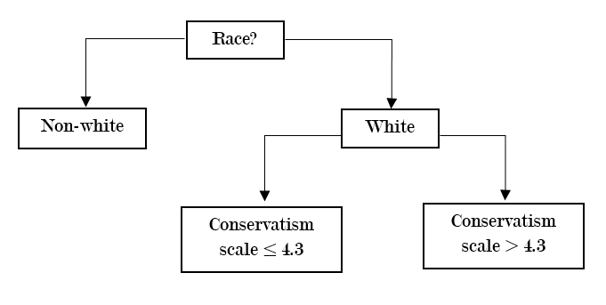
Example of a Decision Tree
In this simple example, the observations (or respondents) in the training set are assigned to one of three non-overlapping regions in the predictor space: $R_{1}=\{Vote|minority\}$, $R_{2}=\{Vote|white,conservatism≤4.3\}$, and $R_{3}=\{Vote|white,conservatism>4.3\}$. To predict the outcome class of an observation in the validation or test set, we simply look at which region the observation would be assigned to based on its predictor values (e.g., is $x_{1}=white$?), and then choose the most common class of that region. For instance, if the test observation would belong to $R_{3}$, and $70\%$ of the training observations in $R_{3}$ voted for Trump, then the predicted class of that test observation would be $Vote=1$. In general, of course, there are usually more than three regions (or terminal nodes); the splitting ends once a stopping point is reached: e.g., in order to satisfy the minimum terminal node size.
Individual decision trees suffer from high variance: i.e., the structure of the tree is highly dependent on which specific observations randomly end up in the training set. To address this issue, we can use the average prediction of many different trees. Methods for combining these different trees are called decision tree ensembles. There are three popular approaches: bagging, random forests, and boosting

Model Class: Support Vector Machines
Support Vector Machines (SVMs) are a class of methods that seek to assign observations to the correct outcome by using hyperplanes as decision boundaries. Hyperplanes are a $p−1$ dimensional flat subspace in a $p$-dimensional space: e.g., if $p=2$ (there are 2 predictors), then the hyperplane is simply a line. For instance, let us assume a simple case in which we are predicting the binary outcome $Vote$ using only two predictors; in this case, the separating hyperplane is a line. If the respondents in the training set who voted for Trump are labeled as $y_{i}=1$, and those who did not vote for Trump are labeled as $y_{i}=−1$, then the separating hyperplane can be formally described as follows:
$$y_{i}\left(β_{0}+β_{1}x_{i1}+β_{2}x_{i2}\right)>0$$
In this case, when $β_{0}+β_{1}x_{i1}+β_{2}x_{i2}>0$, $y_{i}=1$ and if $β_{0}+β_{1}x_{i1}+β_{2}x_{i2}<0$, then $y_{i}=−1$. That is, we can classify the observations based on whether they are above or below the separating hyperplane.
Next, I will briefly review how SVMs have been designed to address two key practical challenges. The first challenge is that there are often many hyperplanes that can correctly classify the observations, since the hyperplane can be slightly adjusted in any direction and probably still produce the same classifications. If we return to the equation above, it is easy to see that there are many ways the coefficients $β0$, $β1$, and $β2$ can be slightly adjusted (e.g., a $0.5\%$ increase or decrease) and still perfectly classify the observations. The solution is to maximize the margins, or the distance between the training data points and the separating hyperplane: this is also known as the maximal margin classifier or MMC.
Unfortunately, the MMC approach faces its own problems. Sometimes, there is simply no perfectly separating hyperplane; and even if there is, it is highly sensitive to individual observations, which can lead to overfitting (and high variance). The solution is a more flexible form of the MMC that allows some observations to fall on the wrong side of the margin and/or hyperplane: this is also known as the support vector classifier (SVC). The SVC is more robust in that it is less sensitive to individual observations, such as outliers (i.e., since some violations of the margin are allowed); this property allows the SVC to do a better job of classifying the observations in general.
Like the MMC, the SVC seeks to maximize the margin, but it is subject to a number of important constraints (James et al. 2013, 346–47). Here, I will specifically focus on the cost parameter ($C$), since that is what is generally optimized using cross-validation. Below, $ϵi$ indicates how severely the $i$th observation violates the margin and separating hyperplane. When $ϵi=0$, the $i$th observation is located on the correct side of the margin (i.e., no error); when $ϵi>0$, it is on the wrong side of the margin; and if $ϵi>1$, it has actually violated the separating hyperplane. That is, $C$ essentially represents the budget for the number and severity of the classification errors across the $n$ observations. When $C$ is small, the SVC will fit more tightly to the training observations in the feature space, at the cost of higher variance; and when $C$ is large, the opposite can occur. To optimize this bias-variance trade-off, we can use k-fold CV.
$$∑{i=1}^{n}ϵi≤C$$
The SVM is an extension of the SVC, which allows us to model nonlinear decision boundaries using kernels. By using kernels, the SVM allows us to expand the feature space (e.g., include polynomial functions of the predictors) in a computationally efficient manner. For more details on this procedure, we can refer to James et al. 2013, pp. 350-353; and Hastie et al. 2017, pp. 423-426).

Applications
In this section, I review six recent examples of machine learning methods in political science articles. The examples cover applications of both supervised learning (e.g., RF, SVM, naïve Bayes, k-nearest neighbor); and unsupervised methods such as topic modeling, which is related to clustering. Several different subfields of political science are represented: U.S. politics, political theory, comparative politics, international relations, and peace and conflict studies; in addition, the articles use data from many countries around the world (e.g., Argentina, India).

Example 1: U.S. Politics
DW-NOMINATE scores are often used in political science as a measure of a legislator’s ideology; they are based on the actual votes the legislators have made on bills in the U.S. House or U.S. Senate. uses two supervised machine learning methods (i.e., support vector regression and random forests) to address a very interesting problem: how can we predict the ideology of new legislators before they begin casting their votes? Support vector regression (SVR) is very similar to SVM, except that the algorithm has been modified to enable the prediction of a continuous outcome. In the first part of the paper, the author uses 10-fold CV to train models that predict the candidates’ DW-NOMINATE scores based on their campaign contributions, gender, party, and home state. The training set includes candidates with DW-NOMINATE scores between 1980-2014; and the key predictors in the feature matrix are the names of donors who have given to at least 15 candidates (e.g., National Education Association).
According to the results (i.e., RMSE), the support vector regression and random forest methods perform at least as well as the other methods that actually use the roll call data. This is especially impressive when we consider that the roll call data are used to construct the DW-NOMINATE scores. Next, Bonica also shows that the supervised learning methods also do a very good job of correctly predicting the actual votes cast during the 96th-113th Congresses: e.g., 89.9$\%$ of the votes are correctly predicted using DW-NOMINATE, which is not surprising; however, 89.5$\%$ and 89.3$\%$ of the votes are also correctly classified using the RF and SVR methods that were only trained using campaign contributions and a few other predictors.

Example 2: Comparative Politics
How do we know whether an election was rigged? Using synthetic (i.e., simulated) data, Cantú and Saiegh (2011) train a naïve Bayes classifier that successfully identifies fraudulent elections in the Buenos Aires province of Argentina between 1931 and 1941. One of the greatest strengths of the naïve Bayes (NB) algorithm is its simplicity, which is due the assumption that the features (i.e., predictors) are independent. For every election, the algorithm first estimates the posterior probability of membership in each class (i.e., fraudulent or clean) given the set of observed features or attributes associated with the election. The predicted class of each election is the class with the largest posterior probability, per Bayes theorem. For example, given a set of features, if the election is even slightly more likely to be fraudulent than clean, the election is classified by NB as a fraudulent election, and vice versa. After training their NB classifier on a large synthetic dataset (N=10,000), the authors test their model using several well-documented elections in 1936, 1940, and 1941; they show that their method ultimately outperforms key existing fraud detection algorithms (e.g., those based on the distributions of digits in official vote counts).

Example 3: Political Theory
Can machine learning be used to study the evolution of political theory across centuries? During the medieval and early modern period, scholars and other elites often wrote advice books for leaders that covered topics such as military strategy, economic prosperity, and religious devotion. These books provide an insightful view or $"$mirror$"$ into the dominant political theories and paradigms of the day. Blaydes, Grimmer, and McQueen (2018) use automated text analysis to compare how political advice texts in the Medieval Christian and Islamic Worlds changed during the medieval period. Their corpus of text includes 21 texts from the medieval Islamic world, which were produced between the eighth to seventeenth centuries; and 25 texts from Christian Europe, which were produced between the sixth to seventeenth centuries. Specifically, the authors use a hierarchical form of topic modeling based on variational approximation; while topic modeling methods vary in their specific details, all of them are unsupervised learning methods that seek to identify latent or $"$hidden$"$ clusters of topics in bodies of text (Wallach 2006).
Blaydes et al. identify four broad themes and 60 specific sub-themes nested within the broader themes; the four broader themes include: being a good ruler, the personal virtues of rulers, religion, and political geography or space. A key finding of the study is that at the aggregate level, the Christian and Muslim texts generally allocated a similar share of the space for each of the four broad topics. For example, topic 1 was the most prevalent issue across both Christian and Muslim works. However, there are some differences in trends across time. Whereas the prevalence of religious content steadily declined during the medieval period in Christian works, a similar temporal trend was not observed for advice books published in the Islamic world. The authors provide an interesting discussion of what these findings may mean for how we understand the relationship between political theory and institutional development.

Example 4: Comparative Politics
In a very recent study, Parthasarathy, Rao, and Palaniswamy (2019) use natural language processing (NLP) and topic modeling to study deliberative processes in the rural villages of South India. Their dataset includes a corpus of transcripts from a geographically representative sample of 100 village assemblies (or $"$gram sahbas$"$ ) in Tamil Nadu, a state in southern India. Parthasarathy and her coauthors use an unsupervised topic learning approach called structural topic modeling (STM), which identifies clusters of co-occurring words in the corpus of text. They identify 15 topics, with the most popular topics being water, beneficiary and voting lists, and employment and wages. By combining these topics with the use of statistical tests, the authors show that female participants face serious inequalities: “Women are less likely to be heard, less likely to drive the agenda, and less likely to receive a relevant response from state officials” (pp. 637-638). For example, politicians provided a relevant (i.e., on-topic) response to women only 49$\%$ time, but to male speakers 70$\%$ of the time. These disparities are problematic not only because they indicate that female voices tend to matter less in deliberative processes, but also because the issues that disproportionately affect women may be less likely to be translated into meaningful policy outputs.

Example 5: Peace and Conflict
In a fascinating paper, Mueller and Rauh (2018) combine a number of methods (i.e., topic models, lasso regression, linear fixed effects models) to predict political violence using newspaper text. First, they downloaded 700,000 newspaper articles about events in 185 countries from the New York Times (NYT), the Washington Post (WP), and the Economist. All available articles published between 1975-2015 were included in the text corpus. Topic modeling based on Dirichlet allocation (LDA) is used to reduce the high dimensionality of the text corpus (i.e., almost a million unique words, after preprocessing) to 15 topics. The relative prevalence of each topic is aggregated at the level of country-year and used as predictors in linear fixed effects models. The results show that the within-country variation over time in topic prevalence is a robust predictor of the outbreak of civil war and armed conflict: the area under the curve (AUC) indicates that about 73-82$\%$ of the outcomes can be correctly predicted using only within unit variation. The authors also use lasso regressions, an automated variable selection method, to identify the most important predictors: e.g., the prevalence of the $"$justice$"$ topic is a significant predictor of political violence across several different values of lambda, the penalty parameter. This finding is substantively important because it reinforces the idea that institutional design, the rule of law, and social stability are often tightly coupled together in reality.

Example 6: International Relations
Although power is a key concept in international relations, there is no consensus over the best way to measure it. Carroll and Kenkel (2019) use machine learning to develop a new method of measuring power, called the Dispute Outcome Expectations (DOE) score. To create the DOE scores, they used a two-step process: first, a number of machine learning methods (e.g., SVM, k-nearest neighbors, RF, neural nets) were used to predict the outcomes of militarized international disputes between 1816 and 2007. Then, a super learner algorithm was used to combine the results and create an optimal weighted ensemble of the models. Carroll and Kenkel demonstrate that the DOE does a much better job of predicting the probability of conflicts between two states (called dyads) than the national capability ratio, which is frequently used in the literature. Using this superior measure of power also improves our substantive understanding of the nature of interstate conflict: the probability of interstate conflict is the greatest when there is a large disparity in power and the more powerful state does not prefer the status quo—a finding that seems more sensible and in line with existing theories.

Advantages of Method
What are the advantages and disadvantages of machine learning, especially in the context of the social sciences? The advantages are considerable. Machine learning algorithms can increase prediction accuracy, which is especially important when we are attempting to predict highly consequential outcomes (e.g., outbreak of violent conflicts). They can also reduce the effects of human biases, by automating many decisions (e.g., variable selection); in addition, modern machine learning methods are also very computationally efficient (e.g., due to vectorization), which means that truly vast amounts of data can be analyzed.

Disadvantages of Method
However, machine learning methods also face some disadvantages. To accurately predict the outcomes of highly complex or contingent processes, large amounts of data are often necessary but sometimes unavailable; classification methods (e.g., classification trees, SVM) tend to perform poorly when the classes are imbalanced; many algorithms are prone to overfitting; and gains in prediction accuracy can sometimes come at the cost of reduced interpretability. In addition, machine learning methods may also generate results that seem socially undesirable or biased against certain groups. While these challenges are very real, many of them can be addressed by existing best practices as well as future innovations. For example, using k-fold cross-validation can help reduce overfitting and optimize the bias-variance trade-off; we can also minimize the risk of $"$biased algorithms$"$ by remaining cognizant of the biases or problems that may be present in the training data.

Broader significance/use in political science
As evidenced by the examples discussed above, machine learning methods are broadly applicable across the social sciences (Mason et al. 2014). You are more likely to see them used when there are a lot of data, the relationships among variables are highly complex, and the key patterns in the data are not obvious to the human eye. Political scientists have successfully used machine learning methods (e.g., k-fold CV) and algorithms to pursue research questions in subfields including U.S. politics, comparative politics, international relations, and political theory. For instance, political scientists frequently use unsupervised learning methods such as topic modeling to automate the analysis of large bodies of text. In recent years, researchers have also been increasingly using multiple machine learning models in the same project (e.g., topic modeling and linear regressions), in order to address more complex research questions or gain more prediction accuracy.

Conclusion
The era of $"$big data$"$ has arrived. Large technology companies such as Amazon, Apple, Facebook, Google, and Twitter are harvesting unprecedented amounts of data from their users across the globe. At the same time, political scientists and other social scientists (e.g., economists, sociologists) are interested in advancing our understanding of the social world. Why do people choose to vote (or not vote)? Under what conditions will countries go to war with each other? What makes some proposed bills more likely to be passed into law? This is an exciting time for quantitative social science research. Recent advancements in machine learning, while not without their challenges, offer many new and exciting ways to analyze an increasingly large quantity and variety of data. If handled properly, the findings generated from these new methods could improve our understanding of complex social processes, inform policymakers, and improve human societies.

Application Questions
- Imagine you are the director of analytics for a U.S. Senate candidate. Briefly describe how you could use a machine learning method in your work. Why did you choose this method? What are some advantages and disadvantages of the method you chose?
- Imagine you are a consultant and your client is a federal law enforcement agency that wants to predict the likelihood of a violent protest in various regions of the country. Briefly describe how you could use a machine learning method in your work. Why did you choose this method? What are some advantages and disadvantages of the method you chose?

Key Terms
- target function
- training set
- test set
- expected prediction error (EPE)
- training error
- test error
- overfitting
- underfitting
- reducible error
- irreducible error
- expected value
- bias
- variance
- bias-variance trade-offs
- parametric methods
- non-parametric methods
- model interpretability
- model flexibility
- k-fold cross-validation
- prediction v. (causal) inference
- supervised v. unsupervised learning
- regression v. classification methods
- model selection
- candidate model
- tuning parameters
- validation set approach

Answers to Application Questions
There is no single correct answer. However, for both questions, a strong answer will specify the method type (e.g., supervised, regression v. classification) and discuss issues such as the bias-variance trade-off, cross-validation, model interpretability, and prediction accuracy.

Conclusions
By Jean Clipperton
Throughout this text, we’ve covered the fundamental building blocks of political science research. We began with an understanding of theory and how building a strong theory can lead to a set of hypotheses evaluated with data. Evaluating hypotheses, empirical predictions that can be evaluated using a range of quantitative methods, can provide support for your theories and/or lead to new directions of research.
We took up a number of popular quantitative research approaches, considered their advantages and disadvantages, and explored the foundations of how they’ve worked within political science.
As I hope we’ve demonstrated in the text, there are often no right answers within social science. The way you frame your theory, your choice of variable measurement, your selected quantitative approach will all have advantages and disadvantages. Some choices may be better than others but there are often no universally ‘right’ responses. The choices we make in our research will have some costs, some consequences. However, that doesn’t mean that there isn’t value in doing the work. Being mindful of the pitfalls or limitations of our research can help contextualize our findings and help us better understand the phenomena we hope to explain.

Next Steps
From here, you’re well-equipped to analyze academic work in your classes, work on research proposals, and take a quantitative course on the method(s) of your choosing. Consider not just what you’ve learned about these approaches, but how they can help you understand your research question. Your university likely has opportunities for you to work as an RA (research assistant) where you will help collect data and/or readings to develop a publication. Additionally, there may be opportunities for you to conduct your own research, through grants from your department, an office of undergraduate research, and/or research seminars. Using our framework for the scientific method will help you craft a strong proposal with a research method that will help you evaluate your hypotheses and answer your research question. Good luck!

Mathematical Appendix
By Maximilian Weylandt

Calculating the Regression Coefficient
For bivariate regressions, you can calculate the coefficient yourself. The equation is
$$b=\frac{S_{Y}}{S_{X}}R$$
where $S_{Y}$ is the standard deviation in $Y$, $S_{X}$ is the standard deviation in $X$, and $R$ is the correlation between $X$ and $Y$. In our example on gender equality and education, the values are:
$R=0.83$
$S_{X}=2.95$
$S_{Y}=39.32$
Try plugging them into the above equation and seeing whether you get the result you see in regression table, Table 8.3. (Don’t worry if it’s not exact, there’s a fair amount of rounding going on).

Significance Tests
Calculating the p-value
Note: this calculation presumes that you have understood the discussion about hypothesis testing earlier on in this book. If you are unsure, take a few minutes to refresh your memory on the contents of the chapter on Hypothesis Testing.
Our regression result suggests that $b=11.6$. However, this is an estimate, and therefore there is some uncertainty around this number, which is expressed in the standard error. Table 8.1 (and 2) tells us this error is $0.62$. Next, we need a decision rule: how unlikely do we think the p-value can be before we think this result is implausible? Let’s set it as $α=0.05$: if the probability of getting this particular $b$ is less than $5\%$ (assuming a world where the null hypothesis is true) we will reject the null hypothesis.
We can now calculate the Z-score, which standardizes our $b−value$ – in other words, it tells us where it would fall on a standard normal distribution.
$$Z=\frac{\left|b−H_{0}\right|}{SE}=\frac{11.6}{0.62}≈18.71$$
We can now go to our Z-table and see what probability is associated with a large Z value. Your Z-table should indicate that the odds of getting a Z-value this large are very small. Our $p$ is much smaller than the $α$ value set, so we reject the null hypothesis.
Make sure you understand the intuition behind that intuition. If null hypothesis is true and the real $b$ is 0, it would be very weird for us to get this result of 11.6 when calculating the regression line for our sample of countries. Given how weird it is, we might find the alternative hypothesis more plausible: maybe $b$ is not $0$ after all. Thus, we reject the null hypothesis.
Confidence Interval The formula for a confidence interval is fairly straightforward. You’ll need the Z-score that corresponds to your desired degree of confidence. For example, for a $95\%$ level, $z≈1.96$; for a $99\%$ level, $z≈2.58$.
The confidence Interval is:
$$b±z⋅SE$$
Let’s say we want a 95% confidence interval. Then we’d have:
$b=11.6$
$z=1.96$
$SE=0.62$
So the confidence interval is:
$\left[b−z⋅SE;b+z⋅SE\right]$
$=\left[11.6−1.96⋅0.62;11.6+1.96⋅0.62\right]$
$=\left[10.4;12.8\right]$

Error Terms
The regression equations we wrote out above are technically incomplete. In papers, you will often encounter regression equations with an $e$ at the end, like this:
$$Y=a+b_{1}X_{1}+b_{2}X_{2}+e$$
The $e$ basically stands for our residuals, or the difference between what our regression predicts and what the data actually show, and is sometimes called error term. If you plug in any real $X$-value from the actual data, the $Y$ you get is likely to be slightly off, because our regression line is the best fit but does not hit all points. Both sides of an equation have to be equal, and so the error term is brought in to make the right hand side equal to the actual $Y$ at that $X$-value

Logged Variables
While discussing our linear regression, we noted that GDP was not included directly as a control variable, but rather the log of GDP. We do this because we think that a one unit increase does not always mean the same thing across the range of possible values for our variable. Let’s say we are talking about per capita GDP, in units of 1,000 dollars. The differences between a country with a per capita GDP of 1,000 USD and 10,000 USD are massive. (In our data, countries close to those values are Niger, one of the poorest countries in the world and Indonesia, the largest economy in Southeast Asia). Meanwhile, countries with per capita GDP of 38,000 vs 47,000 are likely quite similar, like France and the Netherlands. The extra 9,000 dollars (9 units) don’t have the same effect across the range of values. Taking the log of GDP values allows us to ‘flatten’ the relationship, so that a unit change means a similar thing across $X$-values, but it does make the coefficient a bit harder to interpret. The unit of our variable went from 1 dollar in GDP/capita to the log of 1 dollar, which is not an intuitive number to plug into “an increase of 1 unit $X$ is associated with an increase of $b$ units of $Y$."
But there is a rule of thumb. When an X-variable is logged, we can say "a 1% increase in X corresponds with a $b/100$ change in Y. In our example, that means that a 1% increase in per capita GDP is associated with a 0.159 point increase in the gender equality index.
You can calculate the change in $Y$ associated with other percentage increases ($p$) by using the formula
$$ΔY=b⋅\frac{100+p}{100}$$

References
Alcañiz, Isabella. 2010. “Bureaucratic Networks and Government Spending: A Network Analysis of Nuclear Cooperation in Latin America.” Latin American Research Review 45 (1): 148–72. https://doi.org/10.1353/lar.0.0128.
Amrhein, Valentin, Sander Greenland, and Blake McShane. 2019. “Scientists Rise up Against Statistical Significance.” Nature 567: 305–7.
Angrist, Joshua David, and Jörn-Steffen Pischke. 2015. Mastering ’Metrics: The Path from Cause to Effect. Princeton ; Oxford: Princeton University Press.
Angrist, Joshua D., and Victor Lavy. 1999. “Using Maimonides’ Rule to Estimate the Effect of Class Size on Scholastic Achievement.” The Quarterly Journal of Economics 114 (2): 533–75. https://doi.org/10.1162/003355399556061.
Angrist, Joshua D, Victor Lavy, Jetson Leder-Luis, and Adi Shany. 2017. “Maimonides Rule Redux.” Working {Paper} 23486. National Bureau of Economic Research. https://doi.org/10.3386/w23486.
Ansolabehere, Stephen, and Brian F Schaffner. 2014. “Does Survey Mode Still Matter? Findings from a 2010 Multi-Mode Comparison.” Political Analysis 22 (3): 285–303.
Bacharach, Samuel B. 1989. “Organizational Theories: Some Criteria for Evaluation.” Academy of Management Review 14 (4): 496–515.
Barakso, Maryann, Daniel M Sabet, and Brian Schaffner. 2013. Understanding Political Science Research Methods: The Challenge of Inference. Routledge.
Barrat, A., M. Barthélemy, R. Pastor-Satorras, and A. Vespignani. 2004. “The Architecture of Complex Weighted Networks.” Proceedings of the National Academy of Sciences of the United States of America 101 (11): 3747–52. https://doi.org/10.1073/pnas.0400087101.
Bennett, Andre, Aharo Barth, and Kennet R Rutherford. 2003. “Do We Preach What We Practice? A Survey of Methods in Political Science Journals and Curricula.” PS: Political Science & Politics 36 (3): 373–78.
Blaydes, Lisa, Justin Grimmer, and Alison McQueen. 2018. “Mirrors for Princes and Sultans: Advice on the Art of Governance in the Medieval Christian and Islamic Worlds.” Journal of Politics 80 (4): 1150–67.
Boigelot, Denis. 2011. “An Example of the Correlation of x and y for Various Distributions of (x,y) Pairs.” Wikimedia Commons.
Boix, Carles, and Susan C Stokes. 2003. “Endogenous Democratization.” World Politics 55 (4): 517–49.
Bonilla, Tabitha. 2022. The Importance of Campaign Promises. Cambridge University Press. https://doi.org/10.1017/9781108910170.
Bonilla, Tabitha, and Cecilia Hyunjung Mo. 2018. “Bridging the Partisan Divide on Immigration Policy Attitudes Through a Bipartisan Issue Area: The Case of Human Trafficking.” Journal of Experimental Political Science 5 (2): 107–20. https://doi.org/10.1017/XPS.2018.3.
Booth, Andrew, Anthea Sutton, and Diana Papaioannou. 2016. Systematic Approaches to a Successful Literature Review. SAGE.
Borell-Porta, Mireia, Joan Costa- Font, and Julia Phillip. 2018. “The ’Mighty Girl’ Effect: Does Parenting Daughters Alter Attitudes Towards Gender Roles?” IZA Institute of Labor Economics DP N. 11259.
Bouka, Yolande. 2013. “(Oral) History of Violence: Conflicting Narratives in Post-Genocide Rwanda.” Oral History Forum 33.
Broido, Anna D., and Aaron Clauset. 2019. “Scale-Free Networks Are Rare.” Nature Communications 10 (1): 2–10. https://doi.org/10.1038/s41467-019-08746-5.
Broockman, David, Joshua Kalla, and Peter Aronow. 2015. “Irregularities in LaCour (2014).”
Bullock, John G., and Shang E. Ha. 2011. “Mediation Analysis Is Harder Than It Looks.” In Cambridge Handbook of Experimental Political Science, edited by James N. Druckman, Donald P. Green, James H. Kuklinski, and Arthur Lupia, 508–22. Cambridge: Cambridge University Press. https://doi.org/10.1017/CBO9780511921452.035.
Cantú, Francisco, and Sebastián M. Saiegh. 2011. “Fraudulent Democracy? An Analysis of Argentina’s Infamous Decade Using Supervised Machine Learning.” Political Analysis 19 (4): 409–33.
Carroll, Robert J., and Brenton Kenkel. 2019. “Prediction.” Proxies, and Power. American Journal of Political Science.
Cassese, Erin C, Tiffany D Barnes, and Regina P Branton. 2015. “Racializing Gender: Public Opinion at the Intersection.” Politics & Gender 11 (1): 1–26.
Centers for Disease Control and Prevention. 2017. “About Adult BMI.” Web. \url{https://www.cdc.gov/healthyweight/assessing/bmi/adult_bmi/index.html}.
Chen, Dingding, Chao-yo Cheng, and Johannes Urpelainen. 2016. “Support for Renewable Energy in China: A Survey Experiment with Internet Users.” Journal of Cleaner Production 112 (January): 3750–58. https://doi.org/10.1016/j.jclepro.2015.08.109.
Clark, William Roberts, Matt Golder, and Sona Nadenichek Golder. 2013. Principles of Comparative Politics. Los Angeles, CA: SAGE Publications.
———. 2017. Principles of Comparative Politics. CQ Press.
Coe, Kevin, David Tewksbury, Bradley J. Bond, Kristin L. Drogos, Robert W. Porter, Ashley Yahn, and Yuanyuan Zhang. 2008. “Hostile News: Partisan Use and Perceptions of Cable News Programming.” Journal of Communication 58 (2): 201–19. https://doi.org/10.1111/j.1460-2466.2008.00381.x.
Cohen, Cathy J. 1999. The Boundaries of Blackness: AIDS and the Breakdown of Black Politics. Chicago; London: The University of Chicago Press.
Colleoni, Elanor, Alessandro Rozza, and Adam Arvidsson. 2014. “Echo Chamber or Public Sphere? Predicting Political Orientation and Measuring Political Homophily in Twitter Using Big Data.” Journal of Communication 64 (2): 317–32. https://doi.org/10.1111/jcom.12084.
Collier, David, and John Gerring, eds. 2009. Concepts and Method in Social Science: The Tradition of Giovanni Sartori. New York: Routledge.
Cook, Kathleen E., and Elise Murowchick. 2014. “Do Literature Review Skills Transfer from One Course to Another?” Psychology Learning & Teaching 13 (1): 3–11. https://doi.org/10.2304/plat.2014.13.1.3.
Dawson, Michael C. 2001. Black Visions: The Roots and Contemporary African-American Political Ideologies. Chicago; London: The University of Chicago Press.
De La O, Ana L. 2013. “Do Conditional Cash Transfers Affect Electoral Behavior? Evidence from a Randomized Experiment in Mexico.” American Journal of Political Science 57 (1): 1–14.
Dion, Michelle L., Jane Lawrence Sumner, and Sara McLaughlin Mitchell. 2018. “Gendered Citation Patterns Across Political Science and Social Science Methodology Fields.” Political Analysis 26 (3): 312–27. https://doi.org/10.1017/pan.2018.12.
Dionne, Kim Yi, and Jeremy Horowitz. 2016. “The Political Effects of Agricultural Subsidies in Africa: Evidence from Malawi.” World Development 87 (November): 215–26. https://doi.org/10.1016/j.worlddev.2016.06.011.
Dodds, Peter Sheridan, Roby Muhamad, and Duncan J. Watts. 2003. “An Experimental Study of Search in Global Social Networks.” Science 301 (5634): 827–29. https://doi.org/10.1126/science.1081058.
Druckman, James N., and Donald P. Green. 2021. “A New Era of Experimental Political Science.” In Advances in Experimental Political Science, edited by James N. Druckman and Donald P.Editors Green, 1–16. Cambridge University Press. https://doi.org/10.1017/9781108777919.002.
Druckman, James N, and Cindy D Kam. 2011. “Students as Experimental Participants.” Cambridge Handbook of Experimental Political Science 1: 41–57.
Duverger, Maurice. 1954. Political Parties: Their Organization and Activity in the Modern State. New York, NY: Wiley.
Emerson, Robert M., Rachel I. Fretz, and Linda L. Shaw. 2011. Writing Ethnographic Fieldnotes. Second. Chicago; London: The University of Chicago Press.
Erikson, Robert S, and Kent L Tedin. 2015. American Public Opinion: Its Origins, Content and Impact. Routledge.
Ferguson, Thomas, Benjamin Page, Jacob Rothschild, Arturo Chang, and Jie Chen. 2018. “The Economic and Social Roots of Populist Rebellion: Support for Donald Trump in 2016.” Institute for New Economic Thinking Working Paper Series, no. 83.
Ferrara, Emilio, Onur Varol, Clayton Davis, Filippo Menczer, and Alessandro Flammini. 2016. “The Rise of Social Bots.” Communications of the ACM 59 (7): 96–104. https://doi.org/10.1145/2818717.
Ferree, Karen E. 2006. “Explaining South Africa’s Racial Census.” The Journal of Politics 68 (4): 803–15. https://doi.org/10.1111/j.1468-2508.2006.00471.x.
Fink, Arlene. 2013. Conducting Research Literature Reviews: From the Internet to Paper. 4th ed. SAGE.
Fowler, James H., Bernard Grofman, and Natalie Masuoka. 2007. “Social Networks in Political Science: Hiring and Placement of Ph.d.s, 1960–2002.” PS: Political Science & Politics 40 (04): 729–39. https://doi.org/10.1017/s104909650707117x.
Fraile, Marta, and Irene Sánchez-Vítores. 2019. “Tracing the Gender Gap in Political Interest Over the Life Span: A Panel Analysis.” Political Psychology, May. https://doi.org/10.1111/pops.12600.
Freeman, Linton C. 1977. “A Set of Measures of Centrality Based on Betweenness.” Sociometry 40 (1): 35–41. https://doi.org/10.2307/3033543.
Frymer, Paul. 2017. Building an American Empire: The Era of Territorial and Political Expansion. Princeton; Oxford: Princeton University Press.
García-Rivero, Carlos. 2006. “Race, Class and Underlying Trends in Party Support in South Africa.” Party Politics 12 (1): 57–75. https://doi.org/10.1177/1354068806059344.
Gidengil, Elisabeth, and Dietlind Stolle. 2009. “The Role of Social Networks in Immigrant Women’s Political Incorporation.” International Migration Review 43 (4): 727–63. https://doi.org/10.1111/j.1747-7379.2009.00783.x.
Goertz, Gary. 2006. Social Science Concepts: A User’s Guide. Princeton: Princeton University Press.
González, Yanilda M. 2017. “What Citizens Can See of the State: Police and the Construction of Democratic Citizenship in Latin America.” Theoretical Criminology 21 (4): 494–511.
Gosnell, Harold F. 1927. Getting Out the Vote: An Experiment in the Stimulation of Voting. The University of Chicago press.
Groves, Robert M. 2011. “Three Eras of Survey Research.” Public Opinion Quarterly 75 (5): 861–71.
Guille, Adrien, Hakim Hacid, Cécile Favre, and Djamel A. Zighed. 2013. “Information Diffusion in Online Social Networks: A Survey.” ACM SIGMOD Record 42 (1): 17. https://doi.org/10.1145/2503792.2503797.
Hadaway, C Kirk, Penny Long Marler, and Mark Chaves. 1993. “What the Polls Don’t Show: A Closer Look at US Church Attendance.” American Sociological Review, 741–52.
Hainmueller, Jens, Dominik Hangartner, and Teppei Yamamoto. 2015. “Validating Vignette and Conjoint Survey Experiments Against Real-World Behavior.” Proceedings of the National Academy of Sciences 112 (8): 2395–2400. https://doi.org/10.1073/pnas.1416587112.
Harris-Perry, Melissa V. 2011. Sister Citizen: Shame, Stereotypes, and Black Women in America. New Haven; London: Yale University Press.
Hart, Chris. 1998. Doing a Literature Review: Releasing the Social Science Research Imagination. Thousand Oaks, CA: SAGE Publications.
Hastie, Trevor, Robert Tibshirani, and Jerome Friedman. 2017. The Elements of Statistical Learning: Data Mining, Inference, and Prediction. 2nd ed. New York City: Springer.
Heerwig, Jennifer A, and Brian J McCabe. 2009. “Education and Social Desirability Bias: The Case of a Black Presidential Candidate.” Social Science Quarterly 90 (3): 674–86.
Helmke, Gretchen. 2005. Courts Under Constraints: Judges, Generals, and Presidents in Argentina. Cambridge: Cambridge University Press.
Hochschild, Jennifer L., Vesla Weaver, and Traci D. Burch. 2012. Creating a New Racial Order: How Immigration, Multiracialism, Genomics, and the Young Can Remake Race in America. Princeton; Oxford: Princeton University Press.
Hopkins, Daniel J., and Jonathan M. Ladd. 2014. “The Consequences of Broader Media Choice: Evidence from the Expansion of Fox News.” Quarterly Journal of Political Science 9 (1): 115–35. https://doi.org/10.1561/100.00012099.
Iyengar, Shanto, Mark D. Peters, and Donald R. Kinder. 1982. “Experimental Demonstrations of the ‘Not-So-Minimal’ Consequences of Television News Programs.” American Political Science Review 76 (4): 848–58. https://doi.org/10.1017/S000305540018966X.
James, Gareth, Daniela Witten, Trevor Hastie, and Robert Tibshirani. 2013. An Introduction to Statistical Learning: With Applications in r. 7th ed. New York City: Springer.
Jamison, Julian C. 2019. “The Entry of Randomized Assignment into the Social Sciences.” Journal of Causal Inference 7 (1). https://doi.org/10.1515/jci-2017-0025.
Jesson, Jill, Lydia Matheson, and Fiona M. Lacey. 2011. Doing Your Literature Review: Traditional and Systematic Techniques. Thousand Oaks, CA: SAGE.
Johnson, Janet Buttolph, H. T. Reynolds, and Jason D. Mycoff. 2016. Political Science Research Methods. 8th ed. Washington, DC: CQ Press.
Kadushin, Charles. 2012. Understanding Social Networks: Theories, Concepts, and Findings. Oxford University Press.
Kane, Emily W, and Kimberly J Whipkey. 2009. “Predictors of Public Support for Gender-Related Affirmative Action: Interests, Gender Attitudes, and Stratification Beliefs.” Public Opinion Quarterly 73 (2): 233–54.
Karl, Kristyn L. 2019. “Motivating Participation Through Political Ads: Comparing the Effects of Physiology and Self-Reported Emotion.” Political Behavior, September. https://doi.org/10.1007/s11109-019-09569-2.
Kemp, Simon. 2020. “Digital 2020: Global Digital Overview.” Hootsuite & We Are Social. https://datareportal.com/reports/digital-2020-global-digital-overview.
Kleinberg, Jon M. 2000. “Navigation in a Small World.” Nature 406 (6798): 845. https://doi.org/10.1038/35022643.
Knopf, Jeffrey W. 2006. “Doing a Literature Review.” PS: Political Science and Politics 39 (1): 127–32.
Kramer, Katherine J. 2016. The Politics of Resentment: Rural Consciousness in Wisconsin and the Rise of Scott Walker. Chicago; London: The University of Chicago Press.
Kuenzi, Michelle, and Gina Lambright. 2005. “Party Systems and Democratic Consolidation in Africa’s Electoral Regimes.” Party Politics 11 (4): 423–46. https://doi.org/10.1177/1354068805053211.
Kuhn, Thomas S. 1996. The Structure of Scientific Revolutions, 3rd Ed. The Structure of Scientific Revolutions, 3rd Ed. Chicago, IL, US. https://doi.org/10.7208/chicago/9780226458106.001.0001.
Kuziemko, Ilyana, Jessica Pan, Jenny Shen, and Ebonya Washington. 2018. “The Mommy Effect: Do Women Anticipate the Employment Effects of Motherhood?” NBER Working Paper Series N. 24740.
Lee, Stephanie M. 2018. “Sliced And Diced: The Inside Story Of How An Ivy League Food Scientist Turned Shoddy Data Into Viral Studies.” BuzzFeed News. https://www.buzzfeednews.com/article/stephaniemlee/brian-wansink-cornell-p-hacking.
Leighley, Jan E, and Arnold Vedlitz. 1999. “Race, Ethnicity, and Political Participation: Competing Models and Contrasting Explanations.” The Journal of Politics 61 (4): 1092–1114.
Lewis Jr, Neil A. 2019. “Studying People in Their Local Environments.” APS Observer 32 (3). https://www.psychologicalscience.org/observer/studying-people-in-their-local-environments.
Lewis, Kevin, Jason Kaufman, Marco Gonzalez, Andreas Wimmer, and Nicholas Christakis. 2008. “Tastes, Ties, and Time: A New Social Network Dataset Using Facebook.com.” Social Networks 30 (4): 330–42. https://doi.org/10.1016/j.socnet.2008.07.002.
Lipset, Seymour Martin. 1959. “Some Social Requisites of Democracy: Economic Development and Political Legitimacy.” American Political Science Review 53 (01): 69–105. https://doi.org/10.2307/1951731.
Lombard, Matthew, Jennifer Snyder-Duch, and Cheryl Campanella Bracken. 2002. “Content Analysis in Mass Communication: Assessment and Reporting of Intercoder Reliability.” Human Communication Research 28 (4): 587–604.
Mahoney, James, and Kathleen Thelen. 2009. Explaining Institutional Change: Ambiguity, Agency, and Power. Cambridge University Press.
Marion Suiseeya, Kimberly R., and Laura Zanotti. 2019. “Making Influence Visible: Innovating Ethnography at the Paris Climate Summit.” Global Environmental Politics 19 (2): 38–60. https://doi.org/10.1162/glep_a_00507.
Masuoka, Natalie, and Jane Junn. 2013. The Politics of Belonging: Race, Public Opinion, and Immigration. University of Chicago Press.
Matejka, Justin, and George Fitzmaurice. 2017. “Same Stats, Different Graphs: Generating Datasets with Varied Appearance and Identical Statistics Through Simulated Annealing.” In CHI 2017 Conference Proceedings:
Mayda, Anna Maria, Kevin H O’Rourke, and Richard Sinnott. 2007. “Risk, Government and Globalization: International Survey Evidence.” National Bureau of Economic Research.
Mengel, Friederike, Jan Sauermann, and Ulf Zölitz. 2019. “Gender Bias in Teaching Evaluations.” Journal of the European Economic Association 17 (2): 535–66. https://doi.org/10.1093/jeea/jvx057.
Milgram, Stanley. 1967. “The Small-World Problem.” Psychology Today 1 (1): 61–67.
Milgram, Stanley, and Jeffrey Travers. 1969. “An Experimental Study of the Small World Problem.” Sociometry 32 (4): 425–43. https://doi.org/10.2307/2786545.
Mitchell, Tom. 1997. Machine Learning. New York City: McGraw-Hill Education.
Mitts, Tamar. 2019. “From Isolation to Radicalization: Anti-Muslim Hostility and Support for ISIS in the West.” American Political Science Review 113 (1): 173–94. https://doi.org/10.1017/S0003055418000618.
Mo, Cecilia Hyunjung, and Katharine M. Conn. 2018. “When Do the Advantaged See the Disadvantages of Others? A Quasi-Experimental Study of National Service.” American Political Science Review 112 (4): 721–41. https://doi.org/10.1017/S0003055418000412.
Moore, Barrington. 1966. Social Origins of Dictatorship and Democracy: Lord and Peasant in the Making of the Modern World. Boston, MA: Beacon Press.
Mueller, Hannes F., and Christopher Rauh. 2018. “Reading Between the Lines: Prediction of Political Violence.” Using Newspaper Text. American Political Science Review 112 (2): 358–75.
Munck, Gerardo L. 2009. Measuring Democracy: A Bridge Between Scholarship and Politics. Baltimore: Johns Hopkins University Press.
Murdie, Amanda. 2014. “The Ties That Bind: A Network Analysis of Human Rights International Nongovernmental Organizations.” British Journal of Political Science 44 (1): 1–27. https://doi.org/10.1017/s0007123412000683.
Mutz, Diana C, and Eunji Kim. 2017. “The Impact of in-Group Favoritism on Trade Preferences.” International Organization 71 (4): 827–50.
Newman, MEJ. 2005. “Power Laws, Pareto Distributions and Zipf’s Law.” Contemporary Physics 46 (5): 323–51. https://doi.org/10.1080/00107510500052444.
Ng, Andrew. n.d. “Machine Learning.” Stanford University: Coursera. https://www.coursera.org/learn/machine-learning.
Olson, Mancur. 1965. The Logic of Collective Action: Public Goods and the Theory of Groups. Harvard Economic Studies 124. Cambridge, MA: Harvard University Press.
Onwuegbuzie, Anthony J., and Rebecca Frels. 2016. Seven Steps to a Comprehensive Literature Review: A Multimodal and Cultural Approach. Thousand Oaks, CA: SAGE.
Opsahl, Tore. 2013. “Triadic Closure in Two-Mode Networks: Redefining the Global and Local Clustering Coefficients.” Social Networks 35 (2): 159–67. https://doi.org/10.1016/j.socnet.2011.07.001.
Ostrom, Elinor. 2015. Governing the Commons: The Evolution of Institutions for Collective Action. Canto Classics. Cambridge University Press. https://doi.org/10.1017/CBO9781316423936.
Pan, Jennifer, and Yiqing Xu. 2018. “China’s Ideological Spectrum.” The Journal of Politics 80 (1): 254–73. https://doi.org/10.1086/694255.
Parry, Marc. 2011. “Harvard Researchers Accused of Breaching Students’ Privacy.” The Chronicle of Higher Education. Web. \url{https://www.chronicle.com/article/Harvards-Privacy-Meltdown/128166}.
Parthasarathy, Ramya, Vijayendra Rao, and Nethra Palaniswamy. 2019. “Deliberative Democracy in an Unequal World: A Text-as-Data Study of South India’s Village Assemblies.” American Political Science Review 113 (3): 623–40.
Pattillo, Mary. 2013. Black Picket Fences: Privilege and Peril Among the Black Middle Class. Chicago; London: The University of Chicago Press.
Paxton, Pamela. 2000. “Women’s Suffrage in the Measurement of Democracy: Problems of Operationalization.” Studies in Comparative International Development 35 (3): 92–111.
Pearlman, Wendy. 2017. We Crossed a Bridge and It Trembled: Voices from Syria. New York: HarperCollins.
Pond, Amy. 2017. “Economic Sanctions and Demand for Protection.” Journal of Conflict Resolution 61 (5): 1073–94. https://doi.org/10.1177/0022002715596777.
Price, Paul C, Rajiv Jhangiani, I-Chant A Chiang, et al. 2015. Research Methods in Psychology. BCCampus.
Rice, John. 2007. Mathematical Statistics and Data Analysis. Belmont, CA: Thompson/Brooks/Cole.
Ridley, Diana. 2012. The Literature Review: A Step-by-Step Guide for Students. 2nd ed. Thousand Oaks, CA: SAGE.
Rogers, Reuel R. 2006. Afro-Caribbean Immigrants and the Politics of Incorporation: Ethnicity, Exception, or Exit. Cambridge, New York, Melbourne, Cape Town, Singapore,; Sao Paulo: Cambridge University Press.
Saramäki, Jari, Mikko Kivelä, Jukka-Pekka Onnela, Kimmo Kaski, and János Kertész. 2007. “Generalizations of the Clustering Coefficient to Weighted Complex Networks.” Physical Review E 75 (2): 027105-1-027105-4. https://doi.org/10.1103/physreve.75.027105.
Sartori, Giovanni. 1970. “Concept Misformation in Comparative Politics.” American Political Science Review 64 (4): 1033–53. https://doi.org/10.2307/1958356.
Schroeder, Elizabeth, and Daniel F. Stone. 2015. “Fox News and Political Knowledge.” Journal of Public Economics 126 (June): 52–63. https://doi.org/10.1016/j.jpubeco.2015.03.009.
Schuman, Howard, and Stanley Presser. 1996. Questions and Answers in Attitude Surveys: Experiments on Question Form, Wording, and Context. Sage.
Scotto, Thomas J., Jason Reifler, David Hudson, and Jennifer vanHeerde-Hudson. 2017. “We Spend How Much? Misperceptions, Innumeracy, and Support for the Foreign Aid in the United States and Great Britain.” Journal of Experimental Political Science 4 (2): 119–28. https://doi.org/10.1017/XPS.2017.6.
Seawright, Jason. 2010. “Regression- Based Inference: A Case Study in Failed Causal Assessment.” In Rethinking Social Inquiry: Diverse Tools, Shared Standards, 2nd ed. Rowman & Littlefield Publishers, Inc.
———. 2016. Multi-Method Social Science: Combining Qualitative and Quantitative Tools. Strategies for Social Inquiry. Cambridge: Cambridge University Press.
Seawright, Jason, and John Gerring. 2008. “Case Selection Techniques in Case Study Research: A Menu of Qualitative and Quantitative Options.” Political Research Quarterly 61 (2): 294–308.
Shineman, Victoria Anne. 2018. “If You Mobilize Them, They Will Become Informed: Experimental Evidence That Information Acquisition Is Endogenous to Costs and Incentives to Participate.” British Journal of Political Science; Cambridge 48 (1): 189–211. https://doi.org/http://dx.doi.org.turing.library.northwestern.edu/10.1017/S0007123416000168.
Shoemaker, Pamela J., James William Tankard Jr, and Dominic L. Lasorsa. 2003. How to Build Social Science Theories. Thousand Oaks, CA: SAGE Publications.
Stuart, Gretchen S, and David A Grimes. 2009. “Social Desirability Bias in Family Planning Studies: A Neglected Problem.” Contraception 80 (2): 108–12.
Sumner, Jane Lawrence. 2018. “The Gender Balance Assessment Tool (GBAT): A Web-Based Tool for Estimating Gender Balance in Syllabi and Bibliographies.” PS: Political Science &Amp; Politics 51 (2): 396–400. https://doi.org/10.1017/S1049096517002074.
Takes, Frank W., and Walter A. Kosters. 2011. “Determining the Diameter of Small World Networks.” In Proceedings of the 20th ACM International Conference on Information and Knowledge Management - CIKM 11, 1191–96. https://doi.org/10.1145/2063576.2063748.
Teele, Dawn, Joshua Kalla, and Frances Rosenbluth. 2018. “The Ties That Double Bind: Social Roles and Women’s Underrepresentation in Politics.” American Political Science Review 112 (3): 525–41. https://doi.org/10.1017/S0003055418000217.
Thurston, Chloe N. 2018. At the Boundaries of Homeownership: Credit, Discrimination, and the American State. New York; Melbourne: Cambridge University Press.
Tsai, Lily L. 2007. “Solidary Groups, Informal Accountability, and Local Public Goods Provision in Rural China.” American Political Science Review 101 (2): 355–72. https://doi.org/10.1017/S0003055407070153.
Van de Mortel, Thea F et al. 2008. “Faking It: Social Desirability Response Bias in Self-Report Research.” Australian Journal of Advanced Nursing, The 25 (4): 40.
Vargas, Robert. 2016. Wounded City: Violent Turf Wars in a Chicago Barrio. Oxford University Press.
Wasserman, Stanley, and Katherine Faust. 1994. Social Network Analysis: Methods and Applications. Cambridge University Press.
Watts, Duncan J., and Steven H. Strogatz. 1998. “Collective Dynamics of ‘Small-World’ Networks.” Nature 393 (6684): 440–42. https://doi.org/10.1038/30918.
Weiss, Robert S. 1994. Learning from Strangers: The Art and Method of Qualitative Interview Studies. New York: Free Press.
Whitaker, Richard, and Philip Lynch. 2011. “Explaining Support for the UK Independence Party at the 2009 European Parliament Elections.” Journal of Elections, Public Opinion and Parties 21 (3). https://doi.org/10.1080/17457289.2011.588439.
White, Ariel. 2019. “Family Matters? Voting Behavior in Households with Criminal Justice Contact.” American Political Science Review 113 (2): 607–13. https://doi.org/10.1017/S0003055418000862.
White, Ismail K., Chryl N. Laird, and Troy D. Allen. 2014. “Selling Out?: The Politics of Navigating Conflicts Between Racial Group Interest and Self-Interest.” American Political Science Review 108 (4): 783–800. https://doi.org/10.1017/S000305541400046X.
Ziliak, Steve, and Deirdre Nansen McCloskey. 2008. The Cult of Statistical Significance: How the Standard Error Costs Us Jobs, Justice, and Lives. Ann Arbor: University of Michigan Press.
Zimmer, Michael. 2008. “More on the ‘Anonymity’ of the Facebook Dataset—It’s Harvard College (Updated).” Web. \url{http://www.michaelzimmer.org/2008/10/03/more-on-the-anonymity-of-the-facebook-dataset-its-harvard-college/}.
———. 2010. “‘But the Data Is Already Public’: On the Ethics of Research in Facebook.” Ethics and Information Technology 12 (4): 313–25. https://doi.org/10.1007/s10676-010-9227-5.

A note about this textbook: in its creation, we have worked to balance our references across subfields (see next subsection) and the race and gender of cited scholars. Our aim is to provide a diverse look at political science, incorporating as many different perspectives as possible. We use a tool developed by Jane Sumner (Sumner 2018) that came out of a project with (Dion, Sumner, and Mitchell 2018) to evaluate the balance in each chapter in the textbook.
thank you to Andrew Roberts whose original list has been adapted here
These questions adapted from (Clark, Golder, and Golder 2017)
http://fcea.edu.uy/estudio-del-bienestar-multidimensional-en-uruguay.html
https://www.pewresearch.org/methods/u-s-survey-research/our-survey-methodology-in-detail
Some prefer data as plural while others refer to data as singular. Either way is fine!
This may be a bit confusing. But you may consider it this way. Let’s say, we hypothesize that the average height of all Northwestern undergrads is 5.7 feet. If we do the hypothesis testing as we will learn in this chapter, we will not reject the null hypothesis unless we get a random sample whose average height is much higher than 5.7 or much lower than 5.7 feet. In many cases, we may not reject the hypothesis. However, how likely is the hypothesis true, even if we do not reject it? Almost 0, because the exact average height can be any number slightly different from 5.7 feet, e.g., 5.700001 or 5.697382. As a result, the hypothesis is almost always wrong, but we do not always reject it. Thus, whether to reject the hypothesis or not does not tell us whether it is true or false. Nor does it tell us the probability that it is true.
We have 1.96 in the formula because statisticians tell us if we randomly draw a number from a normal distribution, we have a 95 percent chance of getting a number no more than 1.96 standard errors above or below the mean of the distribution.
We have 2.58 in the formula because if we randomly draw a number from a normal distribution, we have a 99 percent chance of getting a number no more than 2.58 standard errors above or below the mean of the distribution.
As I have tried to explain, the level of significance is not the probability that the research hypothesis is true.
For example, the finding that 1 million investment in education for one student may increase her annual income by 100 dollars after graduation may be statistically significant, but the effect is too small to tell any substantial relations.
https://www.worldatlas.com/articles/richest-counties-in-the-united-states.html
For more discussion, see (James N. Druckman and Kam 2011)
As you recall, a measurable characteristic of a sample is called a statistic. A measurable characteristic of a population is called a parameter.
Because the same questions are asked in different countries around the same time frame, it allows us to compare what people value and how people think in various countries. You can access to WVS here: http://www.worldvaluessurvey.org/wvs.jsp.
http://www.presidency.ucsb.edu/data/popularity.php
Van der Mortel (2008) finds that social desirability-motivated responses were present in approximately 43% out of 14,275 health studies (Van de Mortel et al. 2008).
On the other hand, some studies find that social desirability bias does not significantly affect the conclusion. Heerwig and McCabe find no evidence the college-educated people’s support for a black president were inflated due to social desirability bias (Heerwig and McCabe 2009)
In 1944, only 19 percent of Americans said they regularly or occasionally followed poll results; this figure rose to 41 percent by 1985, to 65 percent in 2001, and to 89 percent in 2008 (Erikson and Tedin 2015).
Here is a more detailed explanation of what is meant by this sentence. The squared difference between $Y$ and $\hat{Y}$ is actually a continuous random variable. In statistical theory, a random variable is a variable whose value is the outcome of a random process. Recall that in the general case $Y=f\left(X\right)+ϵ$, where $X$ represents a set of predictors. Since $Y$ is the function of the random error component $ϵ$, $Y$ is by definition a random variable. Now, notice that since ${\left(Y−\hat{Y}\right)}^{2}$ is a function of the random variable $Y$, ${\left(Y−\hat{Y}\right)}^{2}$ must also be a random variable. In particular, ${\left(Y−\hat{Y}\right)}^{2}$ is a continuous random variable, since it can theoretical take on an infinite number of possible (non-negative) values. We can think of the expected value of a random variable as being the weighted or “long-run” average of the random variable’s possible values. To simplify the notation, let $W={\left(Y−\hat{Y}\right)}^{2}$. Formally, let’s assume that the random variable $W$ has a probability density function $g\left(w\right)$, which determines the distribution of the probabilities associated with the possible values of $W$. The lower-case $w$ represents specific possible values of the random variable $W$. In this case, then $E\left(W\right)=\int_{−∞}^{∞}{w}g\left(w\right)dw$.
Another way to think about bias is that it is the systematic part of the difference between $Y$ and $\hat{Y}$. When $\hat{f}\left(.\right)≠f\left(.\right)$, the observed difference between $Y$ and $\hat{Y}$ is often correlated with the gap between the estimated function and the true function.
Examples of popular supervised learning methods for regression include the ordinary least squares (OLS) regression, penalized/shrinkage methods such as the ridge and lasso regressions, regression trees, and artificial neural networks (ANN).
Examples of popular supervised learning methods for classification include various implementations of the logistic regression (i.e., binary, ordinal, multinomial), k-nearest neighbor (KNN), linear discriminant analysis (LDA), quadratic discriminant analysis (QDA), support vector classifiers (SVC), support vector machines (SVM), classification trees, and artificial neural networks (ANNs).
This entails creating $B$ bootstrap samples by sampling with replacement from the original training set ($n_{1}$). A classification tree is fit using each sample, and then the trees are combined (Cutler et al. 2014). This method is superior to using a single decision tree, because a single decision tree is affected by high variance; in contrast, by averaging the predictions across many $B$ trees, the variance is reduced. The main tuning parameter for bagged trees is $B$, the number of bootstrapped trees.
This is the same as bagging, but now the model is only allowed to consider only a random subset $m$ of the $p$ predictors at each split (such that $m≪p$, e.g., $n≈\sqrt{p}$). The logic here is that by intentionally restricting the number of predictors that can be considered at each split, the trees will become less correlated (Cutler 2005). In many cases, decorrelating the $B$ trees in this way can lead to reduced test error.
With boosted trees, the trees are grown sequentially: each tree is fit to the residuals from the previous model. The logic of this approach is that it allows each successive tree to address the weaknesses of the previous tree.
Root mean squared error (RMSE) is a measure of the average absolute difference between the predicted value of the outcome and the actual observed value. The smaller the RMSE, the more accurate the estimates of the outcome.
Although this is a strong assumption, research has shown that NB algorithm is robust to minor deviations from independence of the features.

